INVITATION TO BID (ITB)
Vendor / Company Name: ____________________________________________________

Date: ____________________________________________________

Cell phone: ____________________________________________________

Date: 30rd November 2024 | No. of pages including this page: 9
Bid title: Sports Supplies | Ref no:

- Background:
Plan International is an independent development and humanitarian organization that advances children’s rights and equality for girls. We believe in the power and potential of every child. But this is often suppressed by poverty, violence, exclusion and discrimination. And its girls who are most affected. Working together with children, young people, our supporters and partners, we strive for a just world, tackling the root causes of the challenges facing girls and all vulnerable children. We support children’s rights from birth until they reach adulthood. And we enable children to prepare for – and respond to – crises and adversity. We drive changes in practice and policy at local, national and global levels using our reach, experience and knowledge. We have been building powerful partnerships for children for over 80 years, and are now active in more than 77 countries.
Submission:
Completed bid documents (Mandatory Requirement along with the Quote) in sealed envelope clearly marked with the Sports Supplies.

Must be deposited in the tender box located at Plan Internation Hargeisa Office, Jigjiga yar behind Sacaadadiin Furniture before the deadline date and time and record the supplier representative in the attendance sheet.
Closing deadline: time: 12.00 pm date: 14th November 2024

Important:
Offers transmitted in any other manner than those indicated above will not be considered.

Requirements:
Plan International Somalia invites qualified and reputable Suppliers with proven experience in sports supplies to make an offer based upon the conditions stated in this invitation to the bid for the items in Annex 1.
Your offer should clearly indicate:
- Unit price and total price as per the attached RFQ
- Price should be net after deduction. Applicable taxes must be clearly specified and separated from the base costs.
- Validity of the offer.
- Delivery time should also be specified.
- Provide a supplier email contacts

Information to bidders:
- Currency of offer should preferably be in US Dollars, but in case local currency is offered, the comparison of offers will be based on the prevailing rate of exchange.
- Plan international reserves the right to accept the whole or part of your offer.
- Plan International reserves the right to accept or reject any application (bid), and is not bound to give reasons for its decisions. Giving false information will lead to automatic disqualification.
- Tender prices must remain valid for 90 days from the date of tender closing

EVALUATION CRITERIA

- Mandatory Requirements:

- Provide a certified copy of a certificate of business registration.

- Provide a certified copy of tax registration or tax clearance

- Provide references from previous customers especially INGOs.

- Updated bank statement

ANNEX 1: QUOTATION -FORM of Sports Supplies
  - Soccer Sports Materials
Item | Description | Unit | Quantity | Pictures | Unit Price | Total Price
- Soccer net | 8 feet high by 24 feet wide, made of durable polyethylene or nylon, with a twine thickness of 3mm to 5mm and a mesh size of about 4 inches | Pcs | 8 | 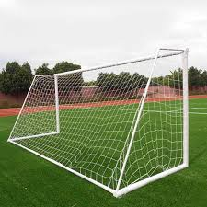
- Speed ladder | made of durable nylon or plastic, 15 to 20 feet long, about 15 inches wide, and features adjustable rungs for versatile drills. It should be lightweight for easy setup and storage | Pcs | 20 | 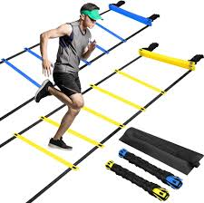
- Cones | made of durable, flexible plastic, about 12 to 15 inches tall, with a wide base for stability. They should be bright in color for visibility and stackable for easy storage | Pcs | 200 | 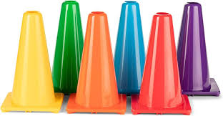
- Training balls | size 4 for youth, made of durable synthetic leather, weighing 410-450 grams, and featuring a well-stitched or thermally bonded design. They should have a high-quality latex or butyl bladder for air retention. And will be mixed with mini tango. | Pcs | 80 | 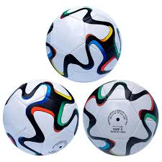
- Referee watch | should have a stopwatch and interval timer, be water-resistant, lightweight, feature a large display, and optionally include vibration alerts for discreet notifications | Pcs | 8 | 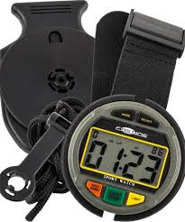
- Goalkeeper gloves | should have high-quality latex for grip, a comfortable cut (flat, roll, or negative, adequate padding for protection, secure wrist closures, and breathable materials for ventilation | Pcs | 20 | 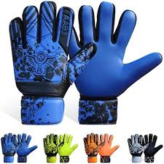
- Soccer shoes | puma and size from 32 to size 39 and (20 shoes with size 40). Most of the shoes should range b/w 36-38 | Pcs | 300 | 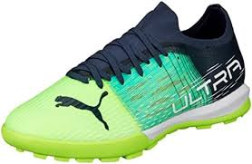
- Soccer Players Jersey | original dresses | Dozens | 28 | 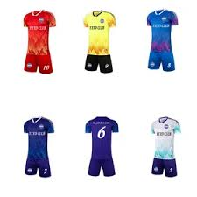
- Under clothes | With tight fitting long-sleeve tops and leggings made from lightweight and breathable fabric for modesty | Pcs | 100 | 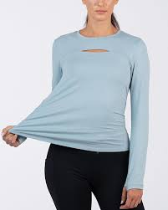
- Shin guards | normal ankle guards from size small to large and provide adequate protection | Pcs | 100 | 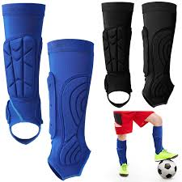
- Socks | knee high socks from size small to size large (more socks from medium to large) | Pcs | 300 | 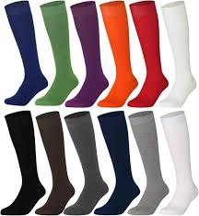
- Cards | yellow/red | Set | 8 | 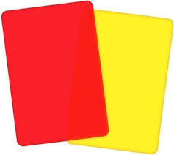
- Referee Jersey | comfortable fit with bright colors features mesh panels for ventilation, and include pockets for cards and tools | Pcs | 12 | 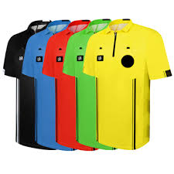
- Referee assistants’ flags | visible bright colors with flexible shaft for easy signaling | Set | 16 | 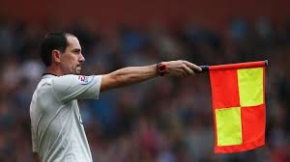
- Corner flags | bright colored for visibility and should be 5 to 6 feet tall and allow easy installation) | Pcs | 32 | 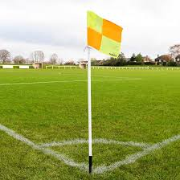
- Substitute board | substitute board should be lightweight and durable, typically made of plastic or aluminum, with a size of 12-18 inches for visibility. It should have a digital display with LED numbers, easy controls for quick changes, and be weather-resistant | Pcs | 4 | 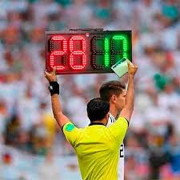
- Whistle | should be durable (plastic or metal), produce a loud, clear tone (around 1100-1200 Hz), and be compact and lightweight for easy handling | Pcs | 4 | 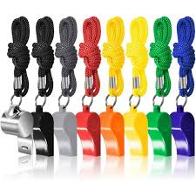
- Substitute dress | training bid for substitute players made from breathable fabric in bright colors | Pcs | 200 | 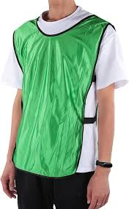
 | Total

  - Volleyball Sports Materials
Item | Description | Unit | Quantity | Pictures | Unit Price | Total Price
- Volleyball balls | round ball made of leather or synthetic material, measuring 65 to 67 cm and weight 260 to 280 grams. The supplier applicants should provide sample. | Pcs | 20 | 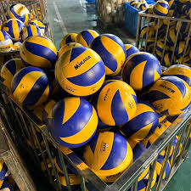
- Volley ball Nets | volleyball net is a rectangular mesh barrier, typically 2.43 meters high for men and 2.24 meters for women, and 9.0 meters wide. Made of durable nylon or polyethylene. The supplier applicants should provide sample | Pcs | 2 | 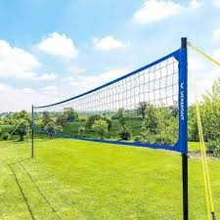
- Badminton poles | Badminton poles are vertical supports that hold the net, typically standing at 1.524 meters. Made from lightweight materials like aluminum, | Pcs | 2 | 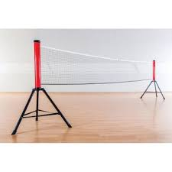
 | Total

  - Basketball Sports Materials
Item | Description | Unit | Quantity | Pictures | Unit Price | Total Price
- Basket balls | has an outer cover made of leather or synthetic materials and is filled with air to provide bounce. The standard size measures around 28.5 inches. The ball is orange with black seams, designed for visibility and grip during play. | Pcs | 30 | 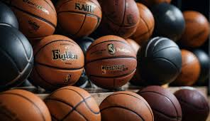
- Nets | 18 inches in diameter and hang from the rim at a height of 10 feet. The nets should be twisted or braided design | Pcs | 16 | 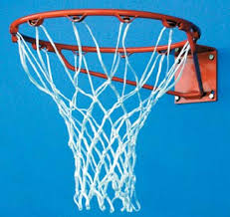
- Basketball poles | Basketball poles consist of a sturdy steel or aluminum pole, a rectangular backboard (typically 6 feet wide by 3.5 feet tall), and a circular rim that is 18 inches in diameter, set at a height of 10 feet and should all be adjustable. | Pcs | 6 | 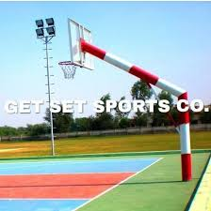
- Basketball shoes | size from 32 to size 39( 20 shoes with size 40). Most of the shoes should range b/w 36-38. | Pcs | 50 | 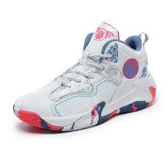
 | Total

