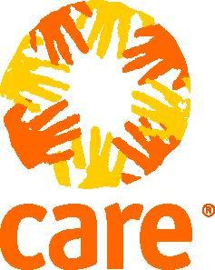

CARE INTERNATIONAL IN SOMALIA

TERMS OF REFERENCE (TOR) FOR PURBLIC AUCTION ADVERTISEMENT

BACKGROUND

About CARE INTERNATIONAL
CARE International in SOMALIA is a development and humanitarian organization with a goal to reduce poverty at the household level and provide relief in emergencies. We have worked with communities in Somaliland, Puntland & South Central, meeting relief needs and phasing in long-term projects.

CARE has been providing emergency relief and lifesaving assistance to the Somali people since 1981. CARE Somalia is currently operational in Somalia and Somaliland. The main programs are Rural Women Program, the Urban Youth Program, and the Emergency program through a process of extensive research and strategizing that started in 2009, CARE has developed two multisector development programs that address the underlying causes of poverty and vulnerability in Somalia/Somaliland. Rural Women and Urban Youth programs are informed by CARE International’s program approach which focuses on addressing the multiple drivers of poverty and vulnerability. These 2 programs are taking a longer-term approach to help us tackle a broad range of issues in local communities and to hold ourselves accountable for achieving significant and measurable results. Our main program activities since then have included projects in water and sanitation, sustainable pastoralist activities, civil society and media development, small-scale enterprise development, primary school education, teacher training, adult literacy, and vocational training. We work in partnership with Somali and international aid agencies, civil society leaders and local authorities.
CARE’s capacity and experience allow us to deliver fast and effective assistance whenever an emergency happens, which is done through the Emergency Program which normally has short-term projects. Our emergency program focuses on supporting Internally Displaced Persons (IDPs) and vulnerable host populations in five main sectors: Food Security/Livelihoods, Water, Sanitation and Hygiene (WASH), Health, Nutrition and Education in Emergencies (EiE). Also, we provide protection support to the people displaced by drought and conflict, helping them secure their safety and improve their relationships with the communities hosting them.

Objectives
The overall objective for this ToR is to efficiently dispose of a damaged vehicle through a public auction. The primary goal is to maximize the value obtained from the sale while ensuring transparency, compliance with legal requirements, and a seamless auction process. By conducting a public auction, the objective is to attract a wide range of potential national buyers and secure the best possible price for the damaged vehicle.

Scope of Work
This activity involves selling a damaged vehicle efficiently through transparent process while adhering to the applicable regulations. The scope covers the following attributes.
- Vehicle condition and inspection process
- Vehicle details
- Vehicle location/address
- Vehicle auctioning timelines

  - Vehicle Condition and inspection procedures
The vehicle is not functioning due to damage sustained during an accident and bidders will be able to inspect further physical checks during the auctioning process.
  - The vehicle specification details are as follows:
S/N | Vehicle Location | Vehicle Make | Vehicle Model | Vehicle Model Year (DD/MM/YY format) | Serial Number or Chassis Number | Condition (Functional, Non-Functional)
1 | Garowe | Toyota double bin | AHTKB8CD502980073 | 2020 | AHTKB8CD502980073 | not functional

Vehicle Pictures
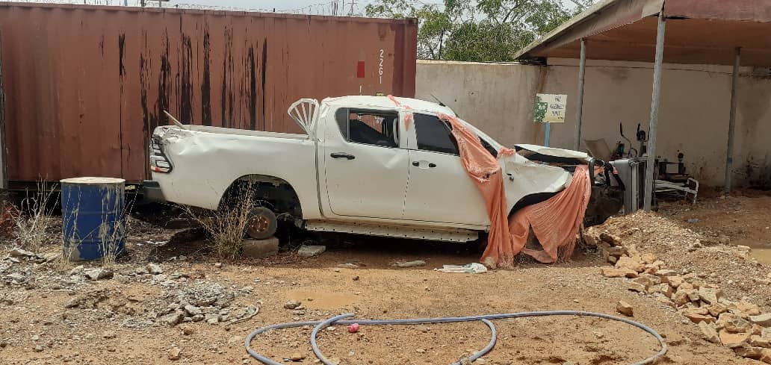 | 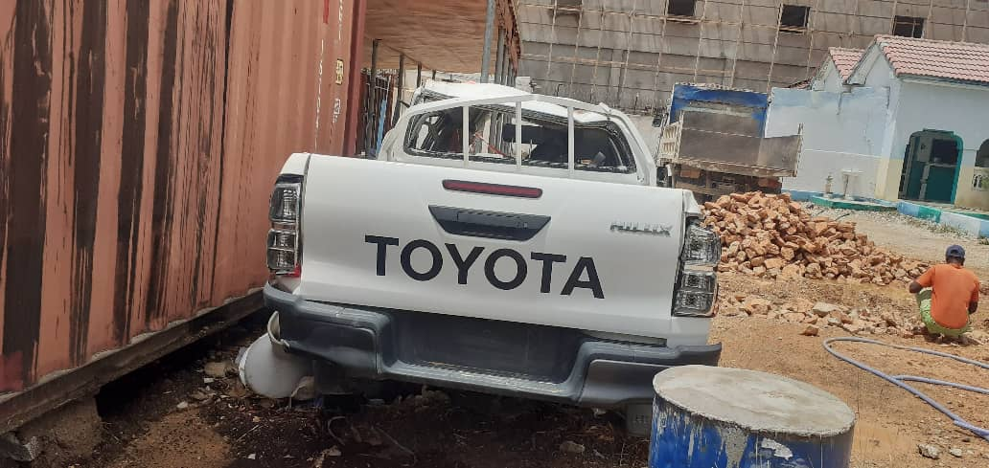

  - Vehicle Location/Address
The vehicle is in CARE Garowe office in Abdirizak H. Hussein Road, Wadajir, Garowe, Somalia

Roles and responsibilities:
Bidders are responsible for the following:
- Inspecting the damaged vehicle
- Understanding auction terms and conditions
- Submitting valid bids
- Complying with auction rules
- Ensure financial readiness for successful bid payments.
- maintain open communication with care to address any queries related to the auction process by sending clarification emails to SOM.Bids@care.org

CARE is responsible for the following:
- Facilitating the vehicle inspection
- Ensure legal and compliance
- Managing the auction process
- Address bidder’s inquiries
- Oversee transfer of ownership

How to Apply
Bidders will be able to use their quotation format and submit their offers ONLY via email to SOM.Bids@care.org indicating the subject line “Pick-up Vehicle Auction” no later than EAT 23:59 on 24 October 2024.

