
Annex II_B: Technical Specification and Photo
Hand Tools for CFW activities
SPR_No: 68165 – Hand tools for CFW of 12 SWC

Pos | Quantity | Description | Specification
Pos | (incl.unit) | (Commodity or Service) | (can use several lines for details)
1 | 216 pcs | Shovels for 12 sites of SWC activities | Shovels with wood sticks 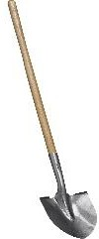
 | 162pcs | Pick axes | Medium size mattock with stout head which combines a vertical axe blade with a horizontal adze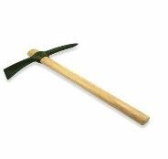
 | 24pcs | Meter tapes | 30meter, soft and thread rounded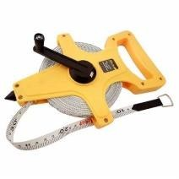
 | 84roll | Rope for levelling | 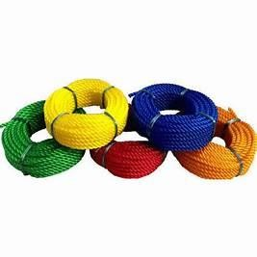
 | 12pcs | Water leveller | Spirit water leveler with small, or 20cm length 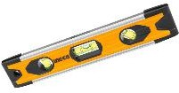
 | 20 rolls | Binding wire | Thin binding wire for Gabions 2mm diameter, 5kg/roll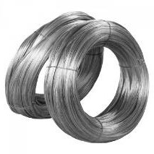
 | 6 pcs | Pliers | 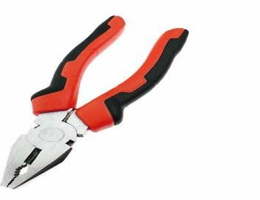having cutting and couching mouth
 | 6 pairs | Gloves for gabions binding | Cut-resistant gloves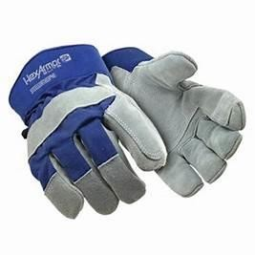
 | 1 | Digital measuring wheel | 1m height, handling, wheel diameter 16cm