REQUEST FOR QUOTATION (RFQ)
RFQ Reference: PR-4200604144 | Date: 16 January 2024
SECTION 1: REQUEST FOR QUOTATION (RFQ) for the provision of Implementation of IOM X Information and Awareness Campaign in Hargeisa.

International Organisation for Migration (IOM) kindly requests your quotation for the provision of goods, works and/or services as detailed in Annex 1 of this RFQ.
This Request for Quotation comprises the following documents:
Section 1: This request letter
Section 2: RFQ Instructions and Data
Annex 1: Schedule of Requirements
Annex 2: Quotation Submission Form
Annex 3: Technical and Financial Offer
When preparing your quotation, please be guided by the RFQ Instructions and Data. Please note that quotations must be submitted using Annex 2: Quotation Submission Form and Annex 3 Technical and Financial Offer, by the method and by the date and time indicated. It is your responsibility to ensure that your quotation is submitted on or before the deadline. Quotations received after the submission deadline, for whatever reason, will not be considered for evaluation.

Thank you and we look forward to receiving your quotations.

Approved by:

IOM Somalia Supply Chain Unit

SECTION 2: RFQ INSTRUCTIONS AND DATA
Deadline for the Submission of Quotation | 29 Jan 2024 5:00 PM  If any doubt exists as to the time zone in which the quotation should be submitted, refer to http://www.timeanddate.com/worldclock/.
Method of Submission | Quotations must be submitted as follows:  ☐ E-tendering  ☒ Email  ☐ Courier / Hand delivery  ☐ Other Click or tap here to enter text.  Bid submission address: procurement-tenderonly@iom.int  - File Format: PDF  - File names must be maximum 60 characters long and must not contain any letter or special character other than from Latin alphabet/keyboard.  - All files must be free of viruses and not corrupted.  - Max. File Size per transmission: 25MB  Mandatory subject of email:  4200604144- Implementation of IOM X Information and Awareness Campaign in Hargeisa.  - Multiple emails must be clearly identified by indicating in the subject line “email no. X of Y”, and the final “email no. Y of Y.  - It is recommended that the entire Quotation be consolidated into as few attachments as possible.  - The proposer should receive an email acknowledging email receipt.
Cost of preparation of quotation | IOM shall not be responsible for any costs associated with a Supplier’s preparation and submission of a quotation, regardless of the outcome or the manner of conducting the selection process.
Supplier Code of Conduct | All prospective suppliers must read the UN Supplier Code of Conduct and acknowledge that it provides the minimum standards expected of suppliers to the UN. The Code of Conduct, which includes principles on labour, human rights, environment and ethical conduct may be found at: Supplier Code of Conduct (ungm.org).
Conflict of Interest | UN encourages every prospective Supplier to avoid and prevent conflicts of interest, by disclosing to UN if you, or any of your affiliates or personnel, were involved in the preparation of the requirements, design, specifications, cost estimates, and other information used in this RFQ.
General Conditions of Contract | Any Purchase Order or contract that will be issued as a result of this RFQ shall be subject to the IOM General Conditions of Contract for provision of goods/services/transportation/medical services available at https://www.iom.int/do-business-us-procurement.
Eligibility | Bidders shall have the legal capacity to enter into a binding contract with IOM and to deliver in the country, or through an authorized representative.
Currency of Quotation | Quotations shall be quoted in USD
Duties and taxes | The International Organization for Migration is exempt from all direct taxes, except charges for public utility services, and is exempt from customs restrictions, duties, and charges of a similar nature in respect of articles imported or exported for its official use. All quotations shall be submitted net of any direct taxes and any other taxes and duties, unless otherwise specified below:  All prices shall:  ☐ be inclusive of VAT and other applicable indirect taxes  ☒ be exclusive of VAT and other applicable indirect taxes
Language of quotation and documentation including catalogues, instructions and operating manuals | English
Documents to be submitted | Bidders shall include the following documents in their quotation:  ☒ Annex 2: Quotation Submission Form duly completed and signed  ☒ Annex 3: Technical and Financial Offer duly completed and signed and in  accordance with the Schedule of Requirements in Annex 1  ☐ Other Click or tap here to enter text.
Quotation validity period | Quotations shall remain valid for 90 days from the deadline for the Submission of Quotation.
Price variation | No price variation due to escalation, inflation, fluctuation in exchange rates, or any other market factors shall be accepted at any time during the validity of the quotation after the quotation has been received.
Partial Quotes | ☒ Not permitted  ☐ Permitted
Payment Terms | ☒ 100% within 30 days after receipt of goods, works and/or services and submission of payment documentation.  ☐ Other Click or tap here to enter text.
Contact Person for correspondence, notifications and clarifications | Focal Person: Abdirisaq Barkad  E-mail address: amohamoud@iom.int  Attention: Quotations shall not be submitted to this address but to the address for quotation submission above.
Clarifications | Requests for clarification from bidders will not be accepted any later than 3 days before the submission deadline. Responses to request for clarification will be communicated through email by 01 December 2023
Evaluation method | ☒The contract will be awarded to the lowest price substantially compliant offer  ☐ Other Click or tap here to enter text.
Evaluation criteria | ☒Full compliance with all requirements as specified in Annex 1  ☒Full acceptance of the General Conditions of Contract  ☐Comprehensiveness of after-sales services  ☐Earliest Delivery /shortest lead time  ☐Others (for ex, environmental criteria/considerations, etc)
Right not to accept any quotation | IOM is not bound to accept any quotation, nor award a contract or Purchase Order
Right to vary requirement at time of award | At the time of award of Contract or Purchase Order, IOM reserves the right to vary (increase or decrease) the quantity of services and/or goods, by up to a maximum 25% of the total offer, without any change in the unit price or other terms and conditions.
Type of Contract to be awarded | Purchase Order for Services
Expected date for contract award. | 29 February 2024
Policies and procedures | This RFQ is conducted in accordance with Policies and Procedures of IOM
UNGM registration | IOM is encouraging all suppliers to register at the United Nations Global Marketplace (UNGM) website at www.ungm.org. The Bidder may still submit a quotation even if not registered with the UNGM, however, if the Bidder is selected for Contract award of USD 100,000 and above, the Bidder is recommended to register on the UNGM prior to contract signature. For vendors who do not have the technical means to register in UNGM, the UNGM has implemented an assisted vendor registration functionality that allows IOM procurement personnel to add local vendors to the UNGM.

ANNEX 1: SCHEDULE OF REQUIREMENTS

TERMS OF REFERENCE (TOR)
Location: | Hargeisa Somaliland
Type of Position: | Service Provider
Title of Position: | The Ground Implementation of the C4D Campaign under the BMM’s IOM X Somalia Project
Duration: | 1st February 2024 – 30st April 2024 (3Months)
Estimated Start Date: | 1st February 2024

- Background:

IOM’s Better Migration Management (BMM) programme is designed to improve migration management, and in particular, to address trafficking in persons and smuggling of migrants from and within the East and Horn of Africa region. Under component three of the BMM programme: Protection of vulnerable as well as potential migrants, IOM is supporting the development of communication strategies in Somalia with the view of bolstering community-level dialogues on causes of irregular migration and options for regular migration.
Under this programme, IOM aims to utilize Communication for Development (C4D) methodologies, as developed under IOM X (IOM’s innovative campaign to encourage safe migration and public action to stop human trafficking and exploitation by leveraging the power and popularity of media and technology to inspire young people and their communities to act against human trafficking and smuggling of migrants) to develop an evidence-based campaign, targeting a clear audience, with concrete action messages to help young Somalis from the communities experiencing irregular migration to take steps to protect themselves and make use of regular migration channels. The communication campaigns will focus more on youth in the age groups 18-30 who might embark on traveling on the eastern migratory corridor which is considered one of the most dangerous migratory corridors in the world. The awareness campaign will involve host communities including returnees along this route, local authorities and other actors providing protection services in transit locations. According to the Migrant Response Plan (MRP), more than twenty thousand migrants experience irregular migration along and Somalis remain the second largest populations experiencing protection and humanitarian concerns in transit locations including Yemen and risk their lives in irregular journeys on the Southern and Northern routes.
The Somali young generation is actively engaged in social media but exposed to the traps of notorious human traffickers and smugglers. Recognizing this challenges, IOM X information campaign intends to utilize theater for Development (T4D) strategies. The main aim is to effectively convey messages to the target audience. To support the efforts of implementing a campaign on the ground, IOM is searching for a service provider proficient in developing C4D activities and materials in Hargeisa, specifically a service provider with experience in C4D/T4D methodologies and implementation of communications campaigns. With the core project team working remotely and/or in Hargeisa, it is crucial to have support on the ground to implement a campaign that will largely be verbal, making it difficult to oversee without support on the ground to coordinate and oversee activities.
- II. Objectives

The main purposes of the IOM X information campaign activities are to:
  - Ensure that all activities are evidence-based by identifying gaps in knowledge, attitudes, and intended practices through stakeholder consultations and research with the target audience.
  - Implement an awareness-raising campaign using creative T4D/C4D methods to target young Somali men and women in the age group 18-30 who are exposed to trafficking and smuggling along the Eastern, Southern and Norther (Central Mediterranean) migratory routes.
  - Disseminate information available for youth and host communities in a target location in Hargeisa, Somaliland. To realize this, the service provider will engage with relevant authorities already providing these services in this location on top of active projects strengthening social cohesion and economic development for this population.
2.0 Specific Tasks:
Under the overall supervision of the MPA Programme Manager in Mogadishu and the Direct supervision of the National Programme Officer (MPA) in Hargeisa, the service provider will perform the following tasks:

      - Conduct stakeholder consultations: In order to ensure that all activities are evidence-based, the Service provider needs to engage in stakeholder consultations. This involves identifying key individuals or organizations that have relevant knowledge and expertise in the field. Through consultations, gaps in knowledge, attitudes, and intended practices can be identified. o Conduct KAP survey with the target audience: Alongside stakeholder consultations, the service provider should conduct Knowledge, Attitude and Practice survey with the target audience. These surveys will help identify gaps and key motivations that will be addressed through the campaign activities, as well as act as a baseline and end-line survey to measure any changes in the target audience.
      - Message Development: Based on the findings from stakeholder consultations and KAP Survey, the service provider should develop clear messages on the key issues push factors youth (18-30), and host communities are facing leading them to embark on irregular migration along the active routes.
      - Use creative T4D/C4D methods: To effectively reach and engage the target audience, the service provider should incorporate creative T4D (Theatre for Development)/C4D (Communication for Development) methods. This may include using theatre play, creative film, social media, mobile cinema, community conversations and other innovative tools to deliver the campaign messages.
      - Target young Somali (male/female in the age group, 18-30) at risk of trafficking and smuggling: The service provider should carefully design the campaign to address the specific issues and challenges faced by this group identified in the KAP baseline outcome. o Collaborate with relevant stakeholders: Collaborate with relevant stakeholders, including government agencies, developmental organizations, and humanitarian agencies, to gather and disseminate accurate and up-to-date information and opportunities for youth and protection services in Hargeisa Somaliland.

3.0 Deliverables:
    - Baseline and endline KAP surveys
    - Report on findings of the baseline KAP surveys
    - Overall campaign delivered using T4D/C4D methodology.
    - Campaign report with pictures of all on the ground activities to be shared.
    - Premium and poster designs and production to be shared.
    - Video recording with English subtitles of the event.
    - Activity reports on-the-ground activities to be shared.
    - Consultation workshop report with the partners, stakeholders, and target audience to be submitted within five working days after the workshop.
    - Endline report with pictures and videos of all on the ground activities
    - The final report incorporated with all the comments and revisions to be submitted on or before March 31, 2024.

4.0: Experience:

      - The service provider should have at least five years of relevant professional experience in community engagement, behaviour change and development programmes.
      - The service provider should have a thorough knowledge of migration issues, policies, and migration management practices, as well as related issues such as refugee protection and combating human trafficking.
      - The service provider should have extensive experience in facilitating and developing awareness-raising campaign sessions.
      - Previous worked with IOM or other UN agencies on awareness raising campaigns is preferable
      - Work and research experience with international organizations, local authorities, and public institutions is desirable.
      - The service provider should have strong planning, organizational, and problemsolving skills.
      - The service provider should have the ability to produce quality results within given deadlines.
      - Excellent writing skills, and experience in report writing, training records, and briefings.
      - Proven analytical, interpersonal, and organizational skills.

5.0 Skills/Competences
      - Demonstrated leadership, proactive communication, and facilitation skills.
      - Excellent writing and communication skills and the ability to maintain effective working relationships with government authorities, national and international organizations, and project partners.
      - Ability to research, interpret information, identify, and analyze problems and propose solutions.

  - Required Documentation
    - The service provider should submit a fully detailed project proposal, including approach, methodology samples of previous awareness raising campaigns and detailed budget breakdown.
    - The service provider should submit a realistic timeline and workplan.
    - The service provider should be registered in both Somaliland and should provide the registration certificates.

  - Timeline:
The contract will start as soon as service provider is recruited for a period of 3 months. a total of 13 weeks is allocated for this activity. o Phase 1: Activity preparation and KAP survey (5-6 weeks) o Phase 2: Activity Implementation (2 weeks) o Phase 3: Activity Reporting and Evaluation (4-5 weeks)

ANNEX 2: QUOTATION SUBMISSION FORM
Bidders are requested to complete this form, including the Company Profile and Bidder’s Declaration, sign it and return it as part of their quotation along with Annex 3: Technical and Financial Offer. The Bidder shall fill in this form in accordance with the instructions indicated. No alterations to its format shall be permitted and no substitutions shall be accepted.
Name of Bidder: | Click or tap here to enter text.
RFQ reference: | PR-4200604144 | Date: 29 February 2024

VENDOR INFORMATION SHEET
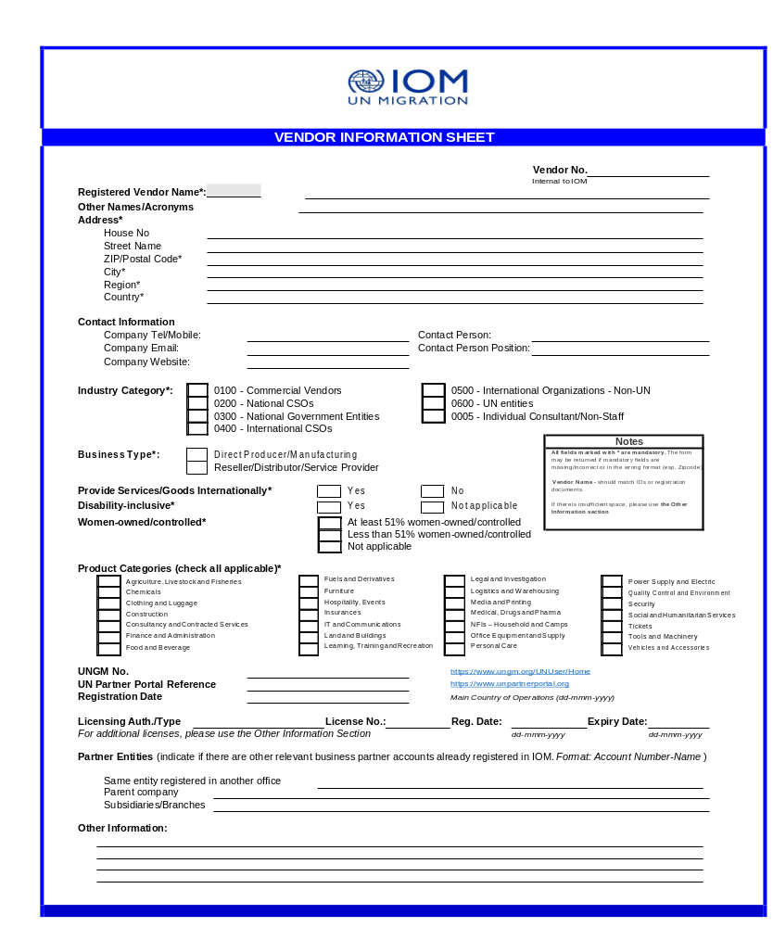


VENDOR INFORMATION SHEET
Section II: Payment and Banking Information
Payment Details

Payment Method* Bank Transfer Check** Cash** Others** Justification for Non-Bank Payment Method**

Notes
Payment currency of the vendor MUST be clearly marked in order to avoid additional bank charges and/or delay in payments. Non-bank payment methods require justification.

Bank Details (mandatory if Payment Method is via Bank Transfer):
Bank Name Bldg and Street City
Postal Code Country
Bank Account Name Bank Keys
Account Currency Bank Account No.
*Depending on the country

Swift Code/BIC (accounts outside U.S.A.) IBAN Number (mandatory for banks in Europe) Clearing No. (CHF accounts in Switzerland) ABA No. for ACH (USD accounts in U.S.A.) Bank Branch Code

Notes
If there are multiple bank accounts, please add an extra sheet, and mark the default bank account.

If awarded, please submit ID/Registration, signed IOM Supplier Code of Conduct and Proof of Banking Details to IOM
I hereby certify that the information above are true and correct. I am also authorizing IOM to validate all claims with concerned authorities.

Printed Name Signature

Position/Title Date

BIDDER’S DECLARATION OF CONFORMITY
Yes | No
☐ | ☐ | On behalf of the Supplier, I hereby represent and warrant that neither the Supplier, nor any person having powers of representation, decision-making or control over it or any member of its administrative, management or supervisory body, has been the subject of a final judgement or final administrative decision for one of the following reasons: bankruptcy, insolvency or winding-up procedures; breach of obligations relating to the payment of taxes or social security contributions; grave professional misconduct, including misrepresentation, fraud; corruption; conduct related to a criminal organisation; money laundering or terrorist financing; terrorist offences or offences linked to terrorist activities; child labour and other trafficking in human beings, any discriminatory or exploitative practice, or any practice that is inconsistent with the rights set forth in the Convention on the Rights of the Child or other prohibited practices; irregularity; creating or being a shell company.
☐ | ☐ | On behalf of the Supplier, I further represent and warrant that the Supplier is financially sound and duly licensed.
☐ | ☐ | On behalf of the Supplier, I further represent and warrant that the Supplier has adequate human resources, equipment, competence, expertise and skills necessary to complete the contract fully and satisfactorily, within the stipulated completion period and in accordance with the relevant terms and conditions.
☐ | ☐ | On behalf of the Supplier, I further represent and warrant that the Supplier complies with all applicable laws, ordinances, rules and regulations.
☐ | ☐ | On behalf of the Supplier, I further represent and warrant that the Supplier will in all circumstances act in the best interests of IOM.
☐ | ☐ | On behalf of the Supplier, I further represent and warrant that no official of IOM or any third party has received from, will be offered by, or will receive from the Supplier any direct or indirect benefit arising from the contract.
☐ | ☐ | On behalf of the Supplier, I further represent and warrant that the Supplier has not misrepresented or concealed any material facts during the contracting process.
☐ | ☐ | On behalf of the Supplier, I further represent and warrant that the Supplier will respect the legal status, privileges and immunities of IOM as an intergovernmental organization.
☐ | ☐ | On behalf of the Supplier, I further represent and warrant that neither the Supplier nor any persons having powers of representation, decision-making or control over the Supplier or any member of its administrative, management or supervisory body are included in the most recent Consolidated United Nations Security Council Sanctions List (the “UN Sanctions List”) or are the subject of any sanctions or other temporary suspension. The Supplier will immediately disclose to IOM if it or they become subject to any sanction or temporary suspension.
☐ | ☐ | On behalf of the Supplier, I further represent and warrant that the Supplier does not employ, provide resources to, support, contract or otherwise deal with any person, entity or other group associated with terrorism as per the UN Sanctions List and any other applicable anti-terrorism legislation.
☐ | ☐ | On behalf of the Supplier, I further represent and warrant that, the Supplier will apply the highest ethical standards, the principles of efficiency and economy, equal opportunity, open competition and transparency, and will avoid any conflict of interest.
☐ | ☐ | On behalf of the Supplier, I further represent and warrant that the Supplier undertakes to comply with the Code of Conduct, available at https://www.ungm.org/Public/CodeOfConduct.
☐ | ☐ | It is the responsibility of the Supplier to inform IOM immediately of any change to the information provided in this Declaration.
☐ | ☐ | On behalf of the Supplier, I certify that I am duly authorized to sign this Declaration and on behalf of the Supplier I agree to abide by the terms of this Declaration for the duration of any contract entered into between the Supplier and IOM.
☐ | ☐ | IOM reserves the right to terminate any contract between IOM and the Supplier, with immediate effect and without liability, in the event of any misrepresentation made by the Supplier in this Declaration.

Signature:
Name: Click or tap here to enter text.
Title: Click or tap here to enter text.
Date: Click or tap to enter a date.

ANNEX 3: TECHNICAL AND FINANCIAL OFFER - SERVICES
Bidders are requested to complete this form, sign it and return it as part of their quotation along with Annex 2 Quotation Submission Form. The Bidder shall fill in this form in accordance with the instructions indicated. No alterations to its format shall be permitted and no substitutions shall be accepted.
Name of Bidder: | Click or tap here to enter text.
RFQ reference: | PR-4200604144 | Date: 29 February 2024

Technical Offer
Provide the following:
- a brief description of your qualification, capacity and expertise that is relevant to the Terms of Reference.
- a brief methodology, approach and implementation plan;
- team composition and CVs of key personnel
Financial Offer
Provide a lump sum for the provision of the services stated in the Terms of Reference of your technical offer. The lump-sum should include all costs of preparing and delivering the Services. All daily rates shall be based on an eight-hour working day.
Currency of Quotation: Click or tap here to enter text.
Ref | Description of Deliverables | Unit | Qty | Unit Price | Total Price
1. | Conduct stakeholder consultations: In order to ensure that all activities are evidence-based, the Service provider needs to engage in stakeholder consultations. This involves identifying key individuals or organizations that have relevant knowledge and expertise in the field. Through consultations, gaps in knowledge, attitudes, and intended practices can be identified | Lump | 1
2. | Conduct KAP survey with the target audience: Alongside stakeholder consultations, the service provider should conduct Knowledge, Attitude and Practice survey with the target audience. These surveys will help identify gaps and key motivations that will be addressed through the campaign activities, as well as act as a baseline and end-line survey to measure any changes in the target audience | Lump | 1
3. | Message Development: Based on the findings from stakeholder consultations and KAP Survey, the service provider should develop clear messages on the key issues push factors youth (18-30), and host communities are facing leading them to embark on irregular migration along the active routes. | Lump | 1
4. | Use creative T4D/C4D methods: To effectively reach and engage the target audience, the service provider should incorporate creative T4D (Theatre for Development)/C4D (Communication for Development) methods. This may include using theatre play, creative film, social media, mobile cinema, community conversations and other innovative tools to deliver the campaign messages. | Lump | 1
Total Price

Compliance with Requirements
 | You Responses
 | Yes, we will comply | No, we cannot comply | If you cannot comply, pls. indicate counter proposal
Delivery Lead Time | ☐ | ☐ | Click or tap here to enter text.
Validity of Quotation | ☐ | ☐ | Click or tap here to enter text.
Payment terms | ☐ | ☐ | Click or tap here to enter text.
Other requirements [pls. specify] | ☐ | ☐ | Click or tap here to enter text.

I, the undersigned, certify that I am duly authorized to sign this quotation and bind the company below in event that the quotation is accepted.
Exact name and address of company  Company NameClick or tap here to enter text.  Address: Click or tap here to enter text.  Click or tap here to enter text.  Phone No.: Click or tap here to enter text.  Email Address: Click or tap here to enter text. | Authorized Signature:  Date: Click or tap here to enter text.  Name: Click or tap here to enter text.  Functional Title of Authorised  Signatory: Click or tap here to enter text.  Email Address: Click or tap here to enter text.

This form is mandatory to fill in and sign by every vendor who submits quotation

