

Supply & delivery and installation of GYM equipment to SOS Children’s Villages Heliwa district - Somalia -Mogadishu
INVITATION TO BID (ITB)

NAME AND ADDRESS OF FIRM | Date: 5th August 2025
_____________________________________________________________________________ | Reference: SOS/SOM/GYM/254/08/2025

Dear Sir/Madam:

We kindly request you to submit your bid for Supply & delivery and installation of GYM equipment to SOS Children’s Villages Heliwa district - Somalia -Mogadishu.
This project is only open to eligible contractors who meet the preset qualification criteria as enlisted in the documents hereto:

This Tender Documents is a formal invitation to interested bidders / agencies to submit offers
and consists of the following:
- Invitation for Bids
- Bidding data
- Instructions to Bidders
- Evaluation Criteria

The Bid (to be completed and returned by bidding Contractor)
- Qualification Information (to be completed by the Bidding agency)

We kindly request you to submit your quotation for the Supply & delivery and installation of GYM equipment to SOS Children’s Villages Heliwa district - Somalia -Mogadishu
The period of submission deadline is Wednesday 13th August 2025

When preparing your bid, please be guided by the table provided in Annex 1 with your own
Bid quotations documents should be submitted in sealed envelopes with Tender No: SOS/SOM/GYM/254/08/2025, on it with the subject line,
National office KM4 in Mogadishu Somalia, and to be dropped in the tender box at SOS CV National Office, Off airport road, Bulo-Hubey Road, KM4 areas, next to Alburuj office. Mogadishu – Somalia on or before 04:00 pm on Wednesday 13th August 2025

Bidding data
The Bid is for the Supply & delivery and installation of GYM equipment to SOS Children’s Villages Heliwa district - Somalia -Mogadishu

Instructions to Bidders
Bidding is open to eligible and interested Contractors. The bidder should have performed works of a similar or related nature over the past years. Proof of claim may be required as an attachment of previously stamped service orders or contracts as evidence.
- The Quoted currency shall be in U.S. Dollars
- The contractor must have suitably qualified staff personnel to fulfil the required functions for the installation and use of the equipment.
- The pages of the Bid to be completed and returned shall be original not copied. The period of Bid quotation validity price should be mentioned.
Evaluation Criteria
Completeness and Correctness of Bids
Bids shall be inspected on their completeness and correctness. Requirements for Completeness of Bids shall include, but are not limited to:
- Submission of Complete Bid
- Submission of Complete Bill of Quantities, and Total Bid Price
- Relevant experience as evidenced by list of completed and ongoing contracts
- Legal and valid registration documents
- Mode of payment
Note: Incomplete and grossly Incorrect Bids shall be rejected.

Technical Evaluation Criteria
The various evaluations will, as much as possible, cover all the technical requirements to successfully accomplish the present evaluation. As such, the technical evaluation is not limited to items of a purely mechanical nature (such as equipment, materials, etc.), but also includes other important aspects, such as experience and personnel, financial and administrative ability, responsiveness, and compliance with the conditions of the Bid.
Consideration will be made of the following aspects of the contractor's competence:
- Updated company profile with the following information.
- Company main office/ branch offices address, contacts/emails
- Valid Local administration certificate or applicable local registration
  - Company Valid and legal registration Certificate Federal Government of Somalia.
  - Company Tax Clearance.
- Contractor’s Experience: Detailed description of at least one similar project completed in the previous years.
- Warranties: Specific warranties related to equipment and workmanship.
- Quality Control (SOBS)
- Financial Proposal: Detailed bill of quantities, realistic cost estimates, inclusive of all taxes. With company stamp.

Child safeguarding: SOS Children’s Villages organization is committed to safeguarding the rights of the children and therefore, it is expected that every individual/partner/supplier who joins or does business with SOS Children’s Villages Somalia understand his/her responsibility in protecting and keeping children always safe. For more click Child Protection Policy.

Kindly, submit your prices refer in the table below or use your own template with the company logo.

Annex 1
Please, quote the below lited items and submit your priceses on or before the deadline above
ITEM DESCRIPTION | Pictures | Size (L*W*H) mm | Weight | QTY | Unit Price | Total Price
DIP CHIN ASSIST |  | 1690x1230x2380 Without handle | 270 | 2
  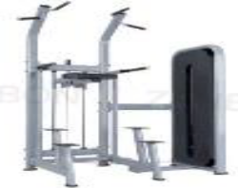
AIR ROWER MACHINE | 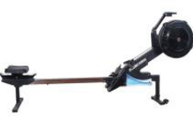 | 2130*610*1170 | 35 | 1
Commercial keyboard treadmill | 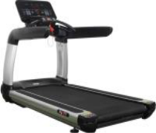 | 2100*1000*740 | 200 | 1
Stair master | 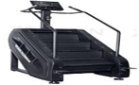 | 1450*880*2060 | 210 | 1
Spinning bike | 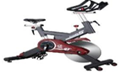 | 1140*560*1180 | 68 | 2
Tire machine | 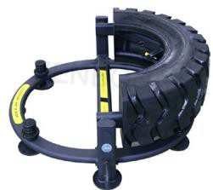 | 1650*1220*510 | 125 | 2
Shoulder press | 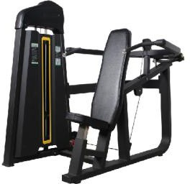 | 1850x1220x1620 | 239 | 1
Multifunctional trainer | 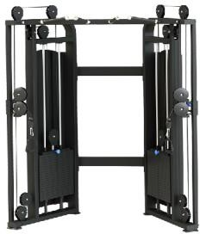 | 1750x1150x2350 | 330 | 1
Beauty dumbbell rack | 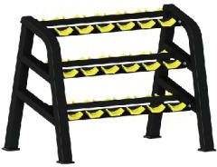 | 680x1390x1010 | 112 | 1
Multi function rack | 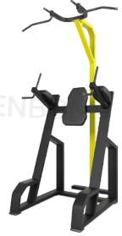 | 790x1430x2200 | 115 | 1
Back extension | 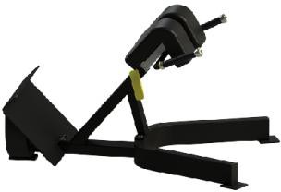 | 1200x920x750 | 55 | 1
Lat pulldown and low row |  | 2200x1000x2130 | 285 | 1
  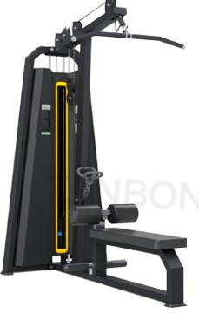
3D smith | 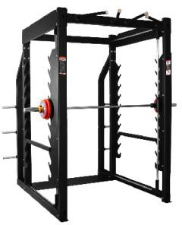 | 2210x1780x2390 | 289 | 1
vertical press | 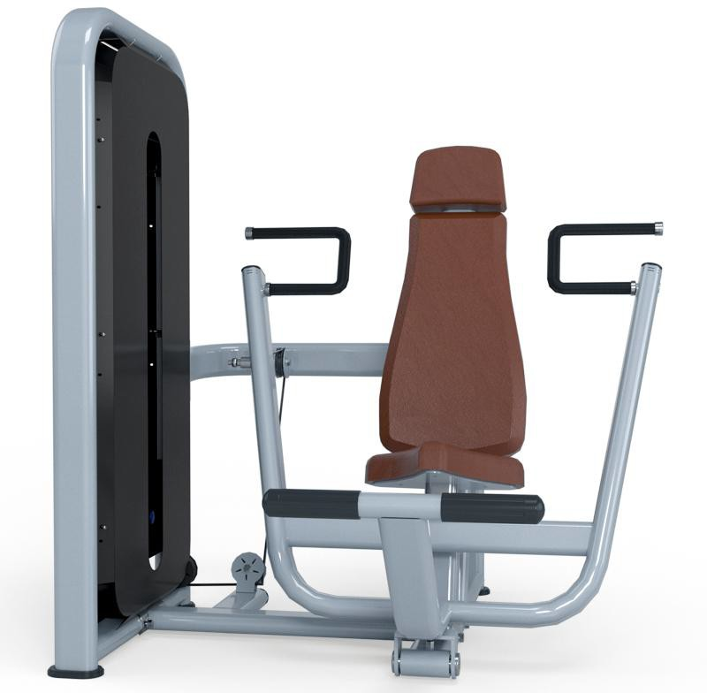 | 1570*1410*1535 | 190 | 1
Single crossover |  | 800*785*2185 | 145 | 1
  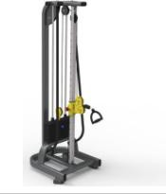
Super bench |  | 1670x700x590 | 48 | 1
  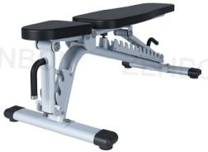
Flat bench | 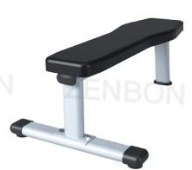 | 1210x715x435 | 15 | 2
Adjustable abdominal bench | 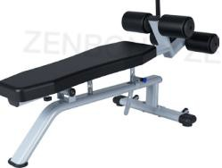 | 1600x718x835 | 30 | 1
45 degree leg press | 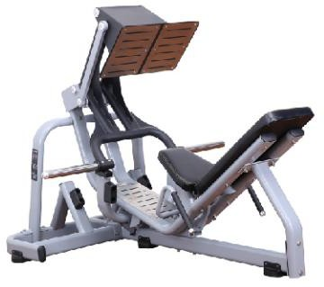 | 3095x1470x1328 | 166 | 1
Incline chest press | 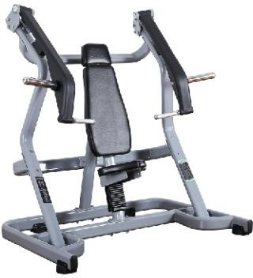 | 1665x1160x1697 | 136 | 1
Handlebar rack | 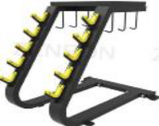 | 950x780x1050 | 70 | 1
Hex rubber dumbbell | 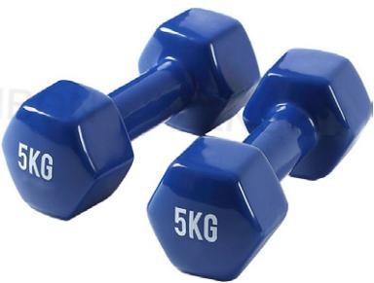 | 2.5kg-50kg,increment 2.5kg/lb ok | 2.5kg-50kg,increment 2.5kg/lb | 20
Lady dumbbell | 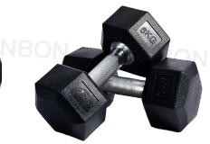 | 1kg/2kg/3kg/4kg/5kg | 1kg/2kg/3kg/4kg/5kg | 10
Rubber weight plate | 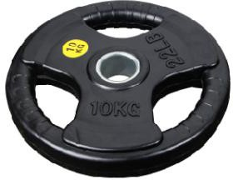 | 2.5/5/10/15/20/25kg/lb ok | 2.5/5/10/15/20/25kg/lb | 20
Kettlebell | 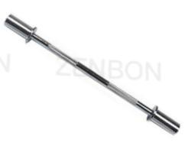  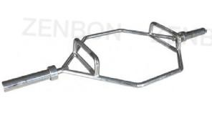  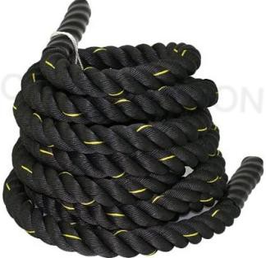 | 2kg-20kg | 2kg-20kg | 5
  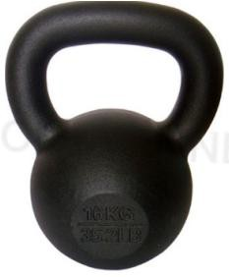
1.2m straight bar |  |  |  | 3
1.2m curl bar | 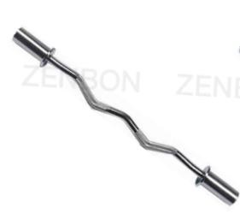 |  |  | 3
1.5m straight bar | 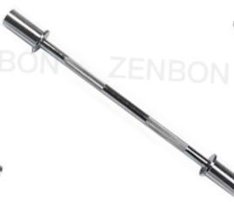 |  |  | 3
1.5m curl bar |  |  |  | 3
1.8m straight bar |  |  |  | 3
Hex bar |  |  |  | 3
Battle rope |  | 38mm*9m(1pcs)  38mm*12m (1pcs)  38mm*15m (1pcs) |  | 3
Abdominal wheel | 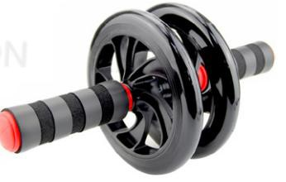 | 320mm*150mm |  | 5
Yoga ball | 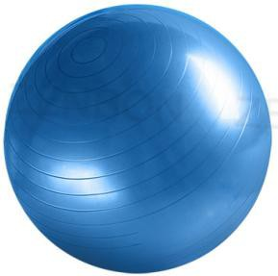 | 550mm |  | 1
Yoga ball |  | 650mm |  | 1
Yoga ball |  | 750mm |  | 1
yoga mat | 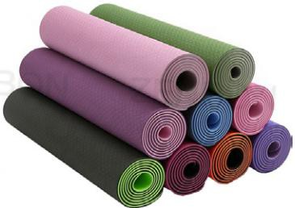 | 1830*610*6mm |  | 3
Sandbag | 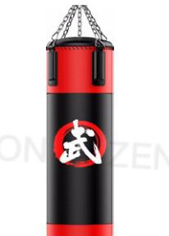 | 140cm |  | 5
Sandbag |  | 160cm |  | 5
Pedal | 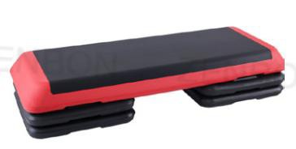 | 110*42*21CM |  | 1
Tricep rope | 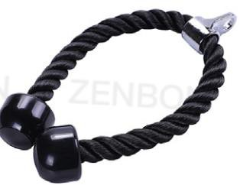 |  |  | 5
Pullbar | 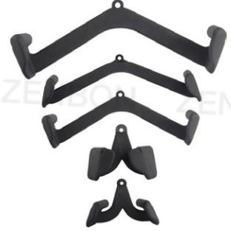 |  |  | 1
Elastic rope | 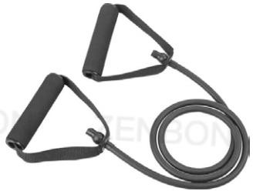 | 15LB, 20LB,30LB | 15LB, 20LB,30LB | 1
GRAND TOTAL

Thank you and we look forward to receiving your bid price and support documents

We hereby confirm that this Bid complies with the Bid validity and bidding documents and as specified in the Bidding Data.

Name of Bidder: ………………………………………………………….
Name and Title: ………………………………………………………….
Signature: ……………………………………………………………….
Address: …………………………………………………………………...
SOS shall not be liable for any costs, expenses or claims associated with preparation of this bid documents incurred by the applicant whether he/she is selected or not

