PHARO FOUNDATION
INVITATION TO TENDER
Design, Supply, Installation and Commissioning of a
Wastewater Treatment System
Pharo Primary School Construction Project
Hargeisa, Somaliland
Tender Reference | ITT/ Pharo International School/July 2026/001
Issue Date | 13 July 2026
Submission Deadline | Wednesday, 22 July 2026 at 2:00 PM East Africa Time
Submission Email | info.SL@pharofoundation.org
Estimated Design Population | Approximately 1,200 persons (1,000 students and 200 staff)
URGENT TENDER - IMMEDIATE MOBILIZATION REQUIRED

1. Invitation
Pharo Foundation invites qualified, technically competent and financially capable companies to submit technical and financial proposals for the design, supply, installation, testing and commissioning of a wastewater treatment system and associated sewage works for Pharo Primary School, which is currently under construction in Hargeisa, Somaliland.
The proposed wastewater treatment system shall be designed to serve an estimated population of approximately 1,200 persons, comprising approximately 1,000 students and 200 teaching, administrative and support staff.
The above population figures shall form the preliminary basis for the system design. Bidders shall undertake the necessary technical calculations to confirm the required hydraulic and treatment capacity, including appropriate allowances for peak demand, operational fluctuations, future growth and safety margins.
This is an urgent procurement process with a short and limited tender period. Bidders must demonstrate that they possess the technical expertise, financial capacity, personnel, equipment and access to materials necessary to mobilize immediately following contract award and issuance of the Notice to Proceed.

2. Project Information and MEP Layouts
Pharo Foundation will provide bidders with the available Mechanical, Electrical and Plumbing (MEP) layouts explaining the general design and arrangement of the school's sewage system.
- Ground-floor sewage piping and drainage arrangements.
- First-floor sewage piping and drainage arrangements.
- Second-floor sewage piping and drainage arrangements.
The layouts illustrate the general sewage routes, drainage connections, inspection points, floor drains and related components across the school development.
The drawings are provided to assist bidders in understanding the general sewage-system design. However, the drawings identify themselves as guidance plans and indicate that they may be subject to technical, administrative, legal, construction or design changes.
Bidders shall therefore:
- Conduct a physical site inspection.
- Verify all relevant dimensions, elevations, gradients and connection points.
- Confirm the location and suitability of the proposed treatment system.
- Identify any design discrepancy, conflict or omission.
- Prepare final technical calculations and shop drawings.
- Obtain written approval of the final technical submission before commencing the relevant works.
The successful contractor shall remain responsible for delivering a complete, functional and properly coordinated system notwithstanding any omission that should reasonably have been identified through site verification and professional technical review.

3. General Scope of Works
The successful contractor shall be responsible for the complete design and delivery of a functional wastewater treatment system, including, but not limited to, the following:

3.1 Investigation and design
1. Review all available architectural, civil, mechanical, electrical, plumbing and sewage documentation.
2. Conduct a detailed site investigation and verify existing construction conditions; sewage collection and discharge points; pipe sizes, routes, gradients and invert levels; ground conditions; available installation space; electrical supply requirements; access for operation, maintenance and sludge removal; treated-effluent discharge or reuse arrangements; and coordination requirements with other construction activities.
3. Assess the expected wastewater volume based on an estimated population of approximately 1,200 persons.
4. Prepare hydraulic calculations, organic-loading calculations, average and peak-flow calculations, process-design calculations, equipment schedules, general arrangement drawings, process-flow diagrams, shop drawings, civil and structural details, mechanical and electrical diagrams, control-system diagrams, and treated-effluent and sludge-management proposals.

3.2 Supply and installation
The contractor shall supply and install all components necessary for a complete wastewater treatment system, including, where applicable:
- Screening and preliminary treatment units.
- Primary treatment units.
- Biological treatment units.
- Tertiary treatment and disinfection units.
- Treatment tanks and chambers.
- Pumps and pumping chambers.
- Pipework, valves and fittings.
- Inspection chambers and manholes.
- Ventilation and odour-control systems.
- Electrical control panels.
- Level controls, alarms and monitoring devices.
- Sludge collection and handling components.
- Access covers, ladders and safety components.
- Treated-effluent storage, discharge or reuse components.
- Required foundations and supporting structures.
- All accessories necessary for safe and proper operation.

3.3 Civil, electrical and associated works
The scope shall include all necessary associated works, including:
- Excavation and trenching.
- Foundations and reinforced concrete works.
- Tank installation and chambers.
- Backfilling and reinstatement.
- Protective structures.
- Electrical cabling, control wiring and earthing.
- Connection to the school sewage network.
- Making good all affected areas.

3.4 Testing, commissioning and handover
The contractor shall:
- Undertake dry and wet testing.
- Conduct leak and pressure testing where applicable.
- Test pumps, controls, alarms and electrical systems.
- Demonstrate the system under operating conditions.
- Carry out treated-effluent sampling and testing.
- Rectify and retest any failed component.
- Commission the complete system.
- Train designated personnel.
- Submit all required handover documentation.
The successful contractor shall provide all labour, supervision, equipment, tools, materials, transportation, consumables and specialist services required to complete the assignment, except where expressly stated otherwise in the final contract.

4. Design Capacity and Performance Requirements
The proposed system shall be designed using an estimated population of approximately 1,200 persons. The bidder shall clearly state:
- The proposed daily wastewater design flow.
- The assumed wastewater generation per person per day.
- The average and peak hydraulic loading.
- The assumed influent characteristics and proposed organic loading.
- The treatment capacity and proposed treatment process.
- The anticipated treated-effluent quality.
- The estimated sludge-generation rate and proposed sludge-treatment and disposal method.
- The anticipated electricity consumption.
- The proposed measures for controlling odour and noise.
- The system's ability to accommodate variations between school operating and non-operating periods.
- Any allowance for future population growth.
- The standards or performance requirements against which the system is designed.
The completed system shall comply with applicable environmental, public-health, wastewater-discharge, construction and occupational-safety requirements.
Where numerical local discharge standards are not specified in the tender documents, the bidder shall identify the recognized wastewater-treatment standard proposed for the project. The proposed standard shall be subject to review and written approval by Pharo Foundation and its appointed project consultants.

5. Mandatory Eligibility and Due-Diligence Documentation
The following documentation shall be submitted by each bidder and shall be evaluated on a mandatory pass-or-fail basis.

5.1 Legal and regulatory documentation
1. A valid business licence.
2. Valid company registration documentation.
3. A valid tax-clearance certificate or equivalent evidence confirming compliance with applicable tax obligations.
4. Evidence of authorization to conduct business and execute the proposed works in Somaliland.
5. Copies of relevant technical licences, engineering registrations or professional certifications.

5.2 Company ownership and directors
1. A current list of all company directors.
2. A current list of shareholders or beneficial owners, where applicable.
3. Copies of valid identification documents for company directors or authorized signatories.
4. The company's memorandum and articles of association, incorporation certificate or equivalent formation documents.
5. A signed board resolution or power of attorney authorizing the person signing and submitting the tender.
6. Disclosure of any actual, potential or perceived conflict of interest involving Pharo Foundation employees, consultants, evaluation committee members or affiliated parties.

5.3 Financial-capacity documentation
Each bidder shall submit either:
- Audited financial statements and corresponding independent audit reports for the last two completed financial years.
or, where audited financial statements are unavailable:
- Bank-issued or bank-certified financial statements or account statements covering the previous four years, together with a current bank reference letter confirming the bidder's banking relationship and financial standing.
Pharo Foundation may request:
- Original or certified copies.
- Direct confirmation from the issuing bank or auditor.
- Additional evidence of working capital.
- Evidence of access to credit facilities.
- Details of current financial commitments.
- Clarification of any material qualification appearing in an audit report.
Submission of false, altered, misleading or unverifiable financial documentation shall be grounds for immediate disqualification and may result in exclusion from future Pharo Foundation procurement processes.

5.4 Technical and operational capacity
- Evidence of relevant wastewater-treatment experience.
- Details of at least three comparable assignments, where available.
- Completion certificates or client references.
- Details of proposed technical personnel.
- Evidence of access to the required equipment and specialist expertise.
- Details of current assignments and contractual commitments.
- Confirmation of immediate mobilization capacity.
- Details of the proposed warranty and after-sales support arrangements.
Failure to submit any mandatory documentation may result in rejection of the proposal. Pharo Foundation may permit clarification of an existing document but shall not be obligated to allow a bidder to submit material eligibility documentation that was entirely absent at the submission deadline.

6. Performance Collateral

6.1 Collateral requirement
The successful bidder shall provide acceptable collateral with a verified value equal to at least 30% of the final contract value.
The collateral shall serve as security for the contractor's:
- Proper performance of the contract.
- Timely mobilization.
- Proper use of any funds advanced.
- Completion of the works.
- Rectification of defective or incomplete works.
- Delivery of all required materials and equipment.
- Testing and commissioning obligations.
- Compliance with all contractual responsibilities.

6.2 Timing
The collateral shall be provided, verified, documented and accepted by Pharo Foundation before issuance of the Notice to Proceed, release of any advance or mobilization payment, or commencement of substantive works, unless Pharo Foundation expressly approves an alternative arrangement in writing.

6.3 Acceptable forms of collateral
Subject to verification and approval by Pharo Foundation, collateral may include:
- Land.
- Buildings or other immovable property.
- Construction or industrial equipment.
- Motorized plant or machinery.
- An unconditional bank guarantee.
- A performance bond issued by an acceptable financial institution.
- Another form of security expressly approved in writing by Pharo Foundation.
Cash collateral shall only be accepted where expressly agreed and documented.

6.4 Collateral documentation
The contractor shall submit:
- Proof of legal ownership.
- Valid identification of the registered owner.
- Evidence that the asset is free from undisclosed liens, charges, disputes or competing claims.
- A current independent valuation from a qualified and acceptable valuer.
- Photographs, serial numbers, title numbers or other identifying information.
- A notarized collateral agreement.
- Consent from any joint owner or spouse where legally required.
- Authority permitting the collateral to be pledged.
- Evidence of insurance where applicable.
- Any registration or perfection documents required to make the security enforceable.
The collateral shall not be sold, transferred, pledged, leased, substituted, removed from the agreed location or otherwise encumbered without Pharo Foundation's prior written approval.

6.5 Valuation
The value of collateral shall be determined using a conservative market value or forced-sale value acceptable to Pharo Foundation.
Pharo Foundation may:
- Reject an asset it considers unsuitable.
- Request an independent second valuation.
- Require additional collateral where the value is insufficient.
- Require replacement collateral where the value materially decreases.
- Physically inspect and verify the collateral.
All costs associated with valuation, notarization, registration, verification and maintenance of the collateral shall be borne by the successful bidder unless otherwise agreed in writing.

6.6 Release of collateral
The collateral shall remain in effect until:
- The works have been successfully completed.
- The system has passed the required testing and commissioning procedures.
- All defects identified before completion have been rectified.
- All manuals, warranties, training records, as-built drawings and handover documents have been submitted and approved.
- All contractor liabilities due at completion have been settled.
- Pharo Foundation has issued a written Completion and Handover Certificate.
Release of collateral shall only occur through written authorization by Pharo Foundation's authorized representative.
Where the final contract provides for part of the collateral or another form of security to remain in effect during the defects-liability period, the applicable portion shall be released only after expiry of that period and rectification of all notified defects.

6.7 Enforcement
The final contract and collateral agreement shall specify the circumstances in which Pharo Foundation may call, realize or enforce the collateral, including:
- Failure to mobilize.
- Abandonment of the works.
- Material breach of contract.
- Misuse of advance or project funds.
- Failure to complete the works.
- Failure to rectify defective work.
- Insolvency.
- Fraud or material misrepresentation.
- Termination caused by the contractor's default.
The enforceability, registration and realization mechanism for any proposed collateral shall be verified before acceptance and reflected in the final contract and notarized collateral agreement.

7. Site Inspection and Bidder Responsibility
Bidders are strongly encouraged to attend a site inspection before submitting their proposals.
Each bidder shall be responsible for:
- Examining the site and tender documentation.
- Reviewing the MEP layouts.
- Verifying dimensions, levels and connection points.
- Assessing access and excavation requirements.
- Confirming the suitability of the proposed treatment technology.
- Identifying conflicts with ongoing or planned construction works.
- Coordinating the proposed solution with the wider construction programme.
- Including all reasonably foreseeable works necessary for a complete system.
A bidder that does not attend the site inspection shall submit a written declaration confirming that it accepts responsibility for understanding the site conditions and that its failure to inspect the site will not form the basis of a later claim.
No additional payment shall be approved solely because the contractor failed to inspect the site, verify the available information or include reasonably foreseeable works necessary for successful completion.

8. Required Tender Submission

8.1 Technical proposal
1. Company profile.
2. All mandatory documentation listed in Section 5.
3. Understanding of the assignment.
4. Description of the proposed wastewater-treatment technology.
5. Design calculations based on an estimated population of 1,200 persons.
6. Proposed average and peak design flows.
7. Proposed treatment stages and anticipated treated-effluent quality.
8. Preliminary layout, process-flow diagram and general arrangement.
9. Proposed connection arrangements with the school sewage network.
10. Implementation methodology.
11. Detailed work programme showing the design, approval, mobilization, procurement, delivery, installation, testing and commissioning periods and the proposed completion date.
12. List of proposed equipment, materials, manufacturers and countries of origin.
13. Technical datasheets.
14. Qualifications and experience of the proposed personnel.
15. Details of similar completed assignments.
16. Health, safety and environmental management plan.
17. Safeguarding and worker-conduct arrangements.
18. Quality-assurance and quality-control plan.
19. Testing and commissioning methodology.
20. Training and handover plan.
21. Warranty and defects-liability arrangements.
22. Maintenance and after-sales support proposal.
23. Earliest possible mobilization date.
24. Confirmation of willingness and ability to provide collateral equal to 30% of the final contract value.
25. Clear disclosure of assumptions, qualifications and exclusions.

8.2 Financial proposal
The financial proposal shall include:
- A detailed priced Bill of Quantities.
- Design and engineering costs.
- Civil and structural costs.
- Mechanical costs.
- Electrical and control costs.
- Treatment equipment costs.
- Pipework and fittings.
- Transportation and delivery.
- Installation.
- Testing and commissioning.
- Training.
- Documentation.
- Spare parts.
- Post-installation support.
- Taxes and statutory charges.
- Proposed payment schedule.
- Tender validity period.
- Completion period.
- Warranty period.
- All exclusions or assumptions.
The financial proposal shall be comprehensive and shall include all costs required to deliver a complete, operational and properly commissioned wastewater treatment system.

9. Bidder Declarations
Each bidder shall submit signed declarations confirming that:
- The proposal has been prepared independently.
- The bidder has not engaged in collusion.
- No bribe, inducement, commission or improper benefit has been offered.
- All actual or potential conflicts of interest have been disclosed.
- All information and supporting documents are accurate and authentic.
- The bidder authorizes Pharo Foundation to verify submitted information.
- The bidder has reviewed the tender documentation and MEP layouts.
- All assumptions and exclusions have been disclosed.
- The bidder accepts the requirement to provide collateral equal to 30% of the final contract value if selected.
- The bidder will comply with Pharo Foundation's safeguarding, anti-fraud and code-of-conduct requirements.
- The bidder has the capacity to mobilize and perform the assignment within the proposed timeframe.

10. Tender Evaluation

10.1 Preliminary mandatory compliance
The following shall be assessed on a pass-or-fail basis:
- Business licence.
- Company registration.
- Tax clearance.
- Director and ownership documentation.
- Authorization of the tender signatory.
- Required financial-capacity documentation.
- Conflict-of-interest declaration.
- Anti-bribery and non-collusion declaration.
- Relevant experience.
- Tender validity.
- Immediate mobilization confirmation.
- Written acceptance of the 30% collateral requirement.
Only substantially compliant bidders may proceed to detailed technical and financial evaluation.

10.2 Evaluation criteria
Evaluation Area | Weight
Proposed treatment technology and design calculations | 20%
Methodology and integration with the MEP sewage system | 15%
Relevant company experience | 10%
Qualifications and availability of proposed personnel | 10%
Work programme and immediate mobilization capacity | 10%
Warranty, operation, maintenance and after-sales support | 5%
Financial proposal | 30%
Total | 100%
A bidder shall be required to achieve at least 70% of the available technical score before its financial proposal is considered.
The lowest-priced proposal shall not automatically be selected. Pharo Foundation shall consider technical suitability, financial capacity, delivery risk, lifecycle cost, operational requirements and overall value for money.
Pharo Foundation may conduct:
- Reference checks.
- Bank verification.
- Auditor verification.
- Site visits to completed projects.
- Interviews with proposed personnel.
- Physical inspection of bidder facilities.
- Verification of proposed collateral.
- Any other reasonable due-diligence review.

11. Commercial Requirements
The successful bidder shall be required to enter into a formal contract containing, among other provisions:
- A defined scope of works.
- Approved drawings and specifications.
- Measurable deliverables.
- Payment milestones.
- Performance collateral equal to 30% of the contract value.
- Advance-payment security, where applicable.
- Retention provisions.
- Insurance requirements.
- Tax responsibilities.
- Delay damages.
- Defects-liability obligations.
- Warranty requirements.
- Testing and acceptance criteria.
- Health and safety obligations.
- Safeguarding requirements.
- Anti-fraud and anti-bribery provisions.
- Termination rights.
- Dispute-resolution procedures.
- Ownership of drawings, designs, manuals and as-built documentation.
The proposed tender validity period shall be at least 60 days from the submission deadline unless otherwise approved by Pharo Foundation.

12. Submission Instructions
Completed technical and financial proposals shall be submitted electronically in PDF format to:
Email: info.SL@pharofoundation.org
The email subject line shall read:
"Tender Submission - Wastewater Treatment Works - Pharo Primary School"
The complete tender must be received no later than:
Wednesday, 22 JULY 2026 AT 2:00 PM EAST AFRICA TIME
Bidders are responsible for ensuring that their submissions are received before the deadline. Late, incomplete, incorrectly addressed or materially non-compliant submissions may be rejected.
The technical and financial proposals should preferably be submitted as separate, clearly labelled PDF files.

13. Clarifications and Site Inspection
Requests for clarification and site-inspection arrangements shall be submitted through:
Email: info.SL@pharofoundation.org
Clarification requests should be submitted no later than:
Friday, 17 July 2026 at 2:00 PM East Africa Time
Pharo Foundation may decline to respond to questions received after the clarification deadline. Any material clarification or amendment affecting the tender shall be communicated to all participating bidders without identifying the bidder that raised the question.

14. Immediate Mobilization
The successful bidder shall be expected to:
- Attend an immediate contract-clarification and kick-off meeting.
- Complete collateral documentation without delay.
- Submit the final work programme.
- Submit technical calculations and shop drawings.
- Mobilize immediately after contract execution and issuance of the Notice to Proceed.
- Coordinate with Pharo Foundation, the architect, engineering consultants and the main construction contractor.
- Commence approved works within the contractual mobilization period.
Failure to provide the required collateral or mobilize within the agreed period may result in withdrawal of the award and selection of another bidder.

15. Reservation of Rights
Pharo Foundation reserves the right to:
- Accept or reject any proposal.
- Reject a materially non-compliant proposal.
- Request clarification or additional supporting documents.
- Verify all documents and representations.
- Conduct negotiations.
- Correct minor procedural irregularities where this does not create an unfair advantage.
- Carry out due diligence.
- Award the entire scope or selected portions.
- Suspend, amend or cancel the tender.
- Decline proposed collateral.
- Require additional or replacement collateral.
- Make no award where no proposal provides an acceptable technical, financial or risk outcome.
Issuance of this invitation does not commit Pharo Foundation to award a contract or reimburse any bidder for expenses incurred in preparing or submitting a proposal.
PHARO FOUNDATION
Hargeisa, Somaliland
Email: info.SL@pharofoundation.org

Annex A - Tender Drawings and Drawing Register
The following MEP sewage drawings form part of the tender information package. The register below identifies each drawing, and complete copies of all three drawings are reproduced on the following pages for bidder review. The drawings are provided for general design coordination and bidder assessment and must be verified against actual site conditions.
No. | Drawing / File | Description
1 | TPF_TD_PL_MEP_Sewage-SW_PL_GF.pdf | Sewage Piping - Ground Floor
2 | TPF_TD_PL_MEP_Sewage-SW_PL_FF.pdf | Sewage Piping - First Floor
3 | TPF_TD_PL_MEP_Sewage-SW_PL_SF.pdf | Sewage Piping - Second Floor
Important: The drawings state that dimensions must be verified on site and that the guidance plans are not definitive construction documents. The successful contractor must submit final coordinated calculations, shop drawings and technical details for approval before construction.
Full-size drawing copies follow. Bidders must review all three drawings together with the tender requirements and verify all dimensions, levels, routes and connection points on site.

Annex A.1 - Sewage Piping: Ground Floor
Drawing file: TPF_TD_PL_MEP_Sewage-SW_PL_GF.pdf
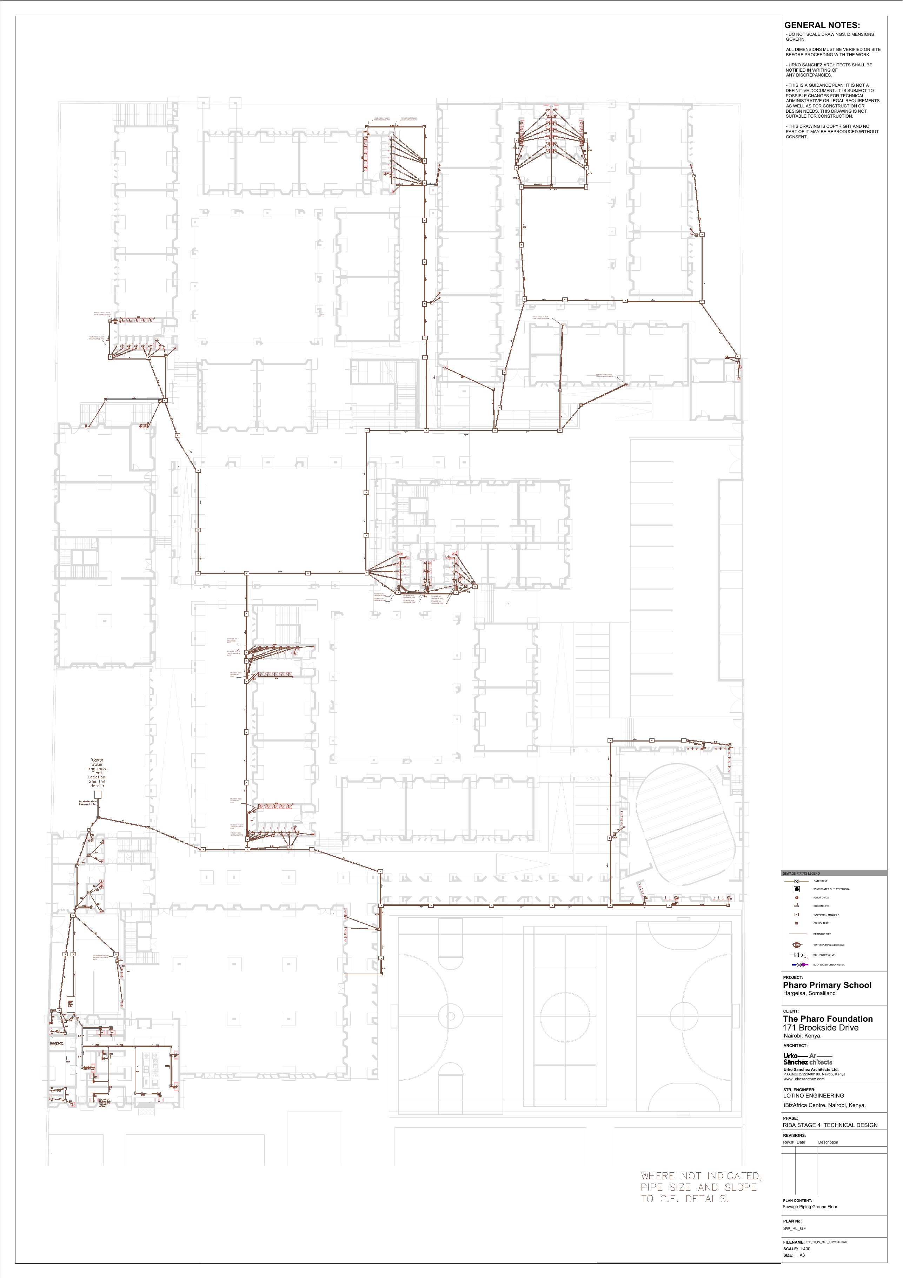

Annex A.2 - Sewage Piping: First Floor
Drawing file: TPF_TD_PL_MEP_Sewage-SW_PL_FF.pdf
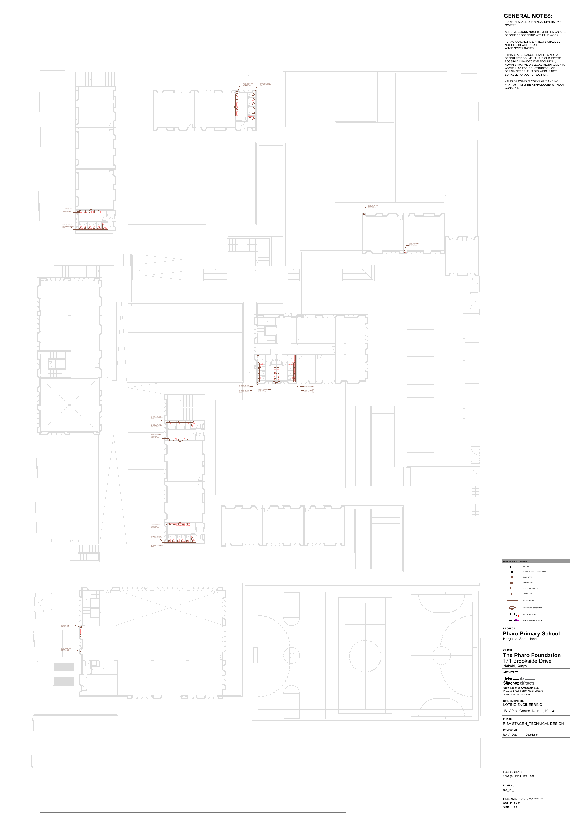

Annex A.3 - Sewage Piping: Second Floor
Drawing file: TPF_TD_PL_MEP_Sewage-SW_PL_SF.pdf
