


Realizing Gender Equality, Attitudinal Change & Transformative Systems in Nutrition (REACTS-IN)



Support Health Facilities with Structural Rehabilitation

World Vision Somalia
Baidoa, Southwest State of Somalia

27th April 2025

 | - BOQ - Construction of Two Rooms of Maternity and Twin Block Latrines (Ribo & Badbaado MCH)
No | Description | Unit | Quantity | Unit Rate USD | Total Amount USD
1 | CONSTRUCTION OF Two Room (8*4)
1.1 | Site Clearance:- removing of debris and preparation of One Room | M² | 32
1.2 | Excavation :-of foundation trenches 40 cm width and 40 cm depth. | m³ | 3.52
1.3 | Construction of Foundation : Construction of Rubble stone with cement mortar by using ordinary Portland cement, 60cm Height and 40cm width | m³ | 5.28
1.4 | Foundation Beam:- cast in place (0.4x0.15x33)m R.C.C plinth beam Mix 1:2:4 /6bags of cem/1cum of concrete __Reinforced with 5D12 with RD stirrups @200mm C/C | m³ | 1.32
1.5 | Backfilling with Good Hardcore and Crashed Stone: supply and fill (imported or Excavated selected material over the ground floor compact AS PER Specification | m³ | 8.8
1.6 | Hardcore: supply and fill 300mm (imported or Excavated selected material over the ground floor compact AS PER Specification | m³ | 6.6
1.7 | Flooring Concrete Slab: lay 100mm thick plain concrete over the crashed stones mix 1:4:8 6bags of Oman ordinary Portland cement/1cum of concrete for the room | m³ | 2.2
1.8 | Construction of hallow blocks:-Hallow blocks for walls (0.2m x 0.4m x 0.2m size each) | m³ | 16
1.9 | Reinforced concrete slab of 15cm thickness for covering the bit with ratio 1:2:4 | M³ | 0.45
2 | Walling
2.1 | Provide and fix pre-painted box profile iron sheets iron gauge 28 for superstructure and roof of the walling including wood posts for walls and roof with timber frames and door | M² | 66
2.3 | Plastering: apply 20mm thick plastering to both faces of the wall | M² | 24
2.4 | White washing: apply No2 coats of white washing to both faces of the wall | M² | 24
2.5 | Emulsion Paint: apply No2 coats of emulsion paint to the external face of the wall (color and type to be approved by the Engineer) | M² | 24
3 | DOOR & WINDOWS
3.1 | DOORS: Purpose-made by 28 gauge galvanized iron sheet the door complete with all the necessary ironmongery overall size 1000 width x 2000mm high also Toilet 2000mmx800mm and Generator Room (2000mmx1200mm | Pcs | 1
3.2 | Windows: Purpose-made by 28 gauge galvanized iron sheet steel casement window made of onto the window frame for anchoring the window complete with all the necessary ironmongery overall size 700mm width x 1000mm high | PCS | 2
4 | ROOFINGS
4.1 | Roofings: Gauge 28 Pre-painted corrugated iron sheets "Galsheet" or equal and approved including all nails and fixing. Area in plan, with complete woodwork, 150x50 tie beam, 150x50redge, 75x50 purlins, 150x50 strut. Iron sheets (3m x 3m): 5 sheets, Fascia boards: 26.4 meters, Timber: 33.6 meters, Nails: approximately 500 | M² | 64
4.2 | Ceilings; Supply and Install Ceiling System | M² | 64
 | Total
 | Grand Total (Two facilities)

- TWIN BLOCK LATRINE
ITEM | DESCRIPTION | UNIT | QUANTITY | RATE (USD) | AMOUNT (USD)
 | TWIN BLOCK LATRINE
1.0 | SUBSTRUCTURE
1.1 | Excavation
 | Excavation including maintaining and supporting sides and keeping free from water, mud and fallen materials by bailing, pumping or otherwise
1.1.1 | Pit excavation and removal of surplus materials from the site including backfilling around the foundations , 3m Deep | m³ | 21.6
1.2 | Filing
1.2.1 | 300 mm thick approved hardcore filling spread, well rammed and compacted in 150mm layers to receive concrete surface bed | m³ | 7.4
1.3 | Insitu concrete: class 15: mix 1:3:6
1.3.1 | 50mm blinding layer under foundations | m² | 13.0
1.3.2 | 50mm blinding layer on hardcore surfaces | m² | 13.0
1.4 | Concrete work
 | Reinforced Concrete class 15
1.4.1 | Strip foundation | m³ | 0.6
 | Reinforced Concrete class 25
1.4.2 | 100mm thick floor slab with surface steel trowelled smooth with 2 squat holes | m² | 24.5
1.5 | Reinforcement
1.5.1 | Reinforcement bars (All sizes) as shown on drawings | kg | 150.0
1.5.2 | Mesh fabric reinforcement ref. No. A142 laid in floor slab with minimum 150 mm side allowance | m² | 29.0
1.6 | Sawn formwork
1.6.1 | Formwork to edges of floor slab girth over 75mm but not exceeding 150mm | m | 22.1
1.6.2 | Formwork to edges of strip footing girth over 75mm but not exceeding 150mm | m | 22.0
1.6.3 | Formwork to edges of strip footing girth over 150mm but not exceeding 2250mm | m | 16.0
1.7 | Walling
1.7.1 | 400mm Thick rubble stone retaining wall in cement and sand mortar (1:3) | m² | 8.7
1.7.2 | 300mm Thick rubble stone foundation walling in cement and sand mortar (1:3) | m² | 17.0
1.7.3 | 150mm thick masonry wall | m² | 2.0
1.7.4 | One layer 1000gauge polythene sheet damp proof membrane under beds: 300mm laps | m² | 21.0
1.8 | Steps
 | Concrete work
 | Reinforced Concrete class 25
1.8.1 | Treads, 300 mm wide | m | 5.0
1.8.2 | Risers, 150 mm high | m | 4.0
1.8.3 | Open string | m² | 0.3
1.8.4 | Waist | m² | 0.2
 | Cement and sand mortar (1:4) trowelled beds: on concrete: to
1.8.5 | Treads, 300 mm wide | m | 5.0
1.8.6 | Risers, 150 mm high | m | 4.0
1.8.7 | Open string | m² | 0.3
1.8.8 | Waist | m² | 0.2
1.9 | Reinforcement
1.9.1 | High tensile reinforcement bars in assorted sizes | kg | 20.0
1.10 | Plinths
1.10.1 | 15mm thick cement sand rendering (1:3) to plinths | m² | 6.0
1.10.2 | Prepare and apply three coats black bituminous paint to rendered plinths externally | m² | 6.0
1.10.3 | 100mm thick approved lining of pit insides up to bottom of pit if in loose formation areas or in areas with ground water (optional) | m² | 39.0
2.0 | SUPERSTRUCTURES
2.1 | Walling
2.1.1 | 150 Thick load bearing solid concrete block walling | m² | 49.6
2.1.2 | 200mm deep x 400mm wide vent block | No | 2.0
 | Wall Coping
2.1.3 | Precast concrete 600 x 300 x 50 mm Thick twice weathered and throated coping jointed and pointed in cement and sand mortar | m | 7.0
2.2 | Concrete Work |  |  | - | -
 | Vibrated reinforced concrete class 25 (1:1.5:3) with 20mm maximum aggregate as described in:
2.2.1 | Lintels | m³ | 0.1
2.3 | Reinforcement
2.3.2 | 8mm Diameter high tensile reinforcement bar | kg | 3.0
2.3.2 | Ditto but 10mm | kg | 7.0
2.4 | Sawn Formwork to:
2.4.1 | Sides and soffits of lintels | m² | 1.2
2.5 | Roofing
 | Roof Structure
2.5.1 | Sawn celcured cypress timber as described in:
2.5.2 | 200mm x 25mm Fascia Board | m | 13.0
2.5.3 | l00x50mmRafters | m | 11.0
2.5.4 | 100mm x 50mm wall plate | m | 12.0
2.5.5 | 50 x 50 Purlins | m | 13.0
 | Roof Covering
2.5.6 | 30 Gauge galvanized corrugated iron sheets fixed to timber Purlins | m² | 12.0
2.7 | Painting and Decorating
2.7.1 | Knot prime stop and apply two undercoats and one gloss finishing coat oil paint to fascia board 200- 300 mm wide | m | 13.0
2.8 | Doors
2.8.1 | 45mm thick Match boarded timber single door, overall size 900x 2100mm high | No | 2.0
 | Wrot cypress 1st grade
2.8.2 | 150x50mm frame two labours plugged screwed and pelleted | m | 10.0
2.8.3 | 50x25mm architrave two labours | m | 10.0
2.8.4 | 25x15mm quadrant one labour | m | 10.0
2.9 | Supply and fix the following ironmongery to timber with matching screws
2.9.1 | Stainless steel hinges | Pairs | 3.0
2.9.2 | Three lever mortice lock | No | 2.0
2.9.3 | Rubber door stop | No | 2.0
2.9.4 | Prepare and apply two undercoats and one finishing coat oil paint to timber door | m² | 8.0
2.10 | Finishes
 | Floor Finishes
 | Cement and sand mortar (1:4)trowelled beds: on concrete: to
2.10.1 | 32mm floors finished to receive ceramic tile flooring | m² | 11.6
 | Wall Finishes
 | 15mm cement and sand (1:4) backing; smoothened plaster finish
2.10.2 | Walls internally | m² | 48.0
 | 12mm lime plaster: steel trowelled finish: on concrete, block work or stonework: to
2.10.3 | Walls externally | m² | 40.0
 | Prepare and apply three coats plastic emulsion paint to:
2.10.4 | Walls externally | m² | 40.0
2.10.5 | Extra over keying | m² | 6.0
2.10.6 | Supply and fix hand washing concrete basin size 300mm x 450mm | No | 1.0
2.10.7 | Pit/squat hole cover | No | 2.0
2.10.8 | 100mm diameter PVC vent pipe with fly screen vent cork | m | 5.0
 | TOTAL OF TWIN LATRINE BLOCK | 1
 | Grand Total | 2

- BoQ: Hand Washing for Health Centre Facility (Kaalmo, Ribo & Badbaado MCH)
S.No | Descriptions | Unit | Quantity | Rate USD | Amount  USD
Note
Hand Washing Facility for Health Center
1 | Construct and excavated 0.5m deep and 0.5m above the ground for the handwashing facility | LS | 1
2 | Metal Box 3 Inch | PC | 2
3 | Metal Box 1 Inch | PC | 1
4 | Supply and Install White 20 Liter Plastic Bucket | PC | 1
5 | Supply and Install Plastic 25 Liter HDPE Drum Open Mouth | PC | 1
6 | Push Cock Taps | No | 1
7 | Extension Spring/Hook Springs | No | 3
8 | Supply and Install Wash Basin Plastic McKesson 8 Quart Rectangle or  Circular Wash Basin | No | 1
9 | Conduct the Weldening of the Metal Frame of the Metal box and fixing as the Desing and Apply two coats of Emulsion paint including  labour installation | LMS | 1
10 | Tranportation cost | No | 1
11 | WVI Visibility Logo | No | 1
GRAND TOTAL USD IN ONE HAND WASHING
GRAND TOTAL USD IN 3 HAND WASHING |  |  | 3

- BOQ - Construction of Incinerator in Health Facilities
ITEM | DESCRIPTION |  |  | UNIT |  | QTY |  | RATE | AMOUNT
 |  |  |  |  |  |  |  | USD | USD
1 | Incinerator
1.1 | Provide a conrete pad with anti crack bars 6mm for the incinerator as per the drawings 2.0mx1.0mx0.10m |  |  | M3 |  | 0.20
1.2 | Provide 110x65x230mm fire clay bricks as the base for the  incinerator |  |  | M2 |  | 2.00
1.3 | Provide 110x65x230mm fire clay brick inner wall for the  main body of incinerator |  |  | M2 |  | 7.00
1.4 | Provide 110x65x230mm fire clay brick outer wall for the  outer body of incinerator |  |  | M2 |  | 8.00
1.5 | Construct RCC lintel beam 350kg/m³ as shown in the drawings with main bars of 12mm dia. main bars and stirrups of 6mm dia. at 200mm c/c and a mix ratio of 1:2:4 of cement/sand/gravel |  |  | M3 |  | 0.15
1.6 | MS angle section as the top frame with MS plate as per the  drawings |  |  | LS |  | 1.00
1.7 | loading door of 3mm MS plate welded on 30x30x3mm MS angle frame, oil painted to approval as per the drawings |  |  | LS |  | 1.00
1.8 | 3mm thick MS plate ash door on 30x30x3mm MS angle frame, oil painted to approval as per the drawings |  |  | LS |  | 1.00
1.9 | 150mm dia,3mm thick MS pipe chimney welded onto the  chimney base plate on the top frame as per the drawings |  |  | Lm |  | 4.00
1.10 | Chimney rain cap as per the drawings |  |  | LS |  | 1.00
 | SHED
2 | EXCAVATE FOUNDATIONS
2.1 | Excavate foundations to a depth not less than 500mm deep.
2.1 | Compact bottom and provide blinding if required, ready to receive reinforcement.
2.2 | Excavate for slab foundation max. depth 250mm starting  from prepared grounds. |  |  | M2 |  | 12.50
2.3 | Excavate for footing foundation min. depth 500mm starting  from prepared grounds. |  |  | M2 |  | 2.60
2.4 | Apply anti-Termite teatment to full footprint of shed as pespecifications before placement of concrete for foundations or floor slab. |  |  | M2 |  | 15.00
3 | REINFORCEMENT STEEL
3.1 | Provide, cut, and place reinforcement steel for slab (BRC 100 x 100 x 8mm) in position with required spacer blocks  ready to receive concrete. |  |  | M2 |  | 12.00
3.2 | Provide, cut, bend and place reinforcement steel for footing in position with required spacer blocks ready to receive concrete. Use 12mm round twisted rebar for footing  reinforcement |  |  | kg |  | 75.00
4 | CONCRETE
4.1 | Supply and place concrete for footings into formwork and vibrate as per specifications. Rate include the required curing to be done as per specifications. 25 MPa |  |  | M3 |  | 0.60
4.2 | Supply and place concrete for slabs into formwork and vibrate as per specifications. Rate include the required curing to be done as per specifications. 30 MPa |  |  | M3 |  | 0.90
5 | Foundation Walling
5.1 | Supply and construct 115 mm thick foundation walls, made from hollow blocks, externally plastered. |  |  | M2 |  | 7.50
5.2 | Supply and construct 230 mm thick block walls, dressed on both sides |  |  | M2 |  | 7.50
6 | Superstructure
6.1 | Supply and fit 200mm x 200mm x 5mm base plates each anchored by suitable anchor bolts as specified by engineer. Base plates to be painted with suitable oil paint. |  |  | No |  | 8.00
6.2 | Supply and fit steel columns, made from 75mm x 3mm round steel piping. Steel columns to firmly welded on base plates specified in 5.1 above and painted with suitable oil paint. |  |  | No |  | 8.00
6.3 | Supply and fit steel rails to hold chainlink fencing. Railings to be firmly welded onto the steel columns with a suitable weld prviding a good finish. 32mm steel tubing to be used for all railing. |  |  | M |  | 45.00
6.4 | Supply and fit 100x100x3mm chainlink fencing. Fence to be at least 2.1m high and should cover all the sides of the shed to prevent intrusion. Fence to be suitably tield onto the rails and columns, bottom to be ebedded in the floor slab. |  |  | M2 |  | 35.00
6.5 | Supply and fit gate for the shed, 2000mm x 750mm, made  from 100 x 100 x 3mm chainlink fencing framed and diagonally braced in 32mm steel tubing. |  |  | No |  | 1.00
7 | Roofing
7.1 | Supply and fix roof trusses complete as per drawings and specifications. |  |  | No |  | 3.00
7.2 | Supply purlins and fix to trusses as per drawing and specifications. Spacing to be suitable for roofing requirement. |  |  | M |  | 25.00
7.3 | Supply and fit bracing to trusses as per drawings and specifications, fixed top and bottom to trusses. |  |  | Sum |  | 1.00
7.4 | Supply and fix IBR profiled roofing sheets fixed to purlins as per recommendation of supplier. |  |  | M2 |  | 20.00
7.5 | Supply and fix 100mm UPVC gutter complete with joints, expansion joints, end stoppers and outlet to downpipe. Fixing with brackets to fascia as per supplier requirements. |  |  | M |  | 9.00
7.6 | Supply and fix 100mm diameter UPVC rain water downpipe including splash shoe, swan neck, fixing clips to wall and gutter outlet. |  |  | M |  | 6.00
7.7 | Supply and fix 25x200mm painted fascia / barge board fixed to roof trusses as per drawings. |  |  | M |  | 18.00
8 | Floor Finishes
8.4 | Cement Screed floor with broom finish |  |  | M2 |  | 12.00
 | Total for one incinerator & Shed
 | Total for 4 Construction of Incinerator & Shed (Ribo, Kaalmo, Towfiq, & Badbado)
- BOQ - Renovation and Rehabilitation of Badbado & Kaalmo MCH with Solar Streetlights

BOQ of Construction of New Pharmcy at Badbaado and Rehabilitation of Kaalmo MCH, Ceilings, & Paintings
No |  | Description | Unit |  | Quantity |  | Unit Rate USD |  | Total Amount USD
1 |  | CONSTRUCTION OF PHARMACY AND FURNITURE, with RENOVATION OF CEILINGS AT KAALMO MCH
1.1 |  | Site Clearance:- removing of debris and preparation of extension | M² |  | 30
1.2 |  | Excavation :-of foundation trenches 40 cm width and 40 cm depth. | m³ |  | 3.52
1.3 |  | Construction of Foundation : Construction of Rubble stone and align with the previous one, cement morter by using ordinary portland cement, 60cm Height and 40cm width | m³ |  | 5.28
1.5 |  | Backfilling with Good Hardcore and Crashed Stone: supply and fill (imported or Excavated selected material over the ground floor compact AS PER Specification | m³ |  | 8.8
1.6 |  | Supply and Install of high-quality, furnitures with a dimesion aligning to the wall using plywood (shelves) | m2 |  | 24
1.9 |  | Supply and Install of high-quality, durable tiles suitable for a sterile healthcare environment for the pharmacy | m2 |  | 40
1.6 |  | Construction of walling for guage #28 for (6*5m) iron sheet for the extension room, and its roofing guage #30. | lamsump |  | 1
1.7 |  | Supply and Install Ceiling Roof with demolishing the previous alteration roofs and some is going to be rehabilitated, Including Thorough Cleaning to Remove Insect Infestations, Apply to Protective white Paint (paiting the ceiling and back to the roof ceiling), and Installation of two Transparent Roofing Sheets to Deter Rodent Infestation. (5 rooms witha dimension of 16.5x1.5m, 4x2m, 4x3m, 4x4m, 4x4m, 5x4m)) | lamsump |  | 1
1.8 |  | Installation of furnitures for Kaalmo MCH Pharmacy as an additional. (3x2m) | lamsump |  | 1
2 |  | Paitings
2.1 |  | White washing: apply No2 coats of white washing to both faces of the wall, Internal and external | M² |  | 192
 |  | Grand Total
- All in one 9M 60W solar streetlights in Badbaado MCH
 |  | Description | Unit Quantity |  | Unit Cost USD |  | Total Cost USD
 |  | Construct 0.7m depth and above 0.5m for the solar streetlights.
1 |  | Solar panel 17.5V 140W (High Efficiency Mono crystalline Silicon)  Voc: 21.6V; Vmp: 17.8V; Isc: 5.42A; Imp: 5.06A, 12.8V/42Ah Lithium Battery(LiFePO4) lifeline of 5-10years, LED light of maximum power of 12V 60W with ligh brighteness with lifeline More than 50000 Hours and viewing angle of 70*140°, | 1
2 |  | 9M Standard Pole | 1
3 |  | Concrete Foundation | 1
4 |  | Installation cost | 1
5 |  | Painting for the poles in blue color, the panel in white color and the visiblity logo IR | 1
6 |  | Packaging and transportation to the site | 1
 |  | Total for one all in one solar street-lighting | 1
 |  | Grand Total for 3pcs complete system street-lighting | 3

SUMMARY PAGE

S/NO | DESCRIPTION | AMOUNT (USD)
1 | Construction of Two Rooms of Maternity and Twin Block Latrines (Ribo & Badbaado MCH)
2 | Two number Twin block latrines(Kaalmo and Towfiq)
3 | Hand Washing for Health Centre Facility (Kaalmo, Ribo & Badbaado MCH)
4 | Total for 4 Construction of Incinerator & Shed (Ribo, Kaalmo, Towfiq, & Badbado)
5 | Construction of New Pharmcy at Badbaado and Rehabilitation of Kaalmo MCH, Ceilings, & Paintings
6 | All in one 9M 60W solar streetlights in Badbaado MCH (3 PIECES)
GRAND TOTAL

- Hand washing.
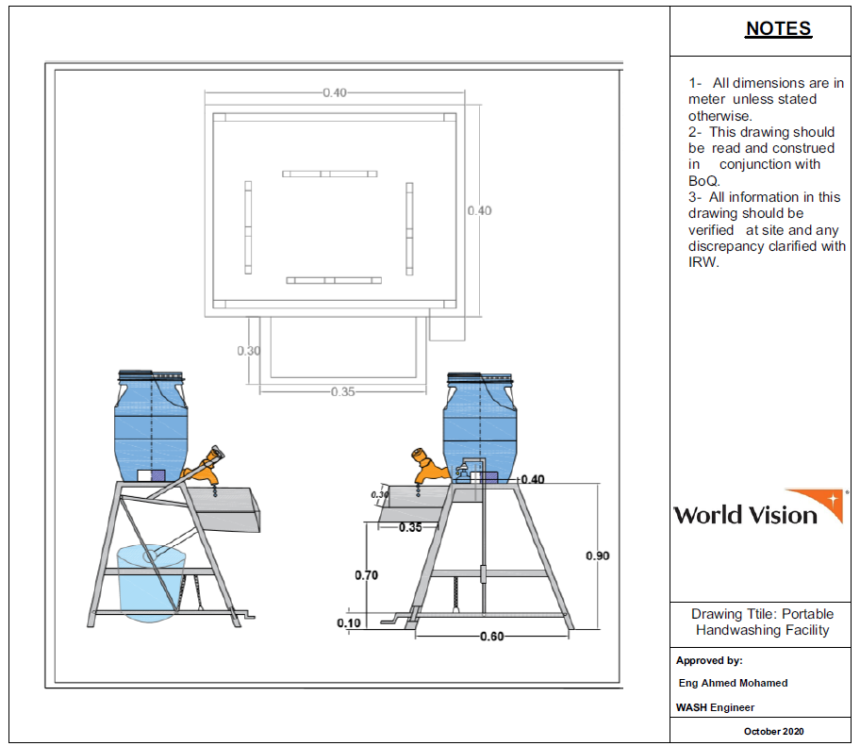

- Incinerator
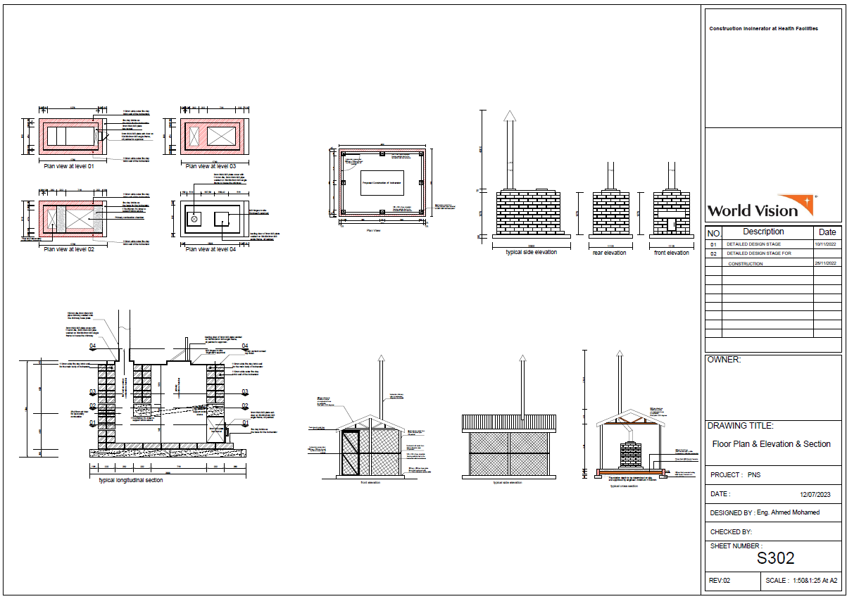

- Latrine
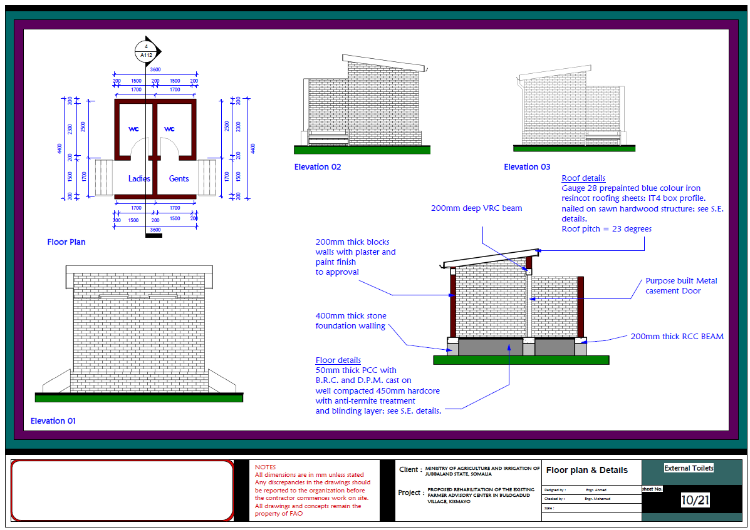
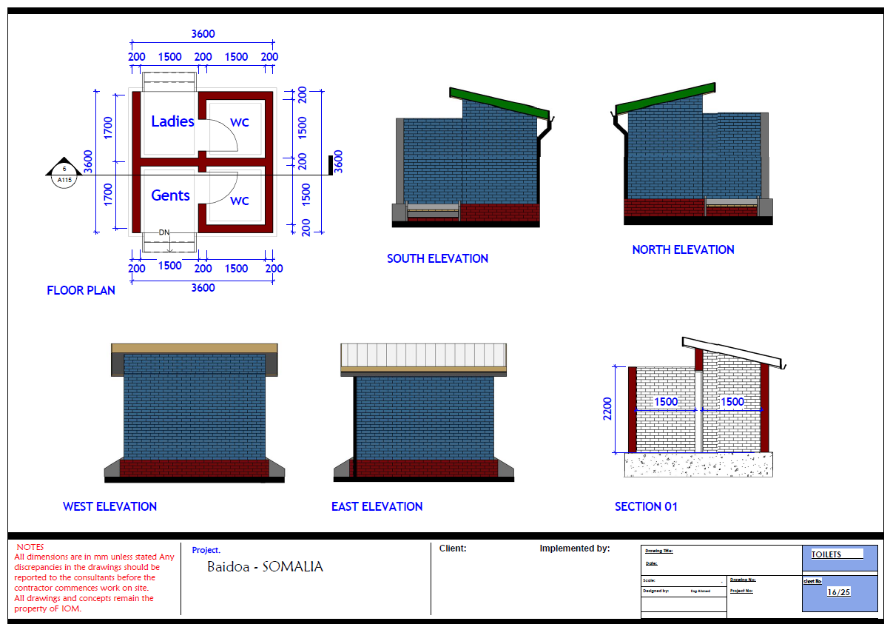

- Site plan
