

Request for Quotation

CASH FOR WORK TOOLS

RFQ DOCUMENT # 37846

RFQ Issue Date: 16 JUNE 2025

Quotation submission deadline: 21 JUNE 2025

CARE SOMALIA

Confidential Document

Prepared by
CARE procurement in garowe office

Table of Contents

1. ABOUT CARE 2
2. GENERAL CONDITIONS and CLAUSES 2
2.1. CARE’s GENERAL CONDITIONS 2
2.2. CONFIDENTIALITY/ NON-DISCLOSURE 3
2.3. PUBLICITY 3
2.4. LIABILITY 3
2.5. FORCE MAJEURE 3
2.6. ERRORS AND OMISSIONS 4
2.7. OWNERSHIP OF WORK 4
2.8. CONFLICT OF INTEREST 4
3. COMPANY PROFILE & BIDDER’S DECLARATION 5
3.1. COMPANY PROFILE 5
3.2. BIDDER’S DECLARATION 6
4. CONDITIONS AND GUIDELINES FOR SUBMISSION OF QUOTATION 7
5. SCHEDULE OF REQUIREMENTS 8
5.1. CARE TECHNICAL SPECIFICATIONS 8
5.2. CARE DELIVERY REQUIREMENTS 8
6. TECHNICAL & FINANCIAL OFFERS 9
6.1. SUPPLIER’S OFFER 9

ABOUT CARE
At CARE, we seek a world of hope, inclusion, and social justice, where poverty has been overcome and people live with dignity and security.
This has been our vision since 1945, when we were founded to send lifesaving CARE Packages® to survivors of World War II. Today, CARE is a leader in the global movement to end poverty. We put women and girls in the center because we know we cannot overcome poverty until all people have equal rights and opportunities. In 2019, CARE worked in 100 countries and reached 70 million people with an incredible range of life-saving programs.
To know more about CARE, https://www.care.org/our-work/

GENERAL CONDITIONS and CLAUSES

CARE’s GENERAL CONDITIONS
The enclosed document is not an offer to contract, but a solicitation of a vendor’s proposed intent. Acceptance of a quotation in no way commits CARE to award a contract for any or all products and services to any vendor.

CARE reserves the right to make the following decisions and actions based on its business interests and for reasons known only to CARE:

- To determine whether the information provided does or does not substantially comply with the requirements of the RFQ
- To contact any bidder after quotation submittal for clarification of any information provided.
- To waive any or all formalities of bidding
- To accept or reject a quotation in whole or part without justification to the bidder
- To not accept the lowest bid
- To negotiate with one or more bidders in respect to any aspect of submitted quotation
- To award another type of contract other than that described herein, or to award no contract;
- To enter into a contract or agreement for purchase with parties not responding to this RFQ
- To request, at its sole discretion, selected Vendors to provide a more detailed presentation of the quotation.
- To not share the results of the bids with other bidders and to award contracts based on whatever is in the best interest of CARE.

Any material statements made orally or in writing in response to this RFQ or in response to requests for additional information will be considered offers to contract and should be included by vendor in any final contract.

CONFIDENTIALITY/ NON-DISCLOSURE
All information gained by any vendor concerning CARE work practices is not to be disclosed to anyone outside those responsible for the preparation of this quotation. Any discussion by the vendor of CARE’s business practices could be reason for disqualification. CARE, at their discretion, reserves the right to require a non-disclosure agreement.

Reciprocally, CARE commits that information received in response to this RFQ will be held in strict confidence and not disclosed to any party, other than those persons directly responsible for the evaluation of the responses, without the express consent of the responding vendor.

Finally, the information contained within this RFQ is confidential and is not to be disclosed or used for any other purpose by the vendor.

PUBLICITY
Any publicity referring to this project, whether in the form of press releases, brochures, or photographic coverage will not be permitted without prior written approval from CARE.

LIABILITY
The selected vendor(s) will be required to show proof of adequate insurance at such time as CARE is prepared to procure the services. The participating vendor will also be required to indemnify and hold harmless CARE for, among other things, any third-party claims arising from the selected vendor’s acts or omissions, and will be liable for any damage caused by its employees, agents or subcontractors.

FORCE MAJEURE
- Neither Party shall be responsible for a performance that is delayed, hindered, or is rendered inadvisable, commercially impracticable, illegal, or impossible by a “Force Majeure Event.” A Force Majeure event includes, without limitation, an act of nature, a pandemic, emergency, civil unrest or disorder, actual or threatened terrorism, war, fire, governmental action or interference of any kind, power or utility failures, strikes or other labor disturbances, a health warning issued by the Center for Disease Control (or similar agency), any other civil or governmental emergency and/or any other similar event beyond a Party’s reasonable control.

- The Party that seeks to invoke this Force Majeure provision (the “Affected Party”) shall provide the other Party (the “Unaffected Party”) with a written notice within ten (10) days of the date the Affected Party determines a Force Majeure Event has occurred.

ERRORS AND OMISSIONS
CARE expects the vendor will provide all labor, coordination, support, and resources required based on the vendor’s quotation and corresponding final SOW. No additional compensation will be available to the vendor for any error or omission from the quotation made to CARE. The only exclusions are add-ons, deletions, and/or optional services for which the vendor has received written authorization from CARE.

OWNERSHIP OF WORK
All work created during this evaluation must be original work, and no third party should hold any rights in or to the work. All rights, title and interest in the work shall be vested in CARE.

CONFLICT OF INTEREST
CARE encourages every prospective Supplier to avoid and prevent conflicts of interest, by disclosing to CARE if you, or any of your affiliates or personnel, were involved in the preparation of the requirements, design, specifications, cost estimates, and other information used in this RFQ.

COMPANY PROFILE & BIDDER’S DECLARATION

Bidders are requested to complete this form, including the Company Profile and Bidder’s Declaration, sign it and return it as part of your quotation. No alterations to its format shall be permitted and no substitutions shall be accepted.

COMPANY PROFILE

Table 4.1.A Previous Work with CARE
Have you already had previous transactions with CARE? | Yes | No
If marked “Yes”, please provide the year of the latest transaction with CARE and the requirement that was delivered. (This is to inform everyone that this information is for system checking only. This will not be part of any evaluation process.)
If you marked, “No” on the table above, please answer the Table 4.1.B. below:

Table 4.1.B Other Information
Item Description | Detail(s)
Legal name of bidder
Legal Address, City, Country
Website
Year of Registration
Company Expertise
Bank Information (Please answer below)
Bank Name:
Bank Address:
IBAN:
SWIFT/BIC:
Account Currency:
Bank Account Number:

Previous relevant experience: 3 contracts
Name of previous contracts | Client & Reference Contact Details | Contract Value | Period of activity | Types of activities undertaken

BIDDER’S DECLARATION

Yes | No
 |  | Ethics: By submitting this Quote, I/we guarantee that the bidder has not engaged in any improper, illegal, collusive, or anti-competitive arrangements with any competitors; has not directly or indirectly contacted any buyer representative (aside from the point of contact) or gather information regarding the RFQ; and has not attempted to influence or offer any type of personal inducement, reward, or benefit to any buyer representative.
 |  | I/We affirm that we will not engage in prohibited behavior or any other unethical behavior with CARE or any other party. We also affirm that we have read the general clause and conditions included in this RFQ and that we will conduct business in a way that avoids any financial, operational, reputational, or other undue risk to CARE.
 |  | Conflict of interest: I/We warrant that the bidder has no actual, potential or perceived Conflict of Interest in submitting this Quote, or entering into a Contract to deliver the Requirements. CARE Procurement's Point of Contact will be notified right away by the bidder if a conflict of interest occurs during the RFQ process.
 |  | Bankruptcy: l/We have not declared bankruptcy, are not involved in bankruptcy or receivership proceedings, and there is no judgment or pending legal issues that could hinder the ability to conduct business.
 |  | Offer Validity Period: I/We confirm that this Quote, including the price, remains open for acceptance for the Offer Validity.
 |  | I/We understand and recognize that you are not bound to accept any quotation you receive, and we certify that the goods offered in our Quotation are new and unused.
 |  | By signing this declaration, the signatory below represents, warrants and agrees that he/she has been authorized by the Organization/s to make this declaration on its/their behalf

Name:
Title/Designation:
Contact (phone):
Company Name:
Date:
Signature

CONDITIONS AND GUIDELINES FOR SUBMISSION OF QUOTATION

This Request for Quotation represents the requirements for an open and competitive process.

Quotations will be accepted until 11:59 PM Somalia time on 21 June 2025, delivered via email to SOM.Bids@care.org, with subject line indicating “CFW TOOLS”.

Additionally, all costs included in quotations must be all-inclusive to include any outsourced or contracted work. Any quotations which call for outsourcing or contracting work must include a name and description of the organizations being contracted.

All costs must be itemized to include an explanation of all fees and costs.

Contract terms and conditions will be negotiated upon selection of the winning bidder for this RFQ. All contractual terms and conditions will be subject to review by the CARE legal department, and will include scope, budget, schedule, and other necessary items pertaining to the project.

You must respond to every subsection including statement, question, and/or instruction without exception.

Any verbal information obtained from, or statements made by representatives of CARE shall not be construed as in any way amending this RFQ. Only such corrections or addenda as are issued in writing by CARE to all RFQ participants shall be official. CARE will not be responsible for verbal instructions.

SCHEDULE OF REQUIREMENTS

CARE TECHNICAL SPECIFICATIONS

SN | UOM | Specification | QTY
1 | EA | Shovel high quality, with red wood handle | 250
2 | EA | Mattock with plastic or red wood handle with high quality | 150
3 | EA | Crowbar high quality 1.2-1.5m average height | 50
4 | Pair | Gloves high quality thick cover used for construction purpose per person | 1443
5 | EA | Gunny bags (50kg), plastic. | 1000
6 | EA | Axe (Faas) local made with steel handle. | 10
7 | LS | Transportation of CFW hand tools to the Sool, Sanaag and Mudug regions (location is attached) | 1
8 | EA | Hummer 3Kg plastic/fiber glass handle | 6
9 | box | First aid kits (50 per box) | 48

CARE DELIVERY REQUIREMENTS

Item # | Other Requirements
1 | Delivery Terms  (incoterms) | EXW [Ex-works (Place)]
1 | Delivery Terms  (incoterms) | FCA [Free Carrier (Port)]
1 | Delivery Terms  (incoterms) | FAS [Free Along-Side Ship (Port)]
1 | Delivery Terms  (incoterms) | FOB [Free On-Board (Port)]
1 | Delivery Terms  (incoterms) | CFR [Cost, & Freight (Port)]
1 | Delivery Terms  (incoterms) | CIF [Cost, Insurance & Freight (Port)]
1 | Delivery Terms  (incoterms) | CPT [Carriage Paid-To (Place)]
1 | Delivery Terms  (incoterms) | CIP [Carriage & Insurance Paid-To (Place)]
1 | Delivery Terms  (incoterms) | DAP [Delivered at Place (Place)]
1 | Delivery Terms  (incoterms) | DPU [Delivered at Place Unloaded (Place)]
1 | Delivery Terms  (incoterms) | DDP [Delivered Duty Paid (Place)]
2 | Custom Clearance  (Must be linked to Incoterms at origin) | Not Applicable. Shall be done by _______________
2 | Custom Clearance  (Must be linked to Incoterms at origin) | Shouldered by CARE
2 | Custom Clearance  (Must be linked to Incoterms at origin) | Supplier/ Bidder
2 | Custom Clearance  (Must be linked to Incoterms at origin) | Freight Forwarder
3 | Exact Address(es) of Delivery Location | Sool  Sanaag  Mudug
Bidders are required to provide or attach the following requirement
1 | Delivery duration
2 | Quotation validity
3 | Payment terms

TECHNICAL & FINANCIAL OFFERS

SUPPLIER’S OFFER

Table 5.1.A Bidder’s Offer if different from CARE requirement
Item # | Description | Bidder’s Specification
1
2

Table 5.1.B Cost Proposal
Item # | Description | Qty | Unit of Measurement | Unit Price  (in USD) | Total Price  (in USD)
1 | Shovel high quality, with strong wood handle | 250 | EA
2 | Mattock with red wood handle with high quality | 150 | EA
3 | Crowbar high quality 1.2-1.5m average height | 50 | EA
4 | Gloves high quality thick cover used for construction purpose per person | 1443 | Pair
5 | Gunny bags (50kg), plastic. | 1000 | EA
6 | Axe (Faas) local made with steel handle). | 10 | EA
7 | Transportation of CFW hand tools to the Sool, Sanaag and Mudug regions (location is attached) | 1 | LS
8 | Hummer 3Kg plastic/fiber glass handle | 6 | EA
9 | First aid kits (50 per box) | 48 | box
Total

Table 5.1.C Compliance with Requirements
 | Yes, we will comply | No, we cannot comply | If marked as “No”, please provide counter proposal
Minimum Technical Specifications
Delivery Lead Time
Delivery Term (INCOTERMS)
Warranty Period (If Applicable)
Validity of Quotation
Other Requirements (Please specify) sample check and Payment terms

Annexes
- Sample pictures
- locations

Items

Specification | Sample Picture (or Equivalent)
Shovel high quality, strong wood handle | 
Mattock with plastic or red wood handle with high quality | 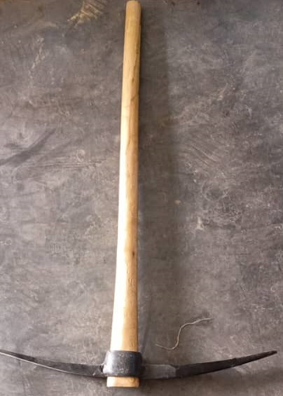
Crowbar high quality 1.2-1.5m average height | 
Gloves high quality thick cover used for construction purpose per person | 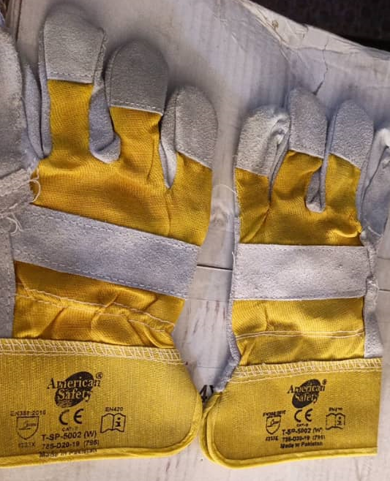
Axe (Faas) local made with steel handle. | 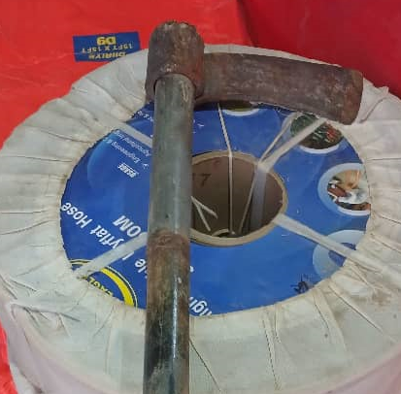
Hummer 3Kg plastic/fiber glass handle | 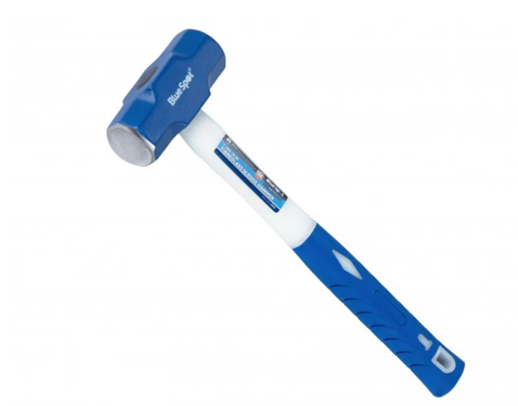
First aid kits (50 per box) | 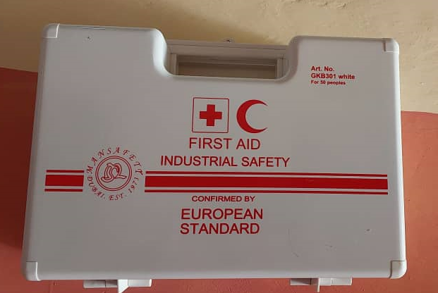

CASH FOR WORK ACTIVITIES IN MUDUG, SOOL AND SANAAG REGIONS
S/N | Village Names | District | Region
1 | Habarshiro | Badhan | Sanaag
2 | Balibusle | Dhahar | Sanaag
3 | Jiicanyo | Dhahar | Sanaag
4 | Habarhumbule | Badhan | Sanaag
5 | Mindhicir | Badhan | Sanaag
6 | Maygaag | Galkacyo | Mudug
7 | Ceelgardi | Galkacyo | Mudug
8 | Laanmaodw | Galdogob | Mudug
9 | Raydable | Jariiban | Mudug
10 | Sarmaanyo | Taleex | Sool
11 | Dhubuqdhubuq | Taleex | Sool
12 | Tuulosamakaab | Lascaanood | Sool
13 | Hohol | Xudun | Sool
14 | Darayageesaweyn | Xudun | Sool

