PROJECT NAME: For Systemic climate-change resilience for food, fodder and water security for vulnerable communities in Burao, Somaliland
PROJECT NO: SOM1068
From: Welthungerhilfe
Airport Road, next to Djibouti Consulate
Hargeisa, Somaliland
Email: procurement.somaliland@whh.de

RFQ-SOM1068

DATE: 16.12.2025

QUOTATION FOR OPERATIONAL AND MAINTENANCE TOOLS FOR WATER STRUCTURES
SPR REFERENCE NO: 68300

Submission Date
Company Name
Address
Tel/Mobile
Official Email

Your company is cordially invited by the Office of Welthungerhilfe to submit a firm offer for the following tools for water structures

SN | ITEM DESCRIPTION | Unit | QTY | IMAGE | Unit Price | Total Price
1 | Spin Mop Cleaning Set with Microfibers Refill for Home & Office Use | Set | 9 | 
2 | Solar panel cleaning Squeegee. With head length of 43.5cm and pole length of 140cm made of wood | Pcs | 9 | 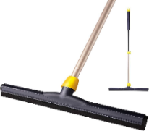
3 | Adjustable Pipe wrench set of 24 inches, made of steel with I beam handle and 65mm drop forged hardened jaws. | Pcs | 9 | 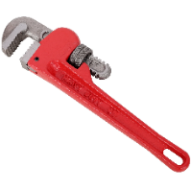
4 | Adjustable Pipe wrench set of 14’ inches, made of steel with I beam handle and 65mm drop forged hardened jaws | Pcs | 9 | 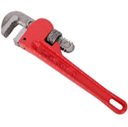
5 | Adjustable spanner 200mm hardened and tempered chrome vanadium steel with graduated scale to fix jaw. | Pcs | 9 | 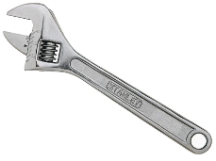
6 | Adjustable Metal hacksaw of 12inch long with high carbon metal blade length 300mm supplied with single blades. | Pcs | 9 | 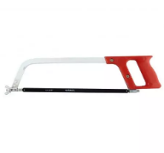
7 | HSS Hacksaw blades 12" x 1/2" x 24tpi, blade length 300mm | Pcs | 27
8 | Sprit level. 45cm length | Pcs | 22 | 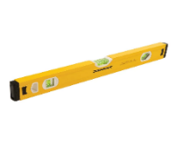
9 | Crowbars form forged steel | Pcs | 13 | 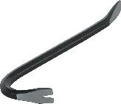
10 | Masons hammer with wood handles. 1.3kg min. | Pcs | 22 | 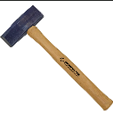
11 | screwdriver varies size, double ended/Z shape with magnetic tip | set | 22
12 | Combination pliers 200mm drop forged hardened and tempered vanadium steel with induction hardened jaws, soft grip handles | Pcs | 9 | 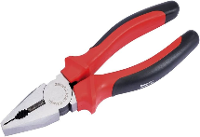
13 | Carpenter claw hammer | Pcs | 13 | 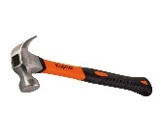
14 | Pick Axe (mattock) with stout head 1.5kg, with wood handle length of 35 inch. | Pcs | 22 | 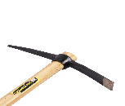
15 | Masons Trowel carbon steel and wood handle | Pcs | 22 | 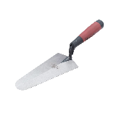
16 | Plain iron sheet scissor | Pcs | 13 | 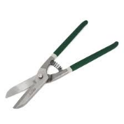
17 | Shovel made of high treated steel, with wood handle length of 1.2m | Pcs | 44 | 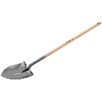
18 | padlocks with key-medium size | Pcs | 44
19 | Wheelbarrows are made of steel blades, with tubeless tires. Big lot. | Pcs | 22 | 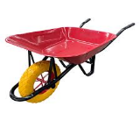
20 | Tape Measure 7.5m | Pcs | 22 | 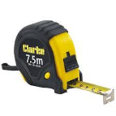
21 | Long measuring tape 50m, soft thread rounded. | Pcs | 22 | 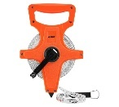
22 | Tap water valves. | pcs | 36 | 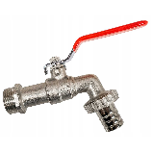
23 | GI Valve Sockets, 2" | Pcs | 27
24 | Gate Valve, 2" | Pcs | 18
25 | HDPE Valve Sockets, 2" | Pcs | 18
26 | GI Gate Valve, 1" | Pcs | 18
27 | Gate Valve 3/4" | Pcs | 18
28 | GI Valve Sockets, 2" | Pcs | 18
29 | GI Valve Sockets, 1" | Pcs | 18
30 | GI Valve Sockets, 3/4" | Pcs | 18
31 | GI Union, 2" | Pcs | 36
32 | HDPE Union, 2" | Pcs | 36
33 | GI union, 1’’ | Pcs | 18
34 | Union, 3/4" | Pcs | 18
35 | GI Elbow 2’’ | pcs | 36
36 | HDPE Elbow 2’’ | pcs | 18
37 | GI Elbow 1’’ | pcs | 18
38 | Thread seal tape | set | 27
39 | Tangit glue | set | 18
40 | Electric tester | pcs | 18 | 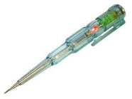
41 | Heavy Metallic box to fit all the above items with dimensions of 550 x 200 x 550mm cantilever lock type and nonremovable trays. | Pcs | 22 | 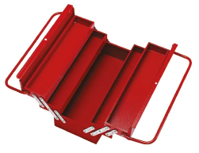
42 | HDPE geomembrane welding machine.  Model LST900D  Rated Voltage: 230 V / 120 V  Frequency: 50 / 60 Hz  Power: 1800 W / 1650 W  Welding Speed: 1 - 5 m/min  Heating Temperature: 50 - 450 ℃  Welding Pressure: 100-1000N  Thickness Welded: 1.0 mm - 3.0 mm （Single Layer）  Overlap Width: 12 cm  Seam Width: 12 mm *2 Interior Cavity 15mm  Seam Strength: ≥ 85 % Material  Net Weight: 13.0 Kg  Digital Display: Temperature and Speed | Pcs | 1 | 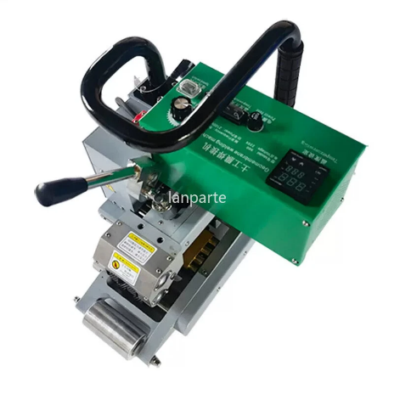
43 | Hot air gun for HDPE lamenting.  Model:YT-82293  Operating Temperature  50-600℃  Gas Consumption  500L/min. Weight: 2KG | Pcs | 1 | 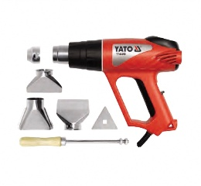
44 | 6.5kva Diesel Generator. Model KINGMAX.  Rate voltage: 220/380  Max current: 23.9/14.5A  Phase No:1&3 Phase  Fuel tank: 16L | Pcs | 1 | 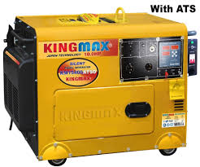
 | Discount
 | Total Amount

The Delivery location is Welthungerhilfe Burco Office

Your quotation should also clearly indicate the following.
- Confirmed Delivery Period: ....................................................
- Validity of the offer (preferable 90days) …………………………………………….

Requirements for Compliance:
- Ensure timely submission of your quotation by the specified deadline, which is up to 23;59 EAT on 23rd December 2025. Companies failing to submit their quotations by this deadline will not be considered.
- All quotation documents along with mandatory documents stated in the Invitation to tender must be submitted through Official Procurement emai procurement.somaliland@whh.de

