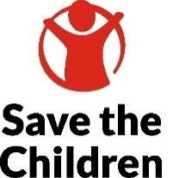
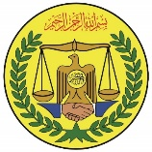
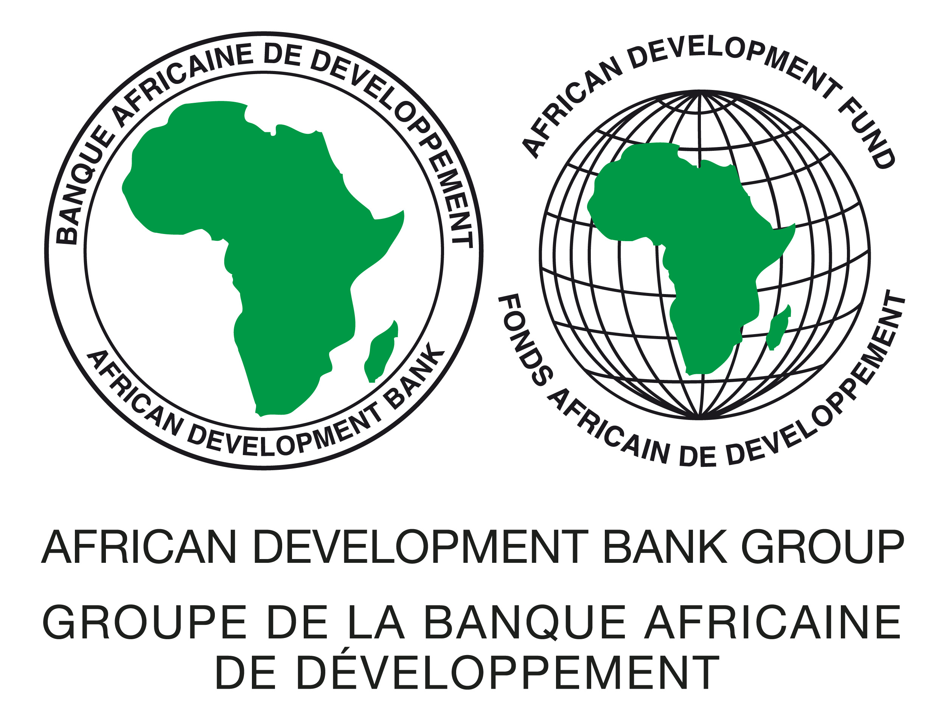
Somaliland
Specific Procurement Notice / Invitation for Bids [IFB]
Goods / (One-Envelope Bidding Process)

IFB Number: BREFONS/SOM/AFG1
Project: Additional Financing to Build Resilience for Food and Nutrition
Security (BREFONS)
Contract title: Supply and Delivery of Native and Improved Varieties of Fodder Seeds in Somaliland (25.5 tons)
Grant No.: P-SO-AA0-009 - AEFPF
Procurement Method: Open Competitive Bidding (International), (OCBI)
OCBI No (s): BREFONS/SOM/AFG1

- This invitation for bids follows the General Procurement Notice for this project that appeared online on 21st July 2022.
- The Government of Somaliland has received financing from the African Development Bank Group toward the cost of the Additional Financing to Build Resilience for Food and Nutrition Security (BREFONS) project and intends to apply part of the proceeds toward payments under the contract Supply and Delivery of Native and Improved Varieties of Fodder Seeds in Somaliland (25.5 tons). Save the Children International fulfils the role of the project’s Implementing Agency. A Direct Payment disbursement method will be used, as defined in the Bank’s Disbursement Guidelines and procedures for Investment Project Financing.
- The Save the Children International as the Implementing Agency for the project now invites sealed Bids from eligible Bidders for Supply and Delivery of Native and Improved Varieties of Fodder Seeds in Somaliland (25.5 tons) as detailed below:

Package  / Lot No. | Name of Contract | Qty | Delivery Site & Term | Required Delivery Schedule | Bid Security Amount USD
1 | Supply and Delivery of Native and Improved Varieties of Fodder Seeds in Somaliland (25.5 tons) | Assorted | CIP Hargeisa | 120 days | $2,500
- Bidding will be conducted through the Open Competitive Bidding (International), (OCBI) method as specified in the Bank’s Procurement Framework dated October 2015 and is open to all eligible bidders as defined in the Procurement Framework.
- Interested eligible Bidders may obtain further information from the Save the Children International via email address brefons.som@savethechildren.org and inspect the bidding document during office hours 08:00 to 16:00 hours at the address given below.
- The bidding document in English may be obtained by interested eligible Bidders upon the submission of a written application quoting BREFONS/SOM/AFG1 in the subject line to the email address brefons.som@savethechildren.org free of charge. The document will be sent by via autoreply containing a downloadable link.
- Bids must be delivered to the address below on or before 23rd October 2024 at 10:00 hrs. local time. Electronic Bidding will not be permitted. Late Bids will be rejected. Bids will be publicly opened in the presence of the Bidders’ designated representatives and anyone who chooses to attend at the address below on 23rd October 2024 at 10:00 hrs. local time.
- All Bids must be accompanied by an original bid security in the form of an unconditional bank guarantee enforceable in the local registered banks in the format provided in the Bidding Document and in the amounts and currency indicated in the Table in paragraph 3.
- Attention is drawn to the Procurement Framework requiring the Borrower to disclose information on the successful bidder’s beneficial ownership, as part of the Contract Award Notice, using the Beneficial Ownership Disclosure Form as included in the bidding document.
- The address referred to above is:
Save the Children International
Procurement Specialist - BREFONS Project
East of Osob mall, Maansoor area, Jigjiga-yar, Hargeisa, Somaliland
Toll-Free number for local incoming calls: 3061
Email: brefons.som@savethechildren.org ;

