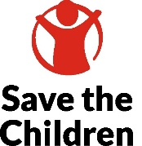
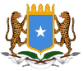
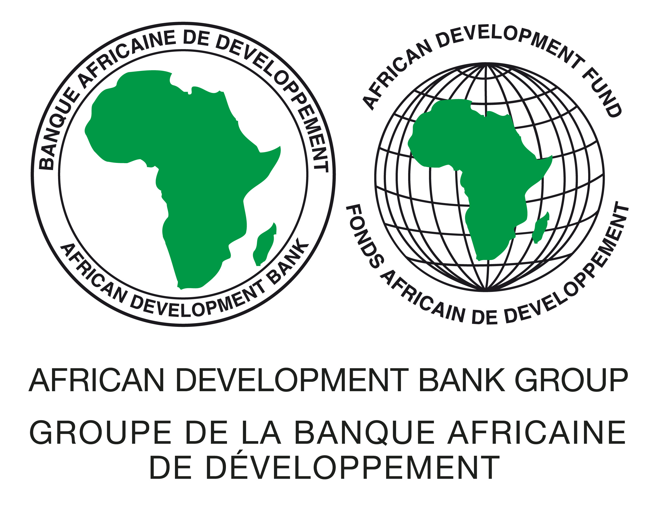
Specific Procurement Notice
______________________________________________________________________________________________
Invitation for Bids [IFB]
Small Works
(One-Envelope Bidding Process)

IFB Number: BREFONS/SOM/OCBN/W14
Employer: Ministry of Livestock, Forestry and Range, Federal Government of Somalia (MoLFR FGS)
Project: Build Resilience for Food and Nutrition Security (BREFONS)
Contract title: Drilling of Two (2) New Boreholes in Galmudug - Adado (1), Galka’ayo (1)
Country: Somalia
Grant No..: TSF -5900155016703 & ADF-2100155041171
Procurement Method: Open Competitive Bidding (national) (OCBN)
OCBN No: BREFONS/SOM/OCBN/W14
Issued on: 04th December 2024
- This invitation for bids follows the General Procurement Notice for this project that appeared online on 21st July 2022.
- The Federal Government of Somalia has received financing from the African Development Bank Group toward the cost of the Build Resilience for Food and Nutrition Security (BREFONS) project and intends to apply part of the proceeds toward payments under the contract Drilling of Two (2) New Boreholes in Galmudug - Adado (1), Galka’ayo (1). The Ministry of Livestock, Forestry and Range serves as the Executing Agency of the project while Save the Children International fulfils the role of the project’s Implementing Agency. The Executing Agency will process the payments for this contract using the Direct Payment disbursement method, as defined in the Bank’s Disbursement Guidelines and procedures for Investment Project Financing.
- The Save the Children International as the Implementing Agency for the project now invites sealed Bids from eligible Bidders for Drilling of Two (2) New Boreholes in Galmudug - Adado (1), Galka’ayo (1) as detailed below:
Package # | Name of Contract | Depth | Location | Construction Period | Bid Security Amount USD
1 | Drilling of Two (2) New Boreholes in Galmudug - Adado (1), Galka’ayo (1) | Miriyaale borehole – 230 meters, Ali-waal borehole – 280 meters. Actual depth of the boreholes may be less than the estimated depth and payment will be based on the actual depth of the borehole verified by the client’s hydrogeologist. | Ali-waal village in Galka’ayo district & Mirisyaale village in Adado district | 5 months | $3,100
Bids are invited, and Bidders shall bid for ‘Works’. A single contract will be awarded to the successful Bidder.

- Bidding will be conducted through the Open Competitive Bidding (national), OCBN procedures as specified in the Bank’s Procurement Framework dated October 2015 and is open to all eligible bidders as defined in the Procurement Framework.
- Interested eligible Bidders may obtain further information from the Save the Children International Somalia Country Office via email address brefons.som@savethechildren.org Copy: info@molfr.gov.so and inspect the bidding document during office hours 08:00 to 16:00 hours from Saturday to Thursday at the address given below.
- The bidding document in English may be obtained by interested eligible Bidders upon the submission of a written application quoting BREFONS/SOM/G7 in the subject line to the email address brefons.som@savethechildren.org Copy: info@molfr.gov.so free of charge. The document will be sent by via autoreply containing a downloadable link.
- Prebid meeting: Pre-bid meeting will be held on Microsoft Teams application at the following date and time: 18th December 2024 at 10:00 hrs. local time through the following link: https://teams.microsoft.com/l/meetup-join/19%3ameeting_MGMzYWVlNDItMzA4NC00ZDY0LThkZWEtNDhjMGVlNDljMjEy%40thread.v2/0?context=%7b%22Tid%22%3a%2237ef3d19-1651-4452-b761-dc2414bf0416%22%2c%22Oid%22%3a%22e2de4f8c-d3b0-4fe4-a117-9fd076f05efa%22%7d . Pre-bid meeting minutes will be published on the following website: https://molfr.gov.so/
- Bids must be delivered to the address below on or before 03rd January 2025 at 10:00 hrs. local time. Electronic Bidding will not be permitted. Late Bids will be rejected. Bids will be publicly opened in the presence of the Bidders’ designated representatives and anyone who chooses to attend at the address below on 05th January 2025 at 10:00 hrs. local time.
- All Bids must be accompanied by an original bid security in the form of an unconditional bank guarantee enforceable in Somalia in the format provided in the Bidding Document and in the amounts and currency indicated in the Table in paragraph 3.
- Attention is drawn to the Procurement Framework requiring the Borrower to disclose information on the successful bidder’s beneficial ownership, as part of the Contract Award Notice, using the Beneficial Ownership Disclosure Form as included in the bidding document.

- The address(es) referred to above is (are):
Save the Children International
Procurement Specialist - BREFONS Project, Somalia
Southwest of Jazeera Palace Hotel, Airport Road, Wadajir District, Mogadishu, Somalia
Toll-Free number for local incoming calls: 3061
Email: brefons.som@savethechildren.org ; Copy: info@molfr.gov.so
Website: https://molfr.gov.so/

