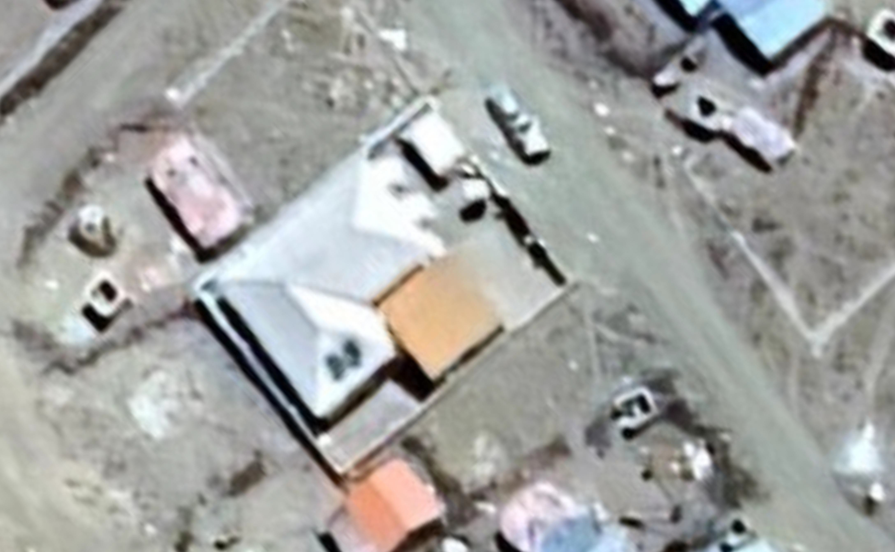







TECHNICAL DRAWING FOR RENOVATION OF HAYAYABE MCH
CLIENT:
inch supply pipe
total of 350m
3
4
inch distribution
pipe total of 40m
1
2

BORAMA, SOMALILAND
FUNDED BY:
JULY 2026

IMPLEMENTED BY:
TECHNICAL IMPLEMENTED PART:

DRAWING BY:

VICINITY MAP
N.T.S

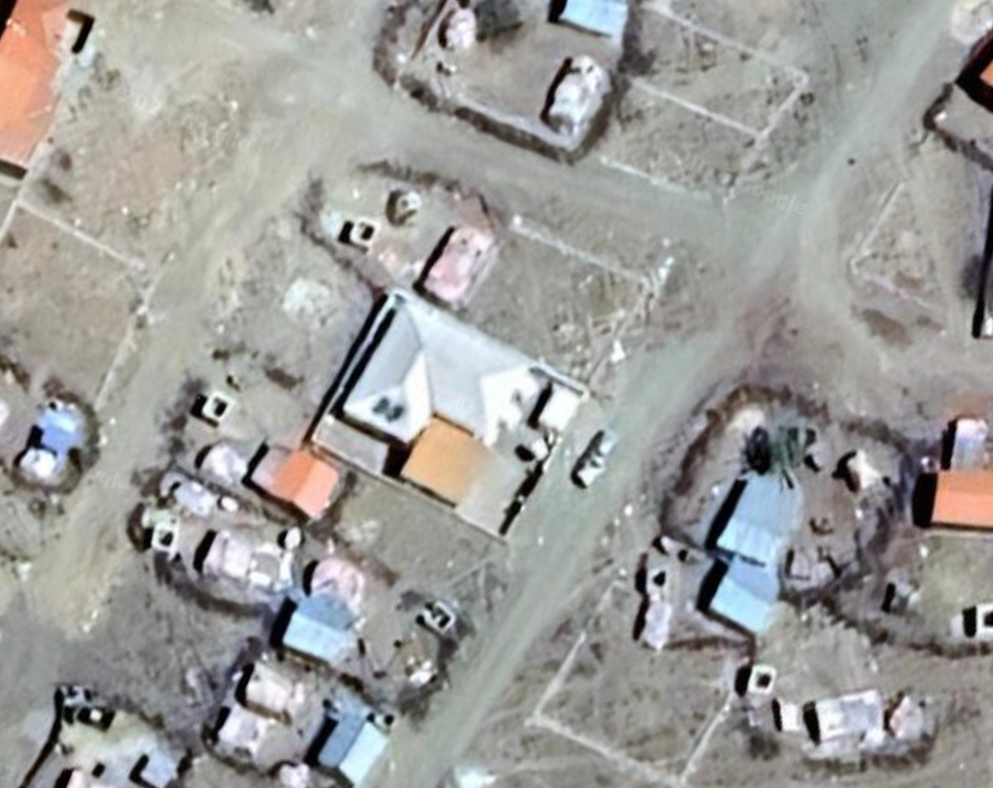

299360.000 299400.000
1097320.000
1097360.000
1097400.000
CLIENT:


FUNDED BY:


IMPLEMENTED BY:


TECHNICAL IMPLEMENTING PARTNER:



DRAWING BY:


GENERAL NOTES:
- ALL DIMENSIONS ARE IN METERS UNLESS NOTED OTHERWISE.
- CONTRACTOR TO CHECK AND VERIFY ALL DIMENSIONS ON SITE BEFORE
COMMENCEMENT
- DO NOT TAKE
DIMENSIONS FROM LAYOUTS, USE STAKEOUT DATA FROM THE DITIGAL DRAWINGS TRANSMITTED TO TOTAL STATION OR GNSS IN RTK MODE IN COLLABORATION WITH THE BENCHMARKS DEVELOPED.
PROJECT:
TECHNICAL DRAWINGS FOR RENOVATION OF HAYAYABE MCH
BORAMA, SOMALILAND
CLIENT: BORAMA LOCAL MUNICIPALITY
TRADE: CIVIL WORKS
DWG REF: M100
TITLE: HAYAYABE MCH SITE
AREA
DRAWN BY |  | RAADSAN CONSULTANCY
REVIEWED BY |  | TAAKULO ORG.
APPROVED BY |  | CITY ALLIANCE
REVISIONS:
NO. | REVISION |  |  | DATE | APPR.
1 | Initial Drawing |  |  | 02/2026
2 | Final Revision |  |  | 07/2026
SCALE :  1:500 |  |  |  | SHEET TYPE:  A3
DATE :  07/08/2026 |  |  |  | PAGE NO.  1

299360.000 299400.000
1
2
inch distribution
pipe total of 40m
1097360.000
3
inch supply pipe
4
total of 350m

0.110.12 1.28
0.92
0.47
0.11 0.11
0.01

1.73
0.11 0.11
0.01
0.01

0.11
110mm wide outer fire clay brick wall of the incinerator
Fire clay bricks as the base for the incinerator.
3mm thick MS plate box tunnel
3mm thick MS plate ash door on 30x30x3mm MS angle frame, oil painted to approval.
0.92
0.47
110mm wide outer fire clay brick wall of the incinerator

0.110.12
0.11 0.11
0.01

0.23

0.22 0.72

1.73

0.11 0.110.12

110mm wide outer fire clay brick wall of the incinerator

Fire clay bricks as the base for the incinerator.

110mm wide outer fire clay brick wall of the incinerator
0.01

Plan view at level 01
0.11 0.11
Plan view at level 03

0.110.12
0.11 0.11
0.01
0.11
0.23
0.22 0.72 0.22 0.12
110mm wide outer fire clay brick wall of the incinerator
Fire clay bricks as the base for the incinerator.

Primary combustion chamber.
support bricks above.
0.71
Flue and secondary combustion chamber.
110mm wide outer fire clay brick wall of the incinerator
0.16 0.36 0.34 0.36 0.29 0.110.12

3mm thick MS plate cover with 114mm dia, 3mm thick MS pipe welded on 30x30x3mm MS angle frame to house the chimney

MS hinges to site Engineer's approval.

loading door of 3mm MS plate welded on 30x30x3mm MS angle frame, oil painted.

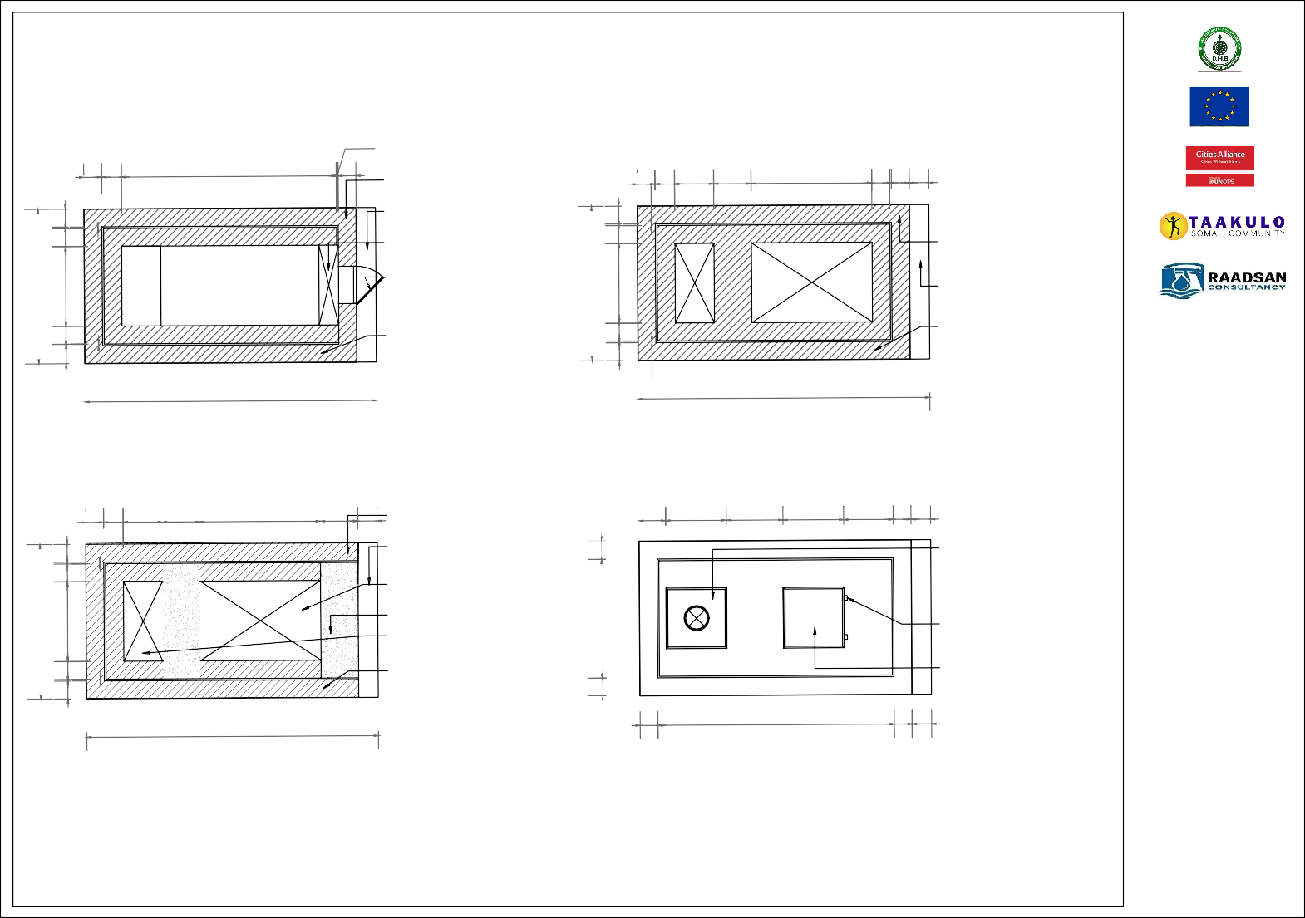
CLIENT:

FUNDED BY:

IMPLEMENTED BY:

TECHNICAL IMPLEMENTING PARTNER:

DRAWING BY:

GENERAL NOTES:
- ALL DIMENSIONS ARE IN METERS UNLESS NOTED OTHERWISE.
- CONTRACTOR TO CHECK AND VERIFY ALL DIMENSIONS ON SITE BEFORE
COMMENCEMENT
- DO NOT TAKE
DIMENSIONS FROM LAYOUTS, USE STAKEOUT DATA FROM THE DITIGAL DRAWINGS TRANSMITTED TO TOTAL STATION OR GNSS IN RTK MODE IN COLLABORATION WITH THE BENCHMARKS DEVELOPED.
PROJECT:
TECHNICAL DRAWINGS FOR RENOVATION OF HAYAYABE MCH
BORAMA, SOMALILAND
CLIENT: BORAMA LOCAL MUNICIPALITY
TRADE: CIVIL WORKS
DWG REF: G100
TITLE: HAYAYABE MCH
INCINERATOR
DRAWN BY |  | RAADSAN CONSULTANCY
REVIEWED BY |  | TAAKULO ORG.
APPROVED BY |  | CITY ALLIANCE
REVISIONS:
NO. | REVISION |  |  | DATE | APPR.
1 | Initial Drawing |  |  | 02/2026
2 | Final Revision |  |  | 07/2026
SCALE :  1:500 |  |  |  | SHEET TYPE:  A3
DATE :  07/08/2026 |  |  |  | PAGE NO.  2

1.73
0.92
0.11 0.11
0.47
0.01
0.11

Plan view at level 02
0.11
1.40 0.110.12

Plan view at level 04

150mm dia,3mm thick MS pipe chimney welded onto the chimney base plate

3mm thick MS plate cover with 114mm dia, 3mm thick MS pipe welded on 30x30x3mm MS angle frame to house the chimney

04
0.04
flue and secondary combustion chamber

loading door of 3mm MS plate welded on 30x30x3mm MS angle frame,
oil painted to approval.
04

110mm wide fire clay brick wall for the main body of incinerator

03
0.67
MS hinges to site Engineer's approval
10mm cement screed top finish

110mm wide fire clay brick wall for the main body of incinerator
110mm wide outer fire clay brick wall of the incinerator

03

02
25x25mm air inlet
for secondary combustion
01
0.46

170x250mm RC lintel to support bricks above
342

170x250mm RC lintel to
503
primary combustion chamber
support bricks above
156

3mm MS plate box tunnel
02
3mm thick MS plate ash door on 30x30x3mm MS angle frame, oil painted.
01
fire clay bricks as
the base for the incinerator

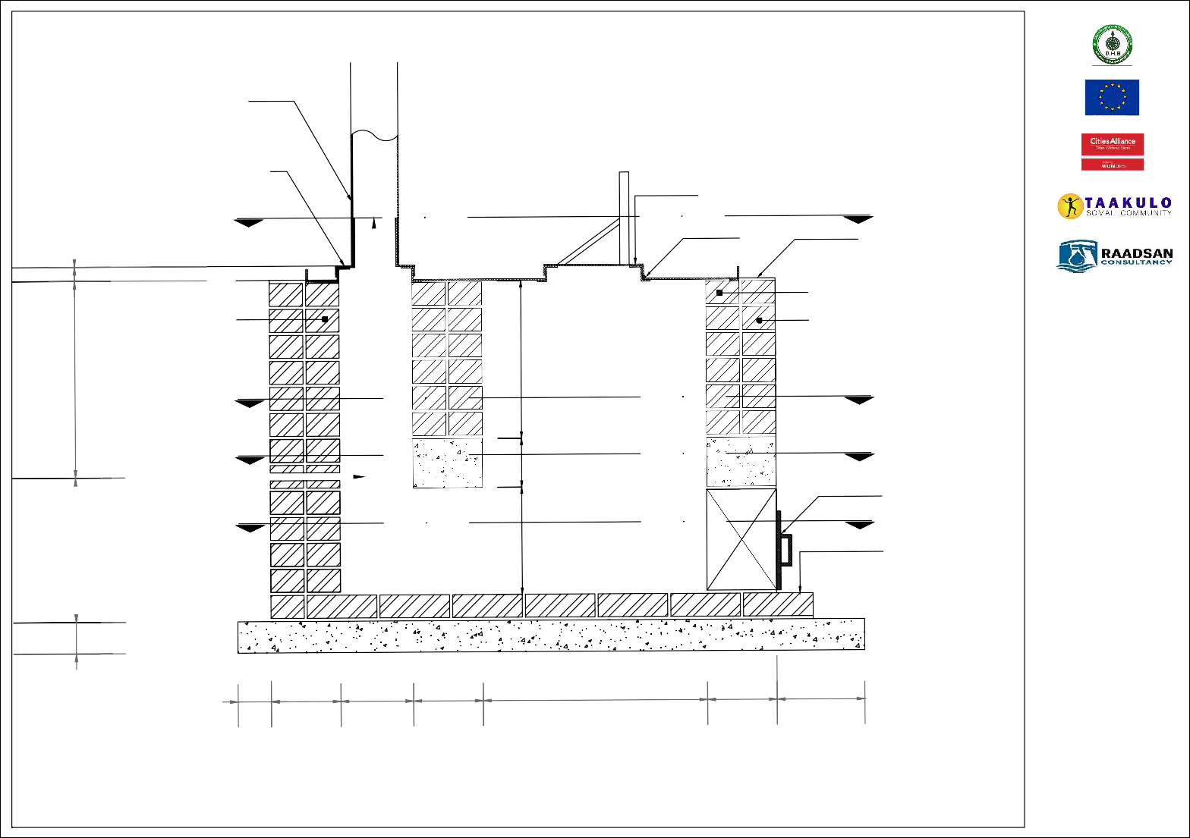
0.11 0.22 0.23 0.22 0.72
0.10
CLIENT:

FUNDED BY:

IMPLEMENTED BY:

TECHNICAL IMPLEMENTING PARTNER:

DRAWING BY:

GENERAL NOTES:
- ALL DIMENSIONS ARE IN METERS UNLESS NOTED OTHERWISE.
- CONTRACTOR TO CHECK AND VERIFY ALL DIMENSIONS ON SITE BEFORE
COMMENCEMENT
- DO NOT TAKE
DIMENSIONS FROM LAYOUTS, USE STAKEOUT DATA FROM THE DITIGAL DRAWINGS TRANSMITTED TO TOTAL STATION OR GNSS IN RTK MODE IN COLLABORATION WITH THE BENCHMARKS DEVELOPED.
PROJECT:
TECHNICAL DRAWINGS FOR RENOVATION OF HAYAYABE MCH
BORAMA, SOMALILAND
CLIENT: BORAMA LOCAL MUNICIPALITY
TRADE: CIVIL WORKS
DWG REF: G100
TITLE: HAYAYABE MCH
INCINERATOR
DRAWN BY |  | RAADSAN CONSULTANCY
REVIEWED BY |  | TAAKULO ORG.
APPROVED BY |  | CITY ALLIANCE
REVISIONS:
NO. | REVISION |  |  | DATE | APPR.
1 | Initial Drawing |  |  | 02/2026
2 | Final Revision |  |  | 07/2026
SCALE :  1:500 |  |  |  | SHEET TYPE:  A3
DATE :  07/08/2026 |  |  |  | PAGE NO.  3

Typical Longitudinal Section
0.22 0.28

2.00 1.12
0.10
1.12

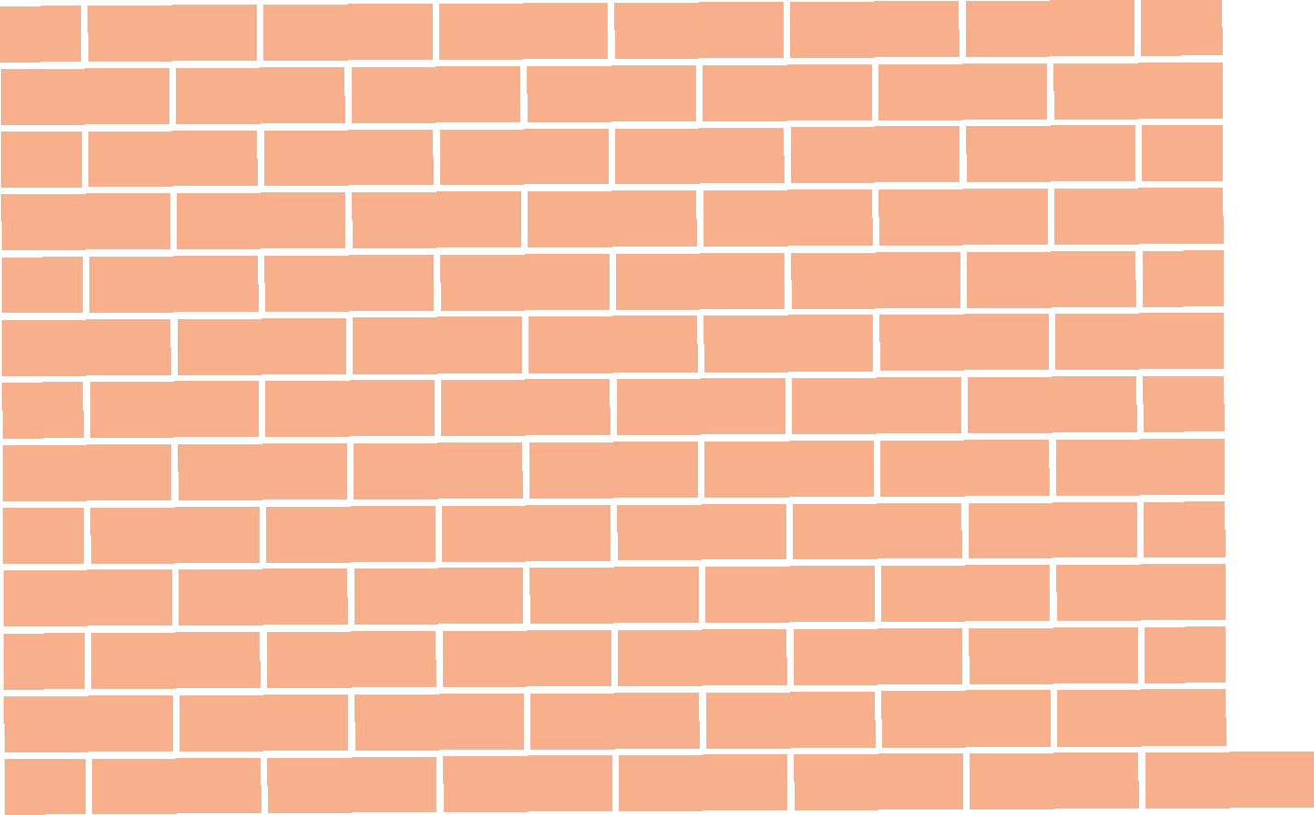

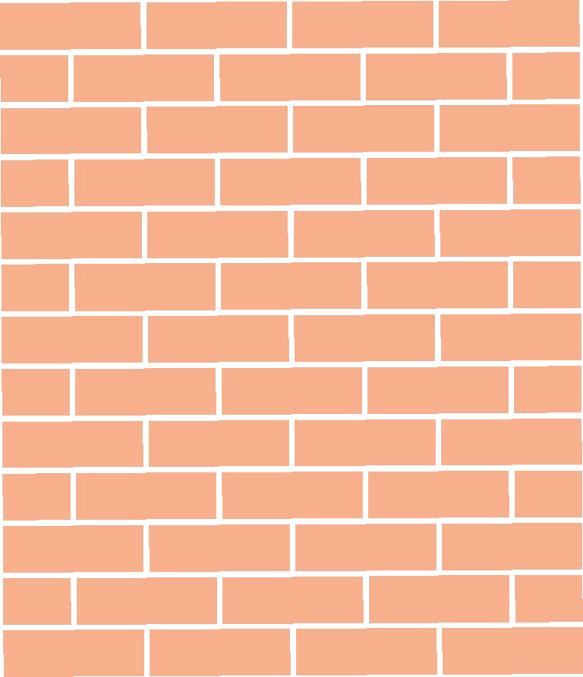



Typical Side Elevation Rear Elevation Front Elevation
0.05
4.00
1.08
1.08
1.08
CLIENT:


FUNDED BY:


IMPLEMENTED BY:


TECHNICAL IMPLEMENTING PARTNER:



DRAWING BY:


GENERAL NOTES:
- ALL DIMENSIONS ARE IN METERS UNLESS NOTED OTHERWISE.
- CONTRACTOR TO CHECK AND VERIFY ALL DIMENSIONS ON SITE BEFORE
COMMENCEMENT
- DO NOT TAKE
DIMENSIONS FROM LAYOUTS, USE STAKEOUT DATA FROM THE DITIGAL DRAWINGS TRANSMITTED TO TOTAL STATION OR GNSS IN RTK MODE IN COLLABORATION WITH THE BENCHMARKS DEVELOPED.
PROJECT:
TECHNICAL DRAWINGS FOR RENOVATION OF HAYAYABE MCH
BORAMA, SOMALILAND
CLIENT: BORAMA LOCAL MUNICIPALITY
TRADE: CIVIL WORKS
DWG REF: G100
TITLE: HAYAYABE MCH
INCINERATOR
DRAWN BY |  | RAADSAN CONSULTANCY
REVIEWED BY |  | TAAKULO ORG.
APPROVED BY |  | CITY ALLIANCE
REVISIONS:
NO. | REVISION |  |  | DATE | APPR.
1 | Initial Drawing |  |  | 02/2026
2 | Final Revision |  |  | 07/2026
SCALE :  1:500 |  |  |  | SHEET TYPE:  A3
DATE :  07/08/2026 |  |  |  | PAGE NO.  4

IBR iron sheets on 50x50mm purlins on engineered truss by specialist
2.70
Roof pitch: 22.5 degrees
0.67

Incinerator access door 2000mm x 750mm framed by 32mm round bar oil
200
painted
1144
4000

100 x 100 x 3mm chainlink fencing suitably tied to the horizontal rails and columns
115
115

150mm Hard Core
2.11
2888
200
3118
Well rammed with a roller Compactor or vibration compactor
Proposed MCH Clinic Incinerator

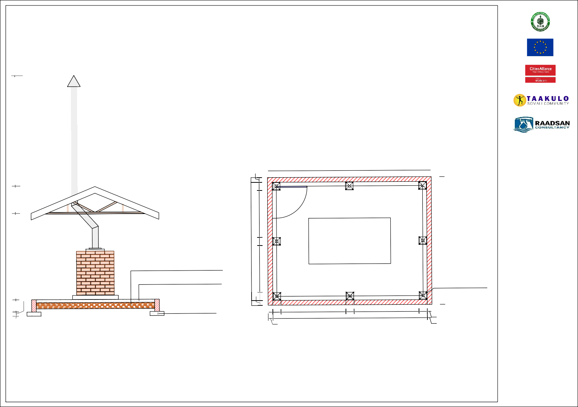
CLIENT:

FUNDED BY:

IMPLEMENTED BY:

TECHNICAL IMPLEMENTING PARTNER:

DRAWING BY:

GENERAL NOTES:
- ALL DIMENSIONS ARE IN METERS UNLESS NOTED OTHERWISE.
- CONTRACTOR TO CHECK AND VERIFY ALL DIMENSIONS ON SITE BEFORE
COMMENCEMENT
- DO NOT TAKE
DIMENSIONS FROM LAYOUTS, USE STAKEOUT DATA FROM THE DITIGAL DRAWINGS TRANSMITTED TO TOTAL STATION OR GNSS IN RTK MODE IN COLLABORATION WITH THE BENCHMARKS DEVELOPED.
PROJECT:
TECHNICAL DRAWINGS FOR RENOVATION OF HAYAYABE MCH
BORAMA, SOMALILAND
CLIENT: BORAMA LOCAL MUNICIPALITY
TRADE: CIVIL WORKS
DWG REF: G100
TITLE: HAYAYABE MCH
INCINERATOR
DRAWN BY |  | RAADSAN CONSULTANCY
REVIEWED BY |  | TAAKULO ORG.
APPROVED BY |  | CITY ALLIANCE
REVISIONS:
NO. | REVISION |  |  | DATE | APPR.
1 | Initial Drawing |  |  | 02/2026
2 | Final Revision |  |  | 07/2026
SCALE :  1:500 |  |  |  | SHEET TYPE:  A3
DATE :  07/08/2026 |  |  |  | PAGE NO.  5

Foundation depth to be determined on site
0.30
0.10
and approved by engineer. minimum = 500mm

Typical Cross Section

NGL
75mm thick M25 Grade Concrete Mixed at a ratio of 1:1:2

100mm thick concrete footing M25 Grade Concrete at a ratio of 1:1:2

121050 1585 200
3770

115

Plan View

100 x 100 x 3mm chainlink fencing suitably tied to the horizontal rails and columns

1585

200
115

115

Steel column made from 75mm diameter pipe mounted on 200 x 200 mm base plate
122,43
115
200
1144

This proposed area is for a toilet of delivery ward. See the drawings for the new
toilet.

This wall is the exterior wall of the delivery ward. The window is removed and an opening will be introduced to the toilet .

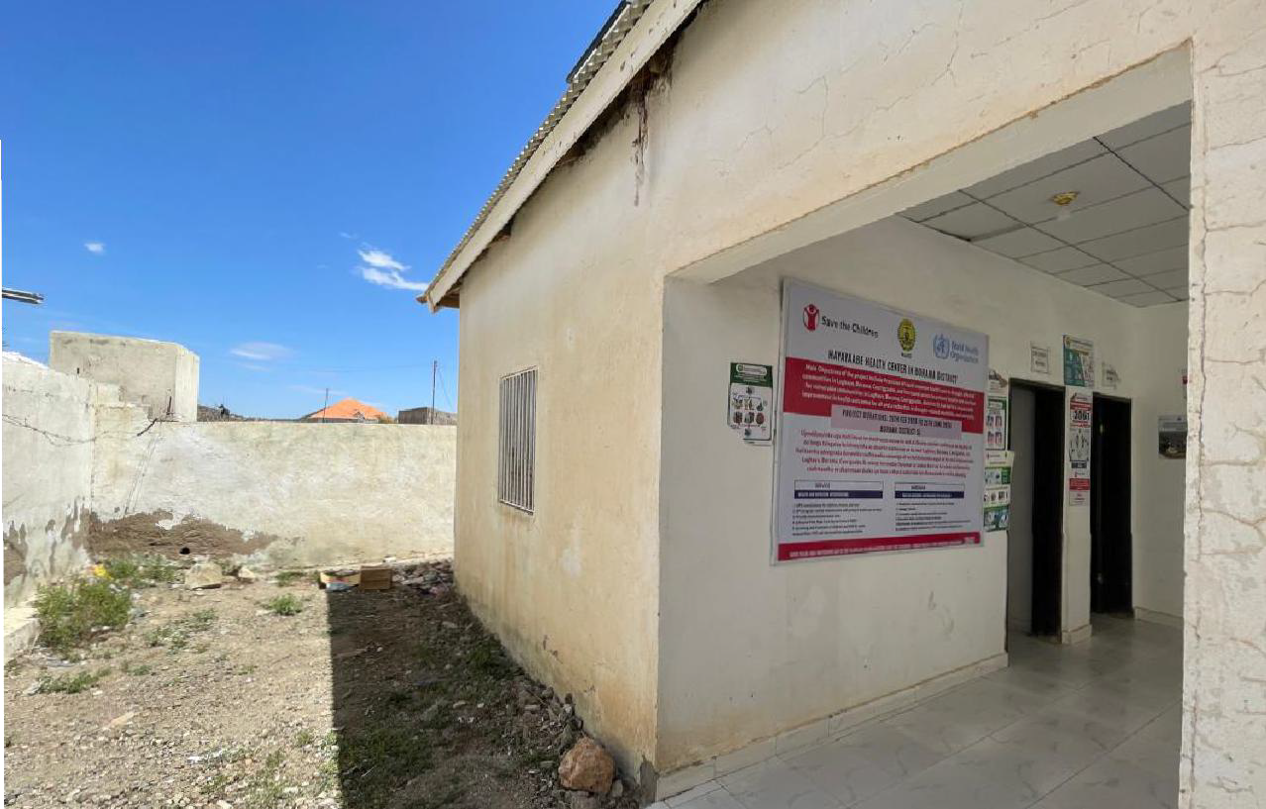
A B
CLIENT:


FUNDED BY:

IMPLEMENTED BY:

TECHNICAL IMPLEMENTING PARTNER:



DRAWING BY:


GENERAL NOTES:
- ALL DIMENSIONS ARE IN METERS UNLESS NOTED OTHERWISE.
- CONTRACTOR TO CHECK AND VERIFY ALL DIMENSIONS ON SITE BEFORE
COMMENCEMENT
- DO NOT TAKE
DIMENSIONS FROM LAYOUTS, USE STAKEOUT DATA FROM THE DITIGAL DRAWINGS TRANSMITTED TO TOTAL STATION OR GNSS IN RTK MODE IN COLLABORATION WITH THE BENCHMARKS DEVELOPED.
PROJECT:
TECHNICAL DRAWINGS FOR RENOVATION OF HAYAYABE MCH
BORAMA, SOMALILAND
CLIENT: BORAMA LOCAL MUNICIPALITY
TRADE: CIVIL WORKS
DWG REF: G100
TITLE: HAYAYABE MCH
DELIVERY WARD TOILET
DRAWN BY |  | RAADSAN CONSULTANCY
REVIEWED BY |  | TAAKULO ORG.
APPROVED BY |  | CITY ALLIANCE
REVISIONS:
NO. | REVISION |  |  | DATE | APPR.
1 | Initial Drawing |  |  | 02/2026
2 | Final Revision |  |  | 07/2026
SCALE :  1:500 |  |  |  | SHEET TYPE:  A3
DATE :  07/08/2026 |  |  |  | PAGE NO.  6

2.20
A
2.05
1.90
3
2.25
2.10

2
3.50
1.10
0.95

1
A

Toilet Plan Scale: 1:100

Toilet entrance level shall be matched with existing delivery ward existing level.

Septic Tank Scale: 1:100




A B
CLIENT:


FUNDED BY:

IMPLEMENTED BY:


TECHNICAL IMPLEMENTING PARTNER:



DRAWING BY:


GENERAL NOTES:
- ALL DIMENSIONS ARE IN METERS UNLESS NOTED OTHERWISE.
- CONTRACTOR TO CHECK AND VERIFY ALL DIMENSIONS ON SITE BEFORE
COMMENCEMENT
- DO NOT TAKE
DIMENSIONS FROM LAYOUTS, USE STAKEOUT DATA FROM THE DITIGAL DRAWINGS TRANSMITTED TO TOTAL STATION OR GNSS IN RTK MODE IN COLLABORATION WITH THE BENCHMARKS DEVELOPED.
PROJECT:
TECHNICAL DRAWINGS FOR RENOVATION OF HAYAYABE MCH
BORAMA, SOMALILAND
CLIENT: BORAMA LOCAL MUNICIPALITY
TRADE: CIVIL WORKS
DWG REF: G100
TITLE: HAYAYABE MCH
DELIVERY WARD TOILET
DRAWN BY |  | RAADSAN CONSULTANCY
REVIEWED BY |  | TAAKULO ORG.
APPROVED BY |  | CITY ALLIANCE
REVISIONS:
NO. | REVISION |  |  | DATE | APPR.
1 | Initial Drawing |  |  | 02/2026
2 | Final Revision |  |  | 07/2026
SCALE :  1:500 |  |  |  | SHEET TYPE:  A3
DATE :  07/08/2026 |  |  |  | PAGE NO.  7

2.20
A
2.05
1.90
3
2.25
2.10

2
3.50
1.10
0.95

1

Toilet Plan Scale: 1:100
A

Chamber with internal dims of 60cm x 60cm

Disability Hand rails to support patient and disable entities.

Toilet entrance level shall be matched with existing delivery ward existing level.

TYPICAL GRADE BEAM
SCALE 1 : 50

A

A
2Ø12 - 1950
1650
150
150
2Ø12 - 1650

TYPICAL TOP TIE BEAM
SCALE 1 : 50

GUAGE 28 CORRU GATED IRON SHEET
7x5cm ZIGBA WOOD PURLIN
12x6cm RAFTER

C

C

2 Ø12 - 1950
150
150
1650
2 Ø10 - 1650

PVC PIPE 100 mm
Ø12 C/C 200

Rubble Stone foundation wall, 40cm wide and 40cm depth, PLASTERED internally.

Septic Tank.

150 mm R.C. SLAB

PVC PIPE 100mm

10cm RCC Cover

60cm*60cm

CHAMBER
SCALE 1 : 50

CEMENT SCREED 100mm THICK R.C SLAB
300mm HARD CORE
Ø8 C/C 200

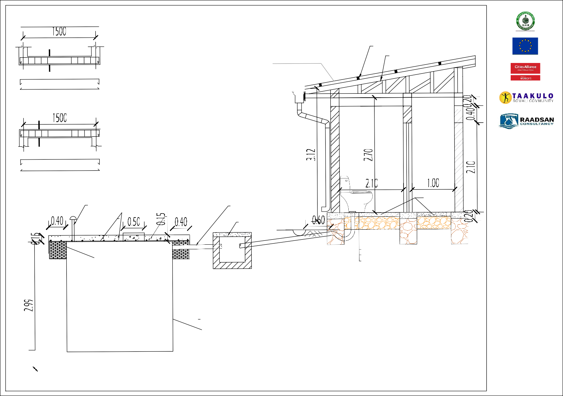
CLIENT:

FUNDED BY:

IMPLEMENTED BY:

TECHNICAL IMPLEMENTING PARTNER:

DRAWING BY:

GENERAL NOTES:
- ALL DIMENSIONS ARE IN METERS UNLESS NOTED OTHERWISE.
- CONTRACTOR TO CHECK AND VERIFY ALL DIMENSIONS ON SITE BEFORE
COMMENCEMENT
- DO NOT TAKE
DIMENSIONS FROM LAYOUTS USE STAKEOUT DATA FROM THE DITIGAL DRAWINGS TRANSMITTED TO TOTAL STATION OR GNSS IN RTK MODE IN COLLABORATION WITH THE BENCHMARKS DEVELOPED.
PROJECT:
TECHNICAL DRAWINGS FOR RENOVATION OF HAYAYABE MCH
BORAMA, SOMALILAND
CLIENT: BORAMA LOCAL MUNICIPALITY
TRADE: CIVIL WORKS
DWG REF: G100
TITLE: HAYAYABE MCH
DELIVERY WARD TOILET
DRAWN BY |  | RAADSAN CONSULTANCY
REVIEWED BY |  | TAAKULO ORG.
APPROVED BY |  | CITY ALLIANCE
REVISIONS:
NO. | REVISION |  |  | DATE | APPR.
1 | Initial Drawing |  |  | 02/2026
2 | Final Revision |  |  | 07/2026
SCALE :  1:500 |  |  |  | SHEET TYPE:  A3
DATE :  07/08/2026 |  |  |  | PAGE NO.  8

SECTION A-A
SCALE 1 : 50
Natural pit shaft rock wall

4Ø12
50
50
150

4Ø12
50
0.15

150
150
150

TOP TIE BEAM
SECTION C-C
Sc,1:20
150

Ø8c/c150-700

4Ø12
50
50
100

0.40

115500
150
150

GRADE BEAM

Ø8c/c150-700
0.15

0.20

100
100
100
50

LINTEL

Ø8c/c150-500











SECTION A-A Sc,1:20
CLIENT:


FUNDED BY:


IMPLEMENTED BY:

TECHNICAL IMPLEMENTING PARTNER:



DRAWING BY:

GENERAL NOTES:
- ALL DIMENSIONS ARE IN METERS UNLESS NOTED OTHERWISE.
- CONTRACTOR TO CHECK AND VERIFY ALL DIMENSIONS ON SITE BEFORE
COMMENCEMENT
- DO NOT TAKE
DIMENSIONS FROM LAYOUTS, USE STAKEOUT DATA FROM THE DITIGAL DRAWINGS TRANSMITTED TO TOTAL STATION OR GNSS IN RTK MODE IN COLLABORATION WITH THE BENCHMARKS DEVELOPED.
PROJECT:
TECHNICAL DRAWINGS FOR RENOVATION OF HAYAYABE MCH
BORAMA, SOMALILAND
CLIENT: BORAMA LOCAL MUNICIPALITY
TRADE: CIVIL WORKS
DWG REF: G100
TITLE: HAYAYABE MCH
DELIVERY WARD TOILET
DRAWN BY |  | RAADSAN CONSULTANCY
REVIEWED BY |  | TAAKULO ORG.
APPROVED BY |  | CITY ALLIANCE
REVISIONS:
NO. | REVISION |  |  | DATE | APPR.
1 | Initial Drawing |  |  | 02/2026
2 | Final Revision |  |  | 07/2026
SCALE :  1:500 |  |  |  | SHEET TYPE:  A3
DATE :  07/08/2026 |  |  |  | PAGE NO.  9

Sc,1: 20

CLIENT:


FUNDED BY:

IMPLEMENTED BY:

TECHNICAL IMPLEMENTING PARTNER:



DRAWING BY:

GENERAL NOTES:
- ALL DIMENSIONS ARE IN METERS UNLESS NOTED OTHERWISE.
- CONTRACTOR TO CHECK AND VERIFY ALL DIMENSIONS ON SITE BEFORE
COMMENCEMENT
- DO NOT TAKE
DIMENSIONS FROM LAYOUTS, USE STAKEOUT DATA FROM THE DITIGAL DRAWINGS TRANSMITTED TO TOTAL STATION OR GNSS IN RTK MODE IN COLLABORATION WITH THE BENCHMARKS DEVELOPED.
PROJECT:
TECHNICAL DRAWINGS FOR RENOVATION OF HAYAYABE MCH
BORAMA, SOMALILAND
CLIENT: BORAMA LOCAL MUNICIPALITY
TRADE: CIVIL WORKS
DWG REF: G100
TITLE: HAYAYABE MCH PIPE LINE
MAP
DRAWN BY |  | RAADSAN CONSULTANCY
REVIEWED BY |  | TAAKULO ORG.
APPROVED BY |  | CITY ALLIANCE
REVISIONS:
NO. | REVISION |  |  | DATE | APPR.
1 | Initial Drawing |  |  | 02/2026
2 | Final Revision |  |  | 07/2026
SCALE :  1:500 |  |  |  | SHEET TYPE:  A3
DATE :  07/08/2026 |  |  |  | PAGE NO.  10
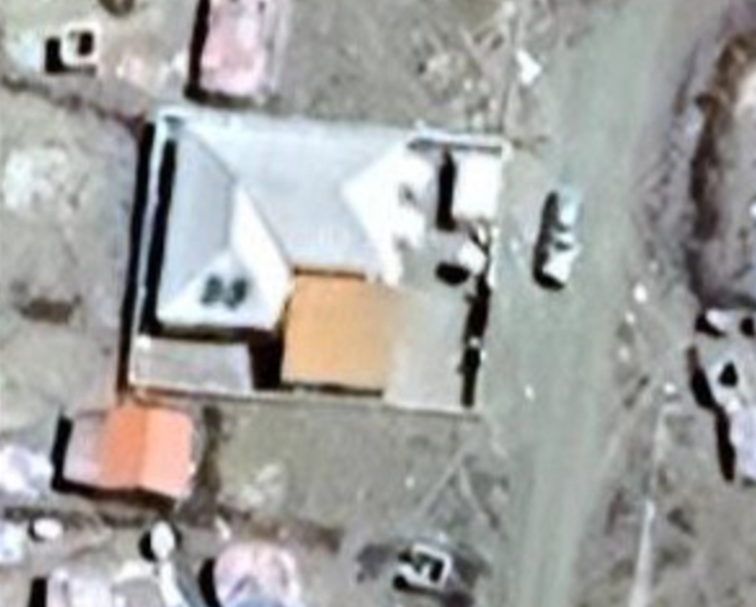

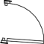

1
2
inch distribution
pipe total of 40m
3
4
inch supply pipe
total of 350m

