
TENDER DOCUMENT

(Supply and Delivery of Three-Wheeler auto – burco)
Muslim Hands is an international relief and development non-government charitable organization established in 1993. Muslim Hands intends to invite Tenders from technically strong and registered Companies to provide services/goods as per bid data
About the Project:
Muslim Hands proposes a livelihood support project aimed at reducing youth unemployment and economic vulnerability in Burao, Somaliland, through the provision of three-wheeler autorickshaws to disadvantaged young people. Burao faces a growing challenge of unemployed youth, particularly among internally displaced persons (IDPs), returnees, and those from low-income households who lack access to capital and sustainable income opportunities. Without viable livelihoods, many youth remain trapped in poverty and dependency.
The project will support vulnerable youth by providing three-wheeler autorickshaws as productive assets, enabling them to engage in self-employment within the local transport and small cargo service sector. In addition to asset provision, beneficiaries will receive basic orientation on road safety, vehicle maintenance, and simple business management to promote safe operation and long-term sustainability of the intervention.
Through direct job creation and income generation, the project will improve household livelihoods, enhance youth self-reliance, and contribute positively to the local economy of Burao. The intervention aligns with Muslim Hands’ commitment to sustainable livelihoods, youth empowerment, and poverty reduction, supporting vulnerable youth to restore dignity and resilience through meaningful employment.
Location Details
Details of items | Quantities | Delivery Point | delivery timeline
3-wheeler auto(detailed description refer bid data sheet) | 10 | Burco | 40 Days

TECHNICAL SPECIFICATION

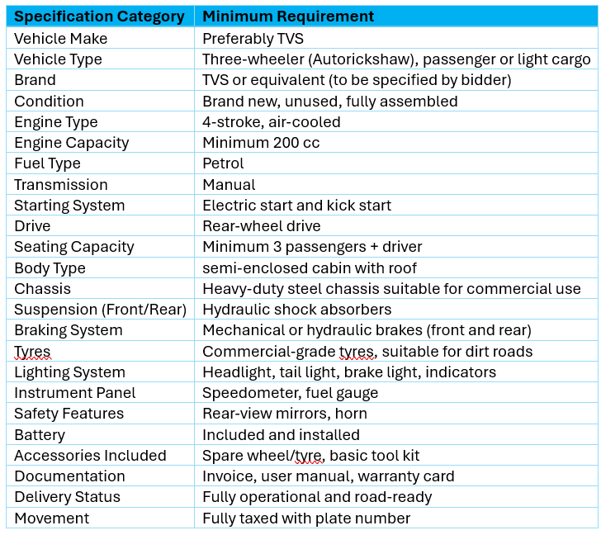

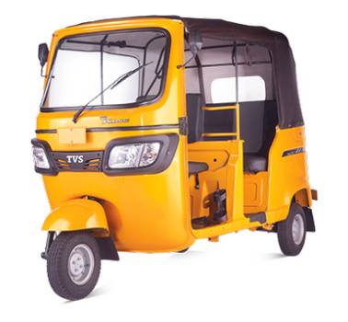

- SCOPE:
The contractor shall supply brand new, unused, and complete three-wheeler autorickshaws (TVS or equivalent) in accordance with the minimum technical specifications provided. The vehicles shall be fully assembled, tested, and delivered in road-ready and operational condition to the final delivery location in Burco (Burao), Somaliland.
The contractor shall be fully responsible for importation, including port clearance, customs procedures, duties, taxes, and any associated fees, as well as vehicle registration and issuance of number plates by the relevant authorities. All costs related to these processes shall be included in the quoted price.
Delivery shall include all standard accessories, battery, spare wheel or tyre, basic tool kit, user manual, warranty documentation, and any compliance certificates required for lawful operation. Muslim Hands shall not be responsible for any additional costs arising from clearance, taxation, or registration beyond the agreed contract price.
LANGUAGE:
Muslim Hands requires the working language accepted within the relevant country, however translated versions into the working language of the relevant country will be considered. In this case English is required.
- QUALIFYING AND CONDITION;
The main criteria for admission to the tender are as follows:
a) Duly registered under applicable laws and authorities
c) Provision of evidence of financial soundness.
d) Provision of evidence of technical soundness and Previous relevant Experience,
f) Good track-record and references from previous clients
g) Good team composition

- TENDER BASIS:
- All Tender Documents must be completed in full; otherwise the application will be disqualified.
- All Applicants will receive identical documents: No applicant should add, omit, or change any item, term or condition in original papers.
- If Applicants have any additional request and conditions, this shall be stipulated in a separate letter accompanying the bid.
- Each bid shall be valid for the period of 30-days from its date of submission.
- Bids shall be made in writing calculated in USD only and clearly stated on the appropriate forms.
- The price schedule must include all information requested, including origin of materials.
- The applicant shall attach a detailed timetable for carrying out the works and propose ways and means to realize the works.
- Muslim Hands will not be liable for any damage to the applicant person or property in the event that something should occur.
- Muslim Hands strongly recommend that all applicants take extra precaution when visiting/delivering supplies to a project site.

- PAYMENTS:
Payment will be made according to the agreed payment schedule, upon satisfactory delivery of the supplies or completion of services, and submission of a technical test report (where applicable), at the location specified in the tender documents/invitation to tender.
- PERFORMANCE STANDARDS:
The work must be undertaken in accordance with all relevant rules, regulations and statutes currently in force in Somaliland.
- ELIGIBILITY OF APPLICANTS:
Applicants cannot apply if they:
- Are bankrupt or in the process of going bankrupt.
- Have been convicted for an offense concerning professional conduct.
- Have been guilty of grave professional misconduct (proven by any means which the contracting authorities can justify).
- Have not fulfilled obligations related to payment of taxes.
- Are guilty of serious misinterpretation in supplying information.
- Are in situations of conflict of interest (with prior relationship to project or family or business relationship to parties on Muslim Hands).
- Were declared at serious fault of implementation owing to a breach of their contractual obligations

- BID EVALUATION:
The Tender Committee will check the tenders to ensure that they contain no amendment to the terms or any other (calculation) errors. To assist in the examination, evaluation and comparison of bids, the Tender Committee may, at its discretion, request clarification from the Muslim Hands staff or consultant.

Technical Evaluation: The offers will first be evaluated on technical merits. The technical evaluation assesses the capacity of the company on the basis of submitted technical documents.
Financial Evaluation: The financial evaluation subject to the technical evaluation is based on the cost of assignment given in the tender.
Other Evaluations: After ranking companies according to financial and technical criteria, the Tender Committee may take into account other criteria, including, but not limited to record of past performance, integrity, samples and reputation within the community and other info provided.
The Supplier are advised to send Tender Documents to the email address provided.

- SELECTION OF TENDER;
Selection of the successful applicant will be based on the ranking of companies according to technical and financial criteria, as well as any other criteria suggested by the Tender Committee. Based on this the Tender Committee will then make a recommendation.

- ACCEPTANCE OF SUCCESSFUL TENDER:
Taking into consideration the recommendation of the Tender Committee, Muslim Hands SO will make the final choice of the awarded firm. (Muslim Hands) will then send a letter of acceptance to the successful applicant. After submitted documentation from the selected firm has been verified, the firm will then be presented to sign the contract for the stated amount. Any amendment to the awarded tender will be documented as an “Annex” to the contract and will be determined by (Muslim Hands SO)

- TECHNICAL PROPOSAL

SN. | Description | Detail | Comments
 | Project ID
 | Name of the Supplier
 | Physical Address
 | Type of Business
 | License # / Permit  Attach License | License Category | License Expire Date
 | Past Experience (in Years)
 | Company Profile with Relevant Experience  Technical  You may attach company profile | Name of orgs you’ve worked with in similar projects, your team composition and technical capabilities etc. (no more than 15 Pages) | As attachment
 | Implementation Strategy (Assignment Timetable) | (as Attachment no more than 500 words) | As attachment
 | Bank Statement | (Past 6 months as attachment)
 | Name of contact person within organization to whom all correspondences shall be addressed Cell #, e-mail etc
 | Name, designation and legal status of person authorized to enter into negotiation and sign any form or agreement
 | Disclosure of relationship with any employee of the firm within Muslim Hands

- FINANCIAL PROPOSAL
Financial Proposal
Name of the Supplier:
SN | Description | Unit | Quantity | Unit Price | Total
Total Cost

Supplier Contact and Address:
Date: ____/______/_______

Supplier Stamp:

Company Quotations might be attached separately (optional)

BID CONDITIONS AND TERMS:
- The successful bidder is responsible for payment of taxes and transportation expenses, therefore this should be considered while submitting the tender.
- Preference will be given to bidders possessing relevant past work experience who have carried out a variety of foot item delivery assignments.
- Tender committee reserves the right to cancel/reject any or all offers without assigning any reason.
- Supplier must provide all details or otherwise mention within the tender document, incomplete proposals may result in cancellation.
- Payment will be made on satisfactory delivery of supplies / completion of work through bank account.
- Copies of tax clearance accompany the tenders.
- Tender committee reserves the right to alter the quantity, if required.
- An agreement will be signed with successful bidder(s) for timely supply of appropriate quality items and method of payment. Failure to meet the conditions of the agreement will result in cancellation of the agreement at the risk and cost of the supplier.
- In case the supplies are delayed, (Muslim Hands) will impose a penalty of 1% per day of the total amount of contract on the delay work and on low quality.
- Payment will be made in subsequent installments depending on the activity and delivery methods.
- (Muslim Hands) reserves the right to forfeit the contract in case of breach of the agreement.
- Tender Offers must be valid for minimum 30 days after the tender opening.
- Tender publication does not constitute any commitment on part of (Muslim Hands) unless a written agreement is signed by both parties.
- The prices should be quoted on the letter head of the company/firm in the given format and all other supporting documents should be attached with it.
- Lowest price; quality, capacity of the vendor, delivery time and previous relevant experience are all important criterion.
NOTE:
ALL TENDER DOCUMENTS CAN BE DOWNLOADED FROM THE PROVIDED LINK; ALL RELEVANT INFORMATION IS INCLUDED, AND NO FURTHER EMAILS OR PHONE CALLS WILL BE ACCEPTED.

Other Tender Instructions
Tender Document
Tender document can be downloaded from the link or requested through email with tender subject line
Tel: 659185498 Email: procurement@so.mhworldwide.org Subject line: Supply and Delivery 3-wheeler auto
Submission Deadline:
The last date for submission of bids (Technical & Financial) is The deadline for submitting Application is 8th Feb 2026. Any tender documents received later than this date will not be considered.

