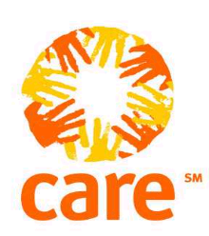
CARE INTERNATIONAL IN SOMALIA.

MOGADISHU OFFICE

DATE: March 27 2024

Company Name: _______________________________________Telephone_______________

Open National Tender Notice for The Procurement of Sports Equipment in Somalia.

Background

Adolescents and youth between the ages of 15 and 29 comprise 23 percent of household members in Somalia, with a higher proportion of women among them. Despite substantial progress made during the past decade, access to education remains limited in Somalia, presenting a major barrier for adolescents' and youth’s participation in the country’s economy.

The gross primary enrolment is only 27 percent (29 percent for boys, 25 percent for girls). Most of today’s Somali youth has never attended school or have had limited access to education, with boys more likely to be attending school at all levels. Overall, 75 percent of the women ages 15-49 have never attended school, but this proportion is likely much higher among marginalized ethnic groups, minority clans, displaced pastoralists, and girls with disabilities. The proportion of women without formal education is also likely much higher in rural areas, reflecting limited service provision and barriers posed by affected adult girls.

The baseline study for the AGES project, conducted in Banaadir, South West and Jubaland, showed that among young women ages 20-24, those who have a disability, belong to a pastoralist household, face food insecurity and/or live in an insecure location were less likely to ever have been enrolled in school.

As part of the program goals, CARE is hereby inviting all interested eligible bidders with previous experience and capacity to submit their bid documents as per the instructions and requirements in the below-mentioned documents.
Below is the summary total quote for the items.

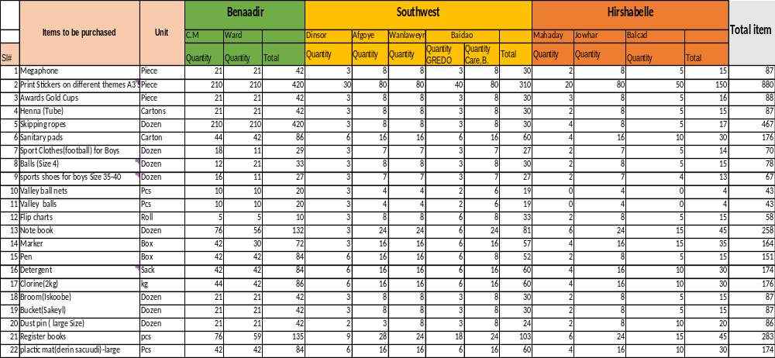
4. Where is the delivery Location

- 11 Districts in Benadir- Hodan, Howlwdaag, Wartanabada, Yaqshid, Kaaran, Bondhere, Waber, Deynile, Kahda, Wadajir and Dharkenley.
- 4 location Southwest- Baidao, Afgoye,Wanlaweyn and Dinsoor
- 3 locations in Hirshablle- Jowhar, Balcad and Mahadaay
We will share the list of schools for the above locations for distribution.
The selection criteria for this bid are as below:
- Updated company profile with your company contacts details and physical address details.
- Valid company registration at FGS or FGMS level.
- Valid Tax compliance at FGS or FGMS level.
- Previous similar experience (attach POs & Contracts with previous organizations)
- Work plan/Delivery plan.
- Bank statement for the last 6 months.
How to apply:
applications should be sent to som.procurement@care.org not late 02/Aprile/ 2024 with email subject line Bid Document for Open National Tender Notice for the Procurement of Sports Equipment in Somalia. no responses will be accepted after this deadline. For any clarifications kindly direct to Khadija Jimale <Khadija.Jimale@care.org
Note: if you send or copy your bid response to any other email your bid documents will be automatically disqualified.

NOTE: please download the RFQ templet from the link below and fill where appropriate and share it back with all other requirement documents for the email address (som.procurement@care.org).

