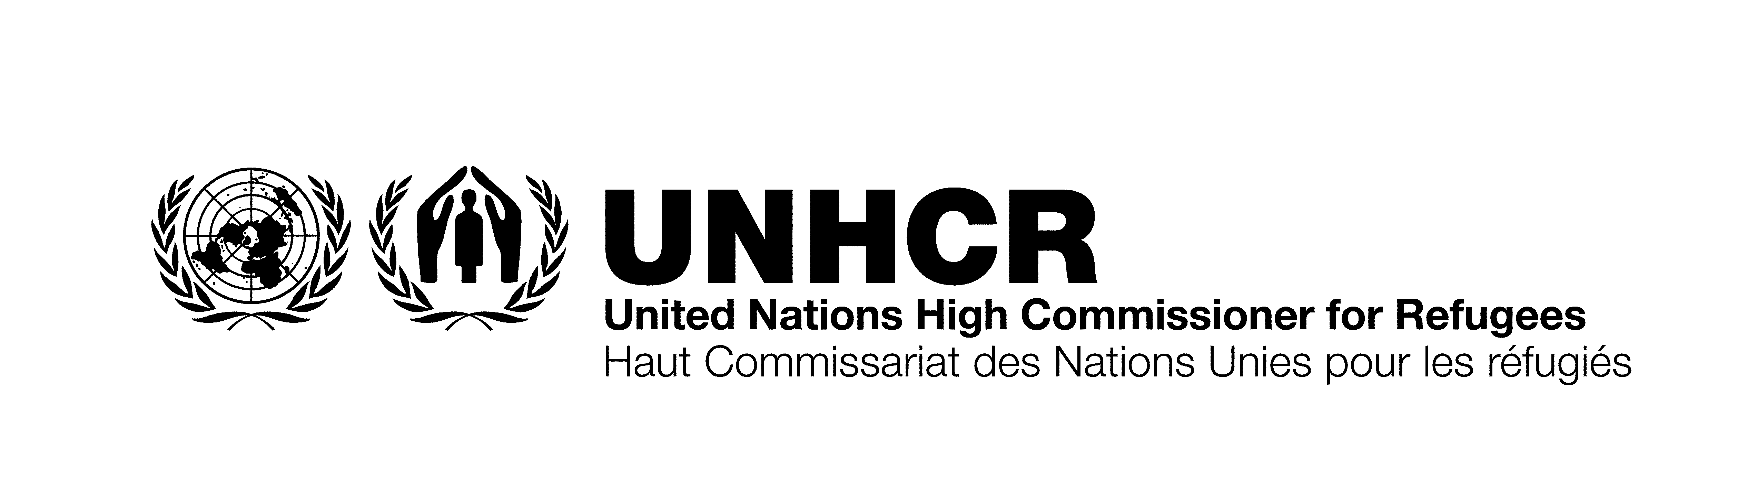
RE-TENDER NOTICE

November 25, 2025
The Office of the United Nations High Commissioner for Refugees (UNHCR) in Somalia, invites qualified suppliers legally registered with the Somaliland government establishment of frame agreement for maintenance and repair of UNHCR vehicles in Hargeisa and Berbera.
Please note that figures have been stated in order to enable bidders to have an indication of the projected requirements. It does not represent a commitment that UNHCR will purchase a minimum quantity of goods / services. Quantities may vary and will depend on the actual requirements and funds available regulated.

TENDER REFERENCE NUMBER | TENDER DESCRIPTION | HOW TO RECEIVE THE TENDER DOCUMENTS
REQUEST FOR QUOTATION: No. UNHCR/RFQ/2160 | ESTABLISHMENT OF FRAME AGREEMENT FOR MAINTENANCE AND REPAIR OF UNHCR VEHICLES IN HARGEISA AND BERBERA | If you are interested in submitting a bid in response to this RFQ, please log in to the Supplier Portal, then search for the negotiation using the reference number UNHCR_RFQ_2160 (see User Guide 39) and prepare your bid in accordance with the requirements and procedures as set out in this RFQ and submit it by the deadline for submission of proposals set out in this document and via the supplier portal.  In case you have never registered before, you can register a profile using this registration link Supplier Registration (oraclecloud.com) and follow the instruction in guides available in the UNHCR website: How to become a supplier | UNHCR and in the User Guide. Do not create a new profile if you already have one. Use the forgotten password feature in case you do not remember your password or username from previous registration (see User Guide slide 36). Should you require further clarification, kindly communicate using the messaging functionality in the system. If you experience issues accessing the Cloud ERP, please contact sommosup@unhcr.org

Deadline for the submissions is: 09/12/2025

UNHCR tenders are free of charge, no fees are charged. Please do not pay for the same.

UNHCR REPRESENTATION FOR SOMALIA.

