

JAMHUURIYADDA FEDERAALKA SOOMAALIYA
WASAARADDA BEERAHA & WARAABKA

جـمـهــو رية الصـومـال الفيدراليه
وزارة الزراعه والري

Federal Republic of Somalia
Ministry of Agriculture & Irrigation
Rural Livelihoods Resilience Program (RLRP)

Terms of Reference for Consulting Services

for

CSA Rapid Assessment

Ref No: SOM-2000004325-0119-CS-CQS

Submission date: November 22th, 2025
Terms of Reference (TOR)
The CSA Rapid Assessment is designed to provide evidence-based insights into the current level of awareness, use, and adoption of Climate-Smart Agriculture (CSA) practices among farmers in the targeted districts. They will also promote innovative and feasible CSA practices that can be scaled up to strengthen resilience, improve productivity, and enhance food security. The findings will directly inform programme design, community engagement strategies, and policy advocacy under the Rural Livelihoods Resilience Programme (RLRP).

Client
The client for this assignment is the Ministry of Agriculture and Irrigation of the Federal Government of Somalia.
- Background
The Rural Livelihoods Resilience Programme (RLRP) is a cornerstone investment by the Federal Government of Somalia and IFAD to bolster the livelihoods of smallholder agro-pastoralists in Jubaland and South-West States. The programme operates in a context of acute fragility, characterized by recurrent climate shocks, degraded natural resources, and weak market systems, as rigorously documented in the recent RLRP Baseline Study (2025).
The Baseline Study reveals a critical paradox: while communities are highly vulnerable to climate shocks (48.95% of households experienced a shock in the last five years), the adoption of climate-resilient practices is critically low. Only 20.3% of households have adopted any environmentally sustainable or climate-resilient practice. Key gaps include:
- Negligible awareness of weather index insurance (<2%).
- Low use of improved seed varieties (17.1%) and improved livestock breeds (30.3%).
- Limited functional irrigation, with high dependence on rainfall and vulnerable river/stream sources.
- Significant barriers to adoption, including limited access to finance (11.33% HH access finance in the RLRP project area) due primarily to a lack of collateral (reported by 38.8% of those seeking finance), limited extension reach, and weak producer organizations.
This CSA Assessment is commissioned to conduct a deep-dive into these findings. Its purpose is to move from quantifying the problem to diagnosing its root causes and co-designing actionable, context-specific solutions to accelerate the adoption of CSA technologies, which is fundamental to achieving RLRP's Project Development Objective.

- The Rural Livelihoods Resilience Programme
Rural Livelihoods Resilience Program is an 8-year program (March 2024 – March 2032). (RLRP)’s development objective is to sustainably increase productivity, incomes and nutrition security and enhance resilience of rural smallholder families in Somalia. It aims to address the challenges underlying the fragility of the agricultural sector in Somalia, e.g. vulnerability to climate change, perpetuating severe water scarcity, violent conflicts leading to displacement of farmers and inadequate access to food, poor access to rural and agricultural production infrastructure and services, limited access to skills training.

RLRP has three main components:
Component 1: Support to Community Resilience. Its expected outcomes are: Strengthened and inclusive communities with enhanced social cohesion so that they can define their livelihood development pathways and manage conflict.
Component 2: Support to Smallholder Livelihoods Enhancement. Its expected outcomes are: increased production and productivity of priority crops and animals for resilience, dietary diversity and food security; and improved incomes.
Component 3: Programme Coordination and Capacity Building. Its expected outcomes are an efficiently and effectively managed programme that integrates gender, youth, environment, climate change, monitoring and evaluation (M&E), knowledge management, and communication (KMC) considerations in all aspects of the programme.

3.0 Objectives of the Assignment
The primary objective is to generate evidence-based, practical strategies to rapidly scale the adoption of Climate-Smart Agriculture (CSA) practices among RLRP beneficiaries. It is important to underscore that climate smart agricultural practices would cover crop and livestock production. In the project design report, the following CSA practices were identified: 1) for crops, a) conservation agriculture; b) vermicomposting agroforestry; c) new drought tolerant, high yielding, and early maturing seed varieties; d) sustainable water management, and waste management; 2) for livestock, a) introduction of drought and stress tolerant improved breeds of shoats; b) pasture species; c) building capacity of shoat producers on good animal husbandry; d) strategic destocking of livestock in anticipation of drought; e) supplementary feeding (including minerals and vitamins, good quality forages and hay as well as fodder storage); f) simple feed ration formulation; g) rangeland management, including rotational grazing to recover vegetation, and restoration of degraded areas.

Specific Objectives:
- To diagnose the root causes of low CSA adoption, disaggregating barriers by age, gender, displacement status, and district.
- To identify, validate, and prioritize a shortlist of the most feasible and high-impact CSA practices for each target district.
- To analyze the enabling environment for CSA, including input supply chains, financial services, extension systems, and market incentives.
- To develop a costed and phased CSA Promotion Strategy for RLRP, detailing implementation modalities, partnerships, and monitoring frameworks.

- Geographical Scope
The assessment will be conducted in the five districts of RLRP, with analysis and recommendations tailored to each district's specific risk profile and livelihood system:
- Jubaland State:
- Kismayo (Ceel Jaalle 1, New Goobweyn, Bulo Bartire, Haji Weyne, Yoontooy, Bulo Gaduud, Farwamo)
- Bardhere (Sarinley, Shimbirole west, Mardhaa, Shimbirole east, Baytul amin, Bandar, Neebsooy)
- South-West State:
- Baidoa
- Afgoye (Afgoye, Anoole, Sabib, Marerey,Idimow,Arbiska,Deefow)
- Elbarde (Elbarde town, Beercaano, Oondhere, Lawareeg, Hiireey, Wargerweyne, Dudumale, Bilan

- Scope of Work and Key Tasks
The consultant will execute the following tasks:
Task 1: Inception and Desk Review
- Conduct a thorough review of the RLRP Baseline Study, project documents, and existing literature on CSA in Somalia covering both crops and livestock.
- Develop and submit an Inception Report detailing the refined methodology, work plan, and data collection tools.
Task 2: Diagnostic Field Assessment
Using a mixed-methods approach, the consultant will:
- Map Existing Practices & Gaps: Document current farming/pastoral practices and identify specific climate vulnerabilities.
- Conduct Barrier Analysis: Through FGDs and KIIs, investigate the socio-economic, cultural, and institutional barriers to adoption for different demographic groups (e.g., why female-headed households show lower adoption rates).
- Analyze the CSA Ecosystem: Assess the availability, affordability, and quality of key inputs (seeds, tools), the capacity of extension services, and the functionality of financial service providers to support CSA investments.
Task 3: CSA Practice Prioritization
- Generate a long-list of potential CSA practices relevant to the Somali context (e.g., drought-tolerant seeds, micro-irrigation, soil moisture conservation, fodder production, improved grain and fodder storage).
- Carry out the benefit/ cost analysis for the long list of potential CSA practices (applicable to crops and livestock).
- Facilitate participatory community workshops in each district to present these options and score them based on locally-defined criteria (e.g., cost, labor requirement, perceived effectiveness, speed of return).
- Produce a finalized, ranked shortlist of 3-5 priority CSA practices per district.

- Deliverales
No. |  | Deliverable | Description | Timeline
1 |  | Inception Report | Detailed methodology, work plan, stakeholder engagement plan, and questionnaires | Within 1 weeks of contract signing
2 |  | Baseline Data Collection Tools | Finalized survey questionnaires, interview guides, and data collection instruments | Within 2 weeks of contract signing
3 |  | Preliminary Findings Report | Initial analysis of awareness, adoption, and influencing factors | Within 4 weeks of contract signing
4 |  | Draft CSA Study Report | Comprehensive findings, analysis, and preliminary recommendations, including charts and maps | Within 5 weeks of contract signing
5 |  | Validation Workshop | Presentation of draft findings to stakeholders for feedback and validation | Within 6 weeks of contract signing
6 |  | Final CSA Study Report | Incorporating stakeholder feedback, detailed analysis, and concrete recommendations | Within 7 weeks of contract signing

- Timeline and Schedule
The entire study is expected to be completed within 7 weeks from contract signing. The Consultant is expected to have their own office space, laptops, vehicle (owned or rented), and all other necessary equipment, software, and communication tools required to carry out the assignment. The costs associated with these will not be covered or reimbursed under this contract.
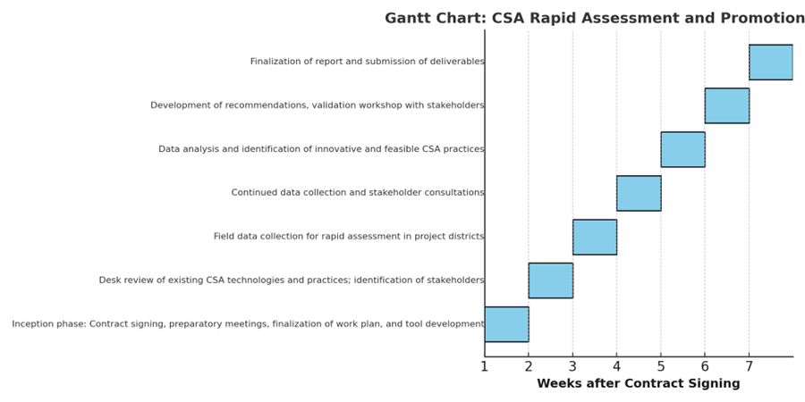

- Competencies Required

8.1 Firm expertise and required qualifications

The selected firm shall possess the following qualifications:

- At least 5 years of experience in agricultural research, rural development, and behavioural studies related to climate adaptation in Somalia.
- At least 5 assessments designed and implemented about Climate Smart Agriculture over the period 2020-2025 in Somalia.
- At least 5 assessments designed and implemented about agriculture and livestock development using mixed-methods research (quantitative and qualitative), including survey tools, data collection, analysis, and reporting, in Somalia.
- Familiarity with CSA practices, rural livelihoods, and socio-economic assessments in Somalia.
- Strong stakeholder engagement and facilitation skills.
- Experience working with government agencies, NGOs, and local communities in Somalia.

- Team Composition and Key Experts

The consulting team shall include:

1. Team Leader / Lead Consultant:
• Bachelor degree in Agriculture, Agricultural Economics, Rural Development, or related field.
• At least 5 years of experience in agricultural research, rural development, and behavioural studies related to climate adaptation.
• Strong track record in designing and implementing mixed-methods research.
• Familiarity with CSA practices, rural livelihoods, and socio-economic assessments.
• Strong stakeholder engagement and facilitation skills.
• Experience with government agencies, NGOs, and local communities.
• Leadership in managing multi-disciplinary teams.
• Fluent in speaking and writing in English and Somali.

2. CSA Livestock Specialist:
• Bachelor degree in Animal science, veterinary, or related field.
• At least 5 years’ experience in CSA technologies applied to livestock and range management.
•
• Strong stakeholder engagement and facilitation skills.
• Experience with government agencies, NGOs, and local communities.
• Fluent in speaking and writing in English and Somali.

3. Socio-Economist:
• Degree in Economics, Sociology, or related field.
• At least 5 years of experience in socio-economic analysis and participatory research.
• Proficiency in conducting benefit/cost analysis.
• Experience with government agencies, NGOs, and local communities.
• Fluent in speaking and writing in English and Somali.

4. Data Analyst / Statistician:
• Degree in Statistics or Data Science.
• At least 5 years of experience in survey design, sampling, and analysis.
• Proficiency in analyzing quantitative and qualitative data.
• Fluent in speaking and writing in English and Somali.

5. Enumerators / Field Researchers:
• Strong local knowledge of the target districts.
• Fluency in Somali and experience in conducting field surveys.
• Minimum of 2 years of relevant field research or data collection experience.

